DRIVER

IN Driver class as It is a map only job set num reduce tasks to zero

Then set output file format as Sequence Output File format.

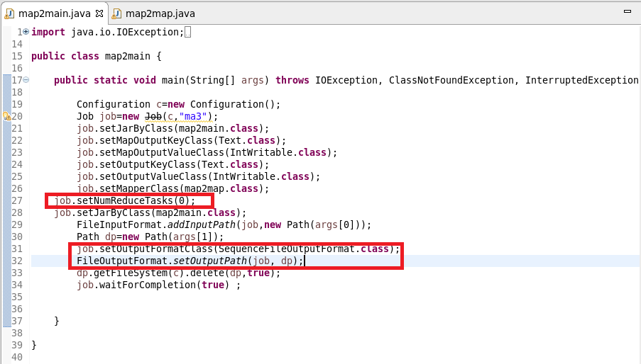

MAPPER CLASS

In mapper class I used a hashmap and updated it in such a way that if the word repeats I will increase the count by 1 and put it in hash map or else give a value of 1

Cleanup Method :I will override the clean method and write the final key and value instead of writing in mapper as mapper will be invoked for each line

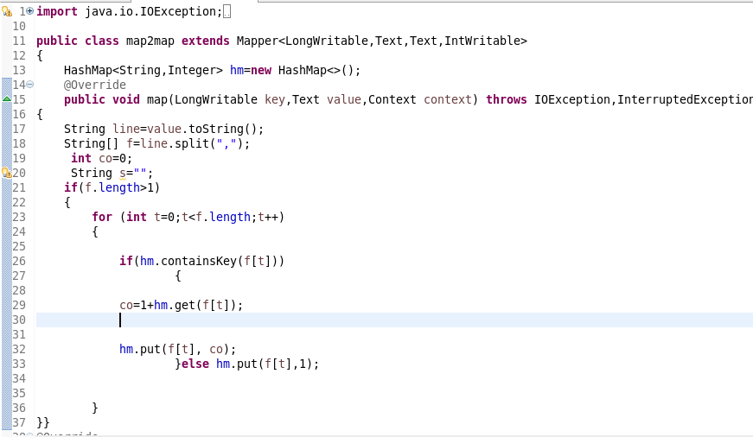

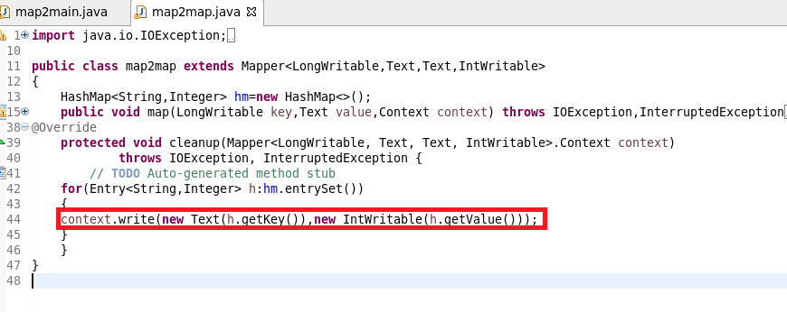

RUNNING JAR

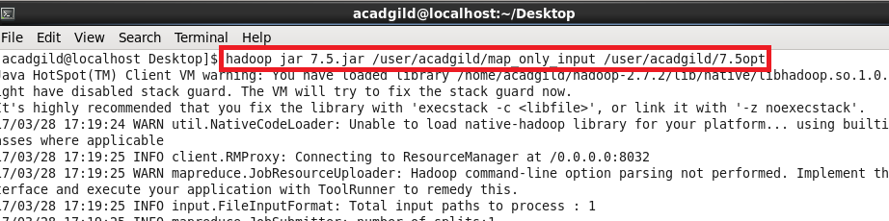

**OUTPUT**

**USED text COMMAND TO OPEN SEQUENCE FILE**

