Before performing join we will create 2 table on which joins will be performed

**Step1:creating customers table and loading data**

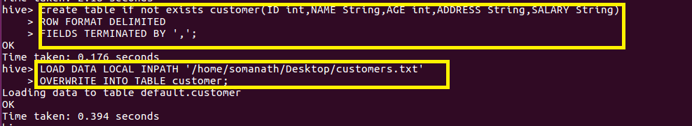

**Step2: :creating orders table and loading data**

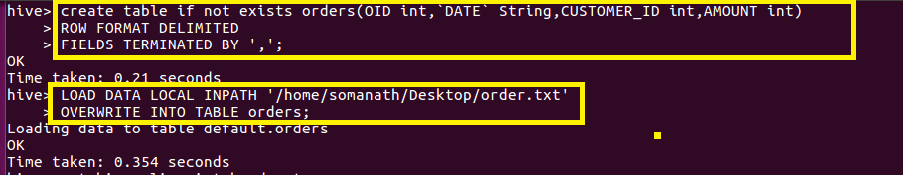

Inner join:

**Inner Join** returns rows when there is a match in both tables (ie ) if we join two table by inner join by say a common field in both tables.Only those records where matching is made alone will be displayed

Here we are joining customer and orders table on id in customer table with customer_id in order table as shown

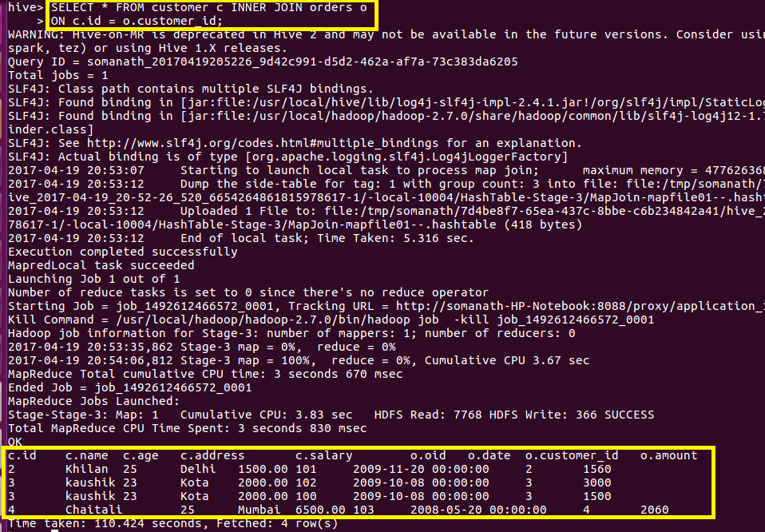

Inference :From output we can infer that only records with matching Id only came

Left Outer Join

The **left outer Join** operation returns all rows from the left table, even if there are no matches in the right relation.

IF there is no matching data on the right table it will display null

Here we are left joining customer and orders table on id in customer table with customer_id in order table as shown

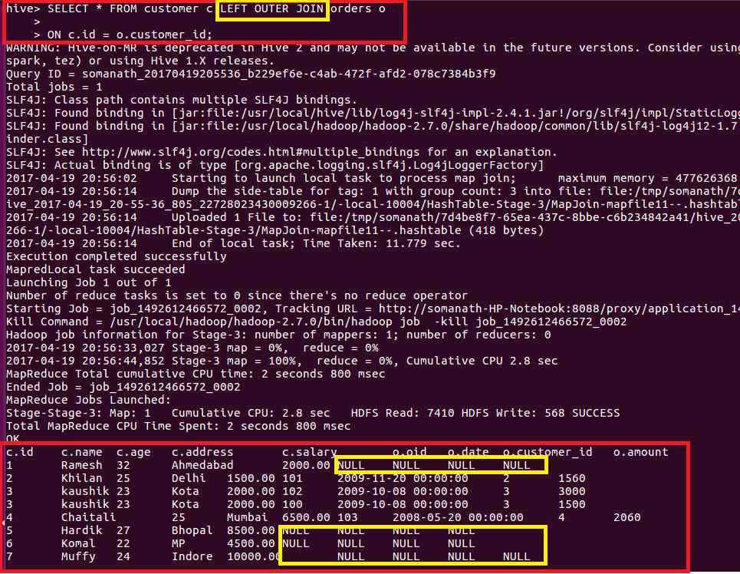

Inference:Here we can see that all records from left Table customer came and null is displayed for the missing records in left table

Right Outer Join

It is just opposite to left outer join.

The **right outer join** operation returns all rows from the right table, even if there are no matches in the left table.

IF there is no matching data on the left table it will display null

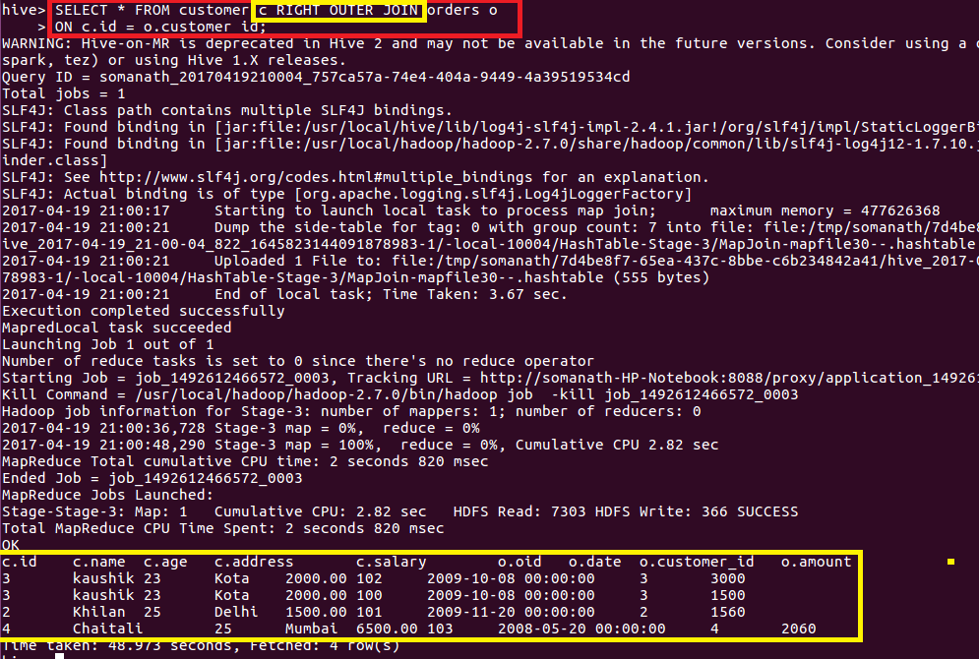

Full outer join

FULL OUTER JOIN

The **full outer join** operation returns rows when there is a match in one of the relations.

In my example,all data from both left and right table came

