1. LOAD AND DUMP

Load DATA FTROM FILE SYSTEM.

Here I am using pig –x local to start IN LOCAL MODE THEN I CRWEA\TED A FOLDER DEMO FROM LOCAL FILE SYSTEM and used Load to load that File into M

Then I used Dump command To Display the Output on GRUNT SHELL AS HIGHLIGHTED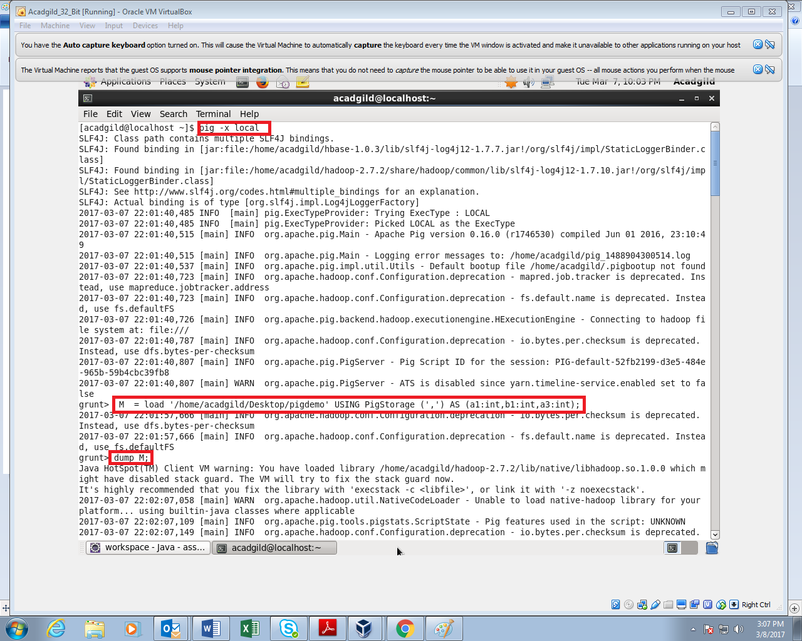

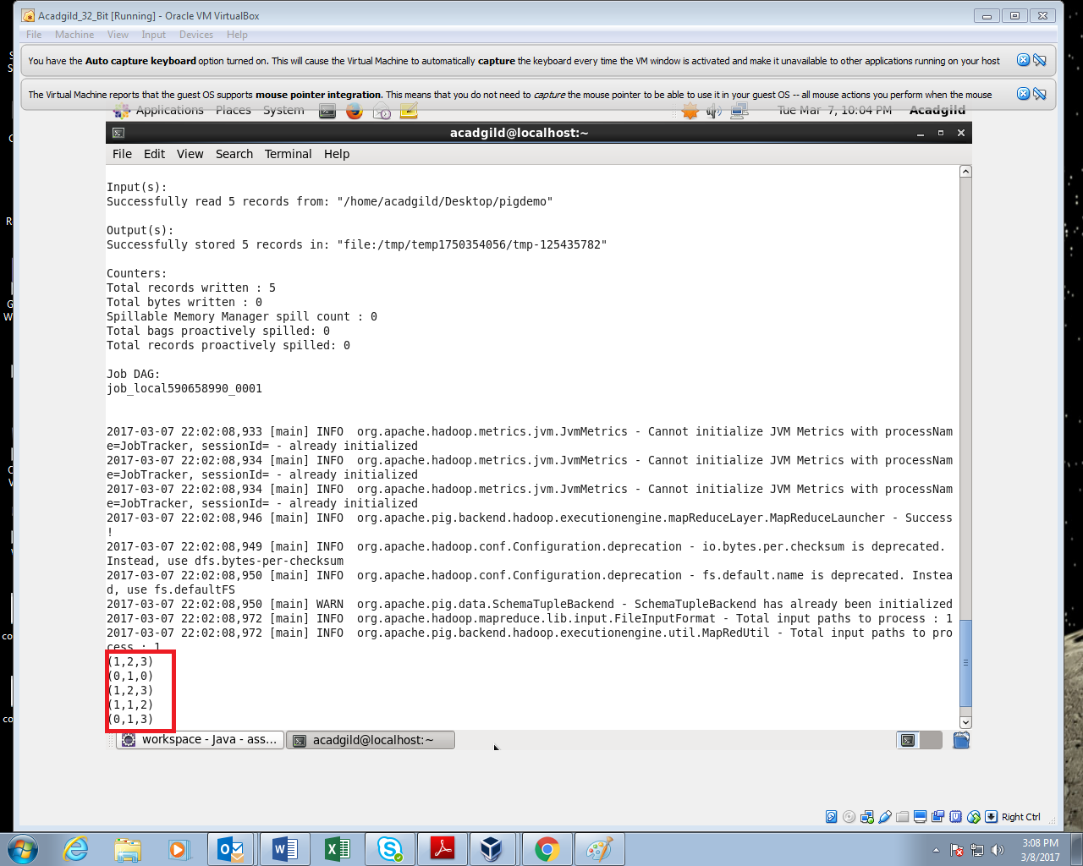

1. STORE

The problem with grunt shell is that once we come out of grunt shell every executed will be

Gone .So we can use Store command to store output

In store If we store without specifying pig storage the output will be delimited by tab(pigDemocopy)

Here I have stored M output in PigDemoCopy Directory and The Map output is stored in the directory as shown below

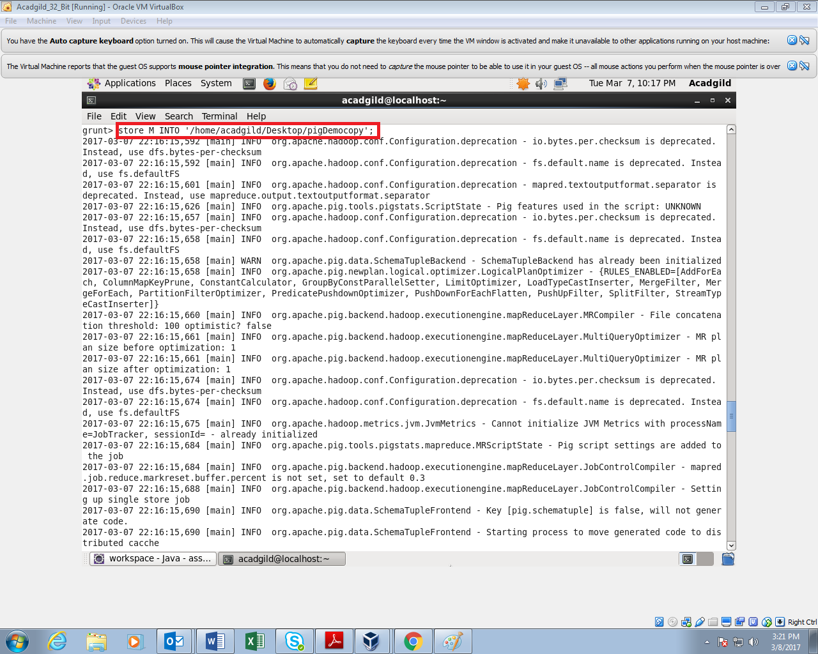

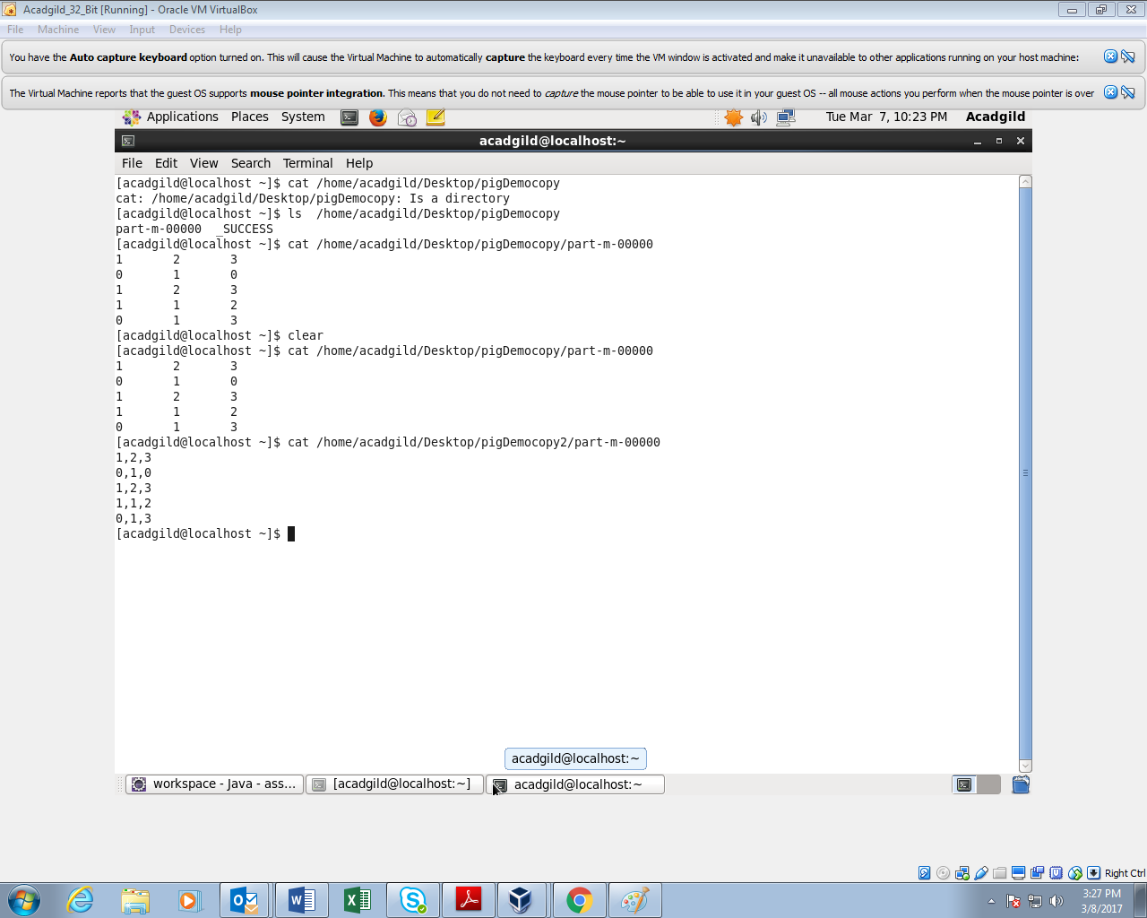

1. FOREACH

Generates data transformations based on columns of data.

It is like \* command in SQL

Here I have used for performing simple manipulation for each ro

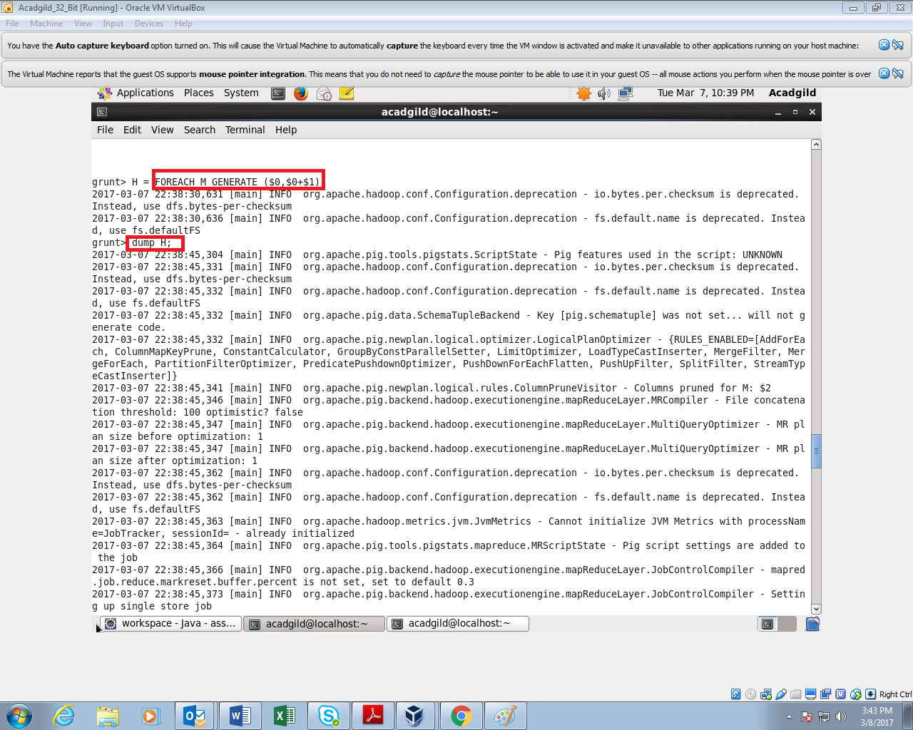

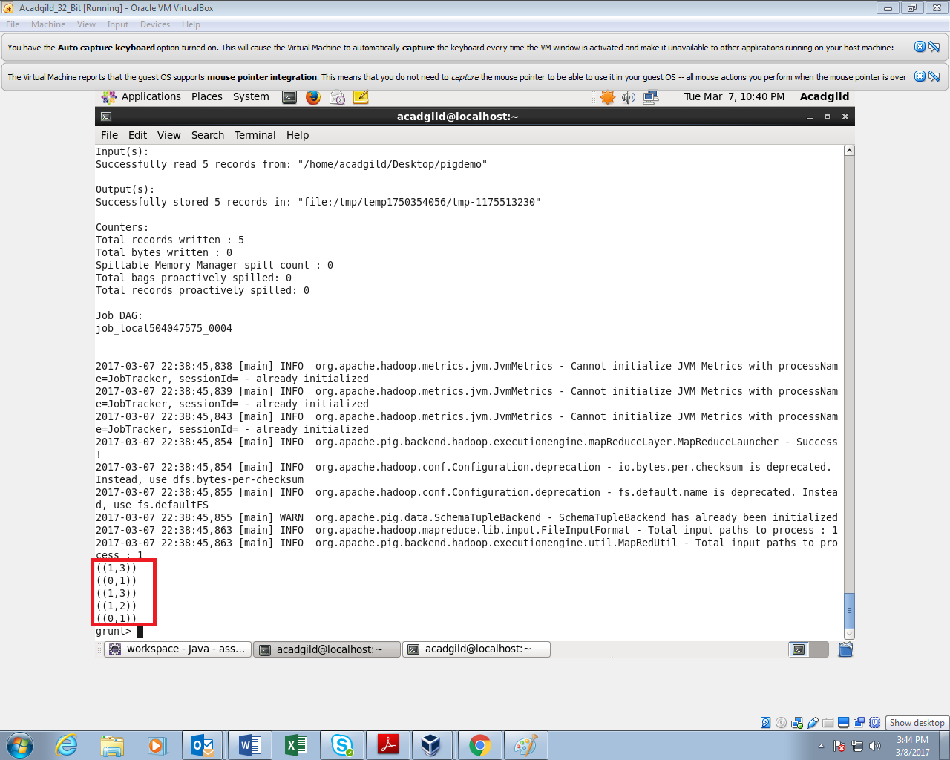

1. FILTER

It is used for filtering the data

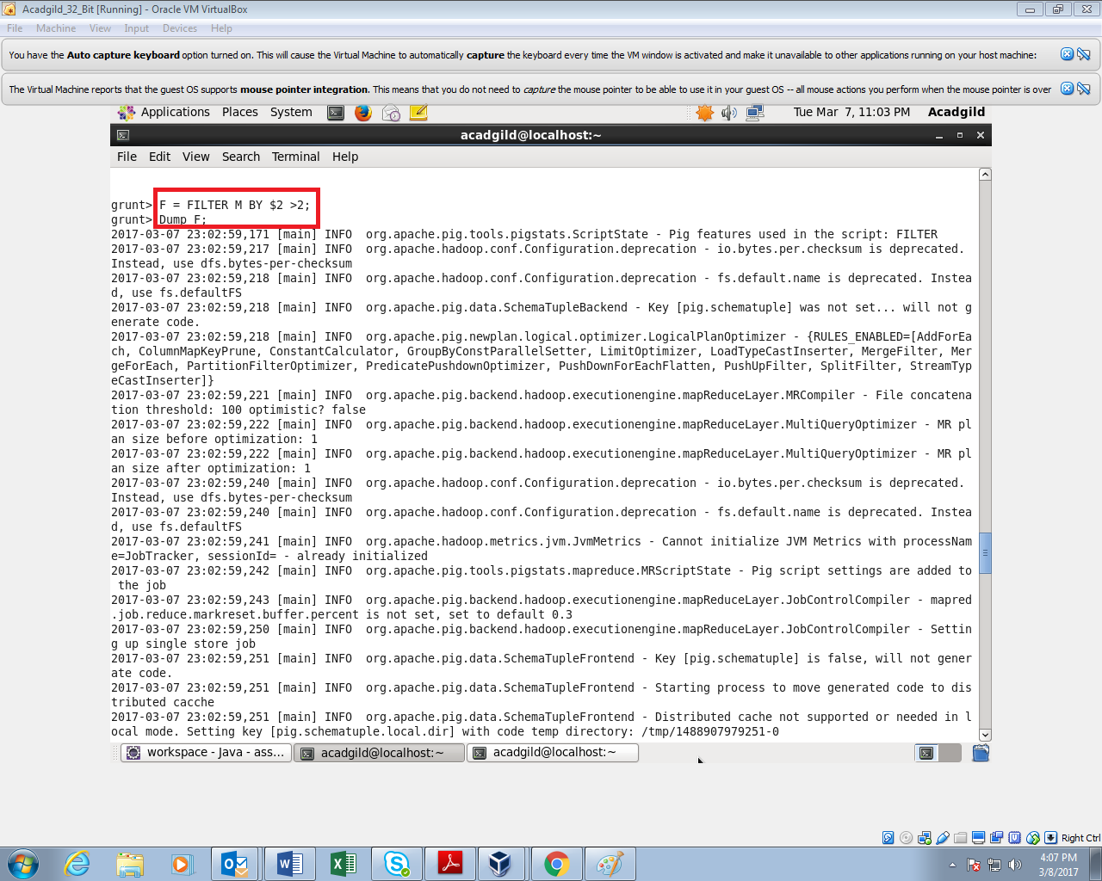

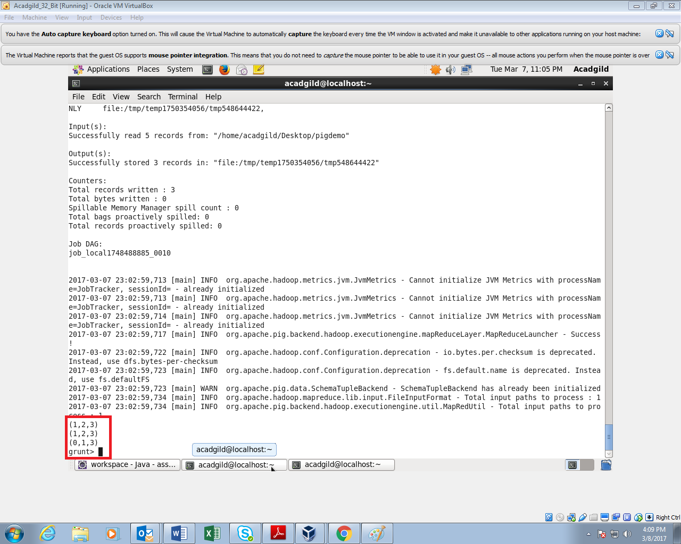

1. GROUP BY

It is used to group data based on the given criteria

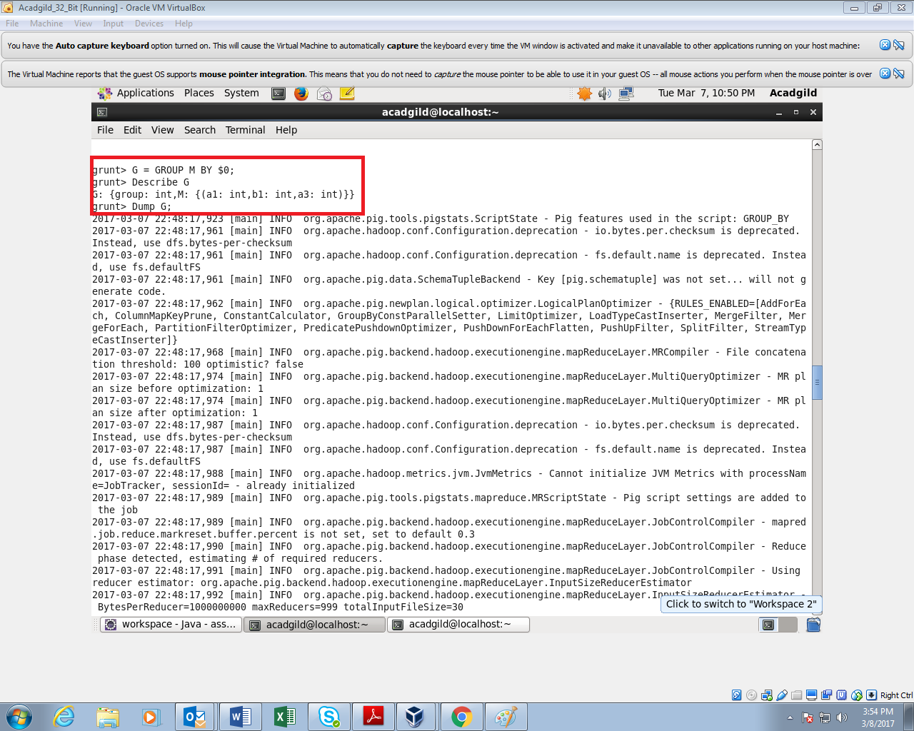

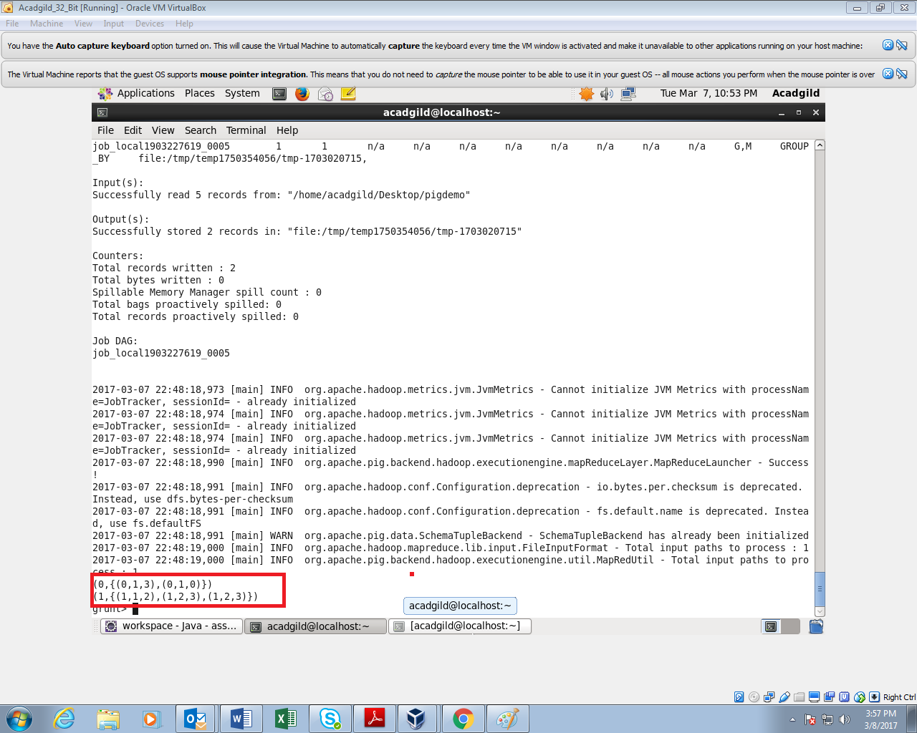

1. ORDER BY

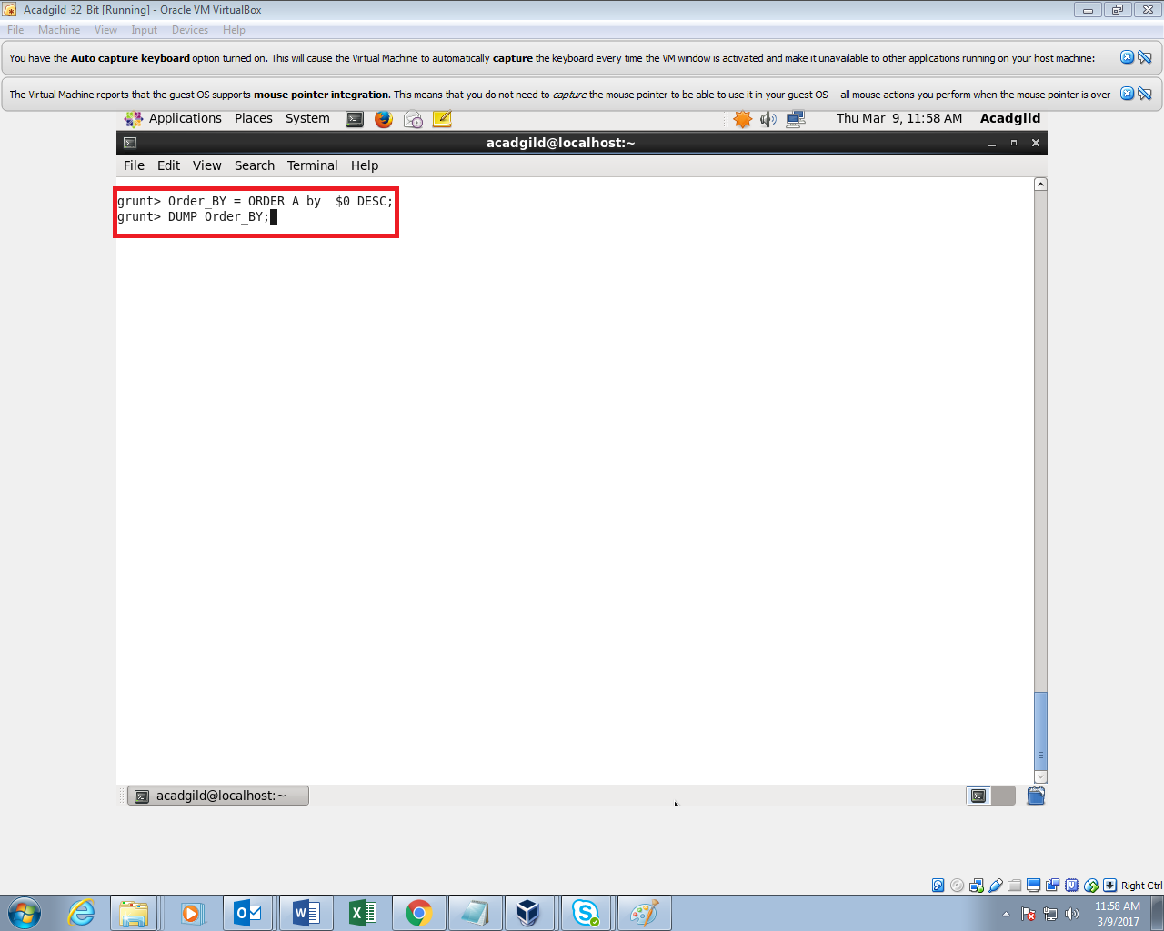

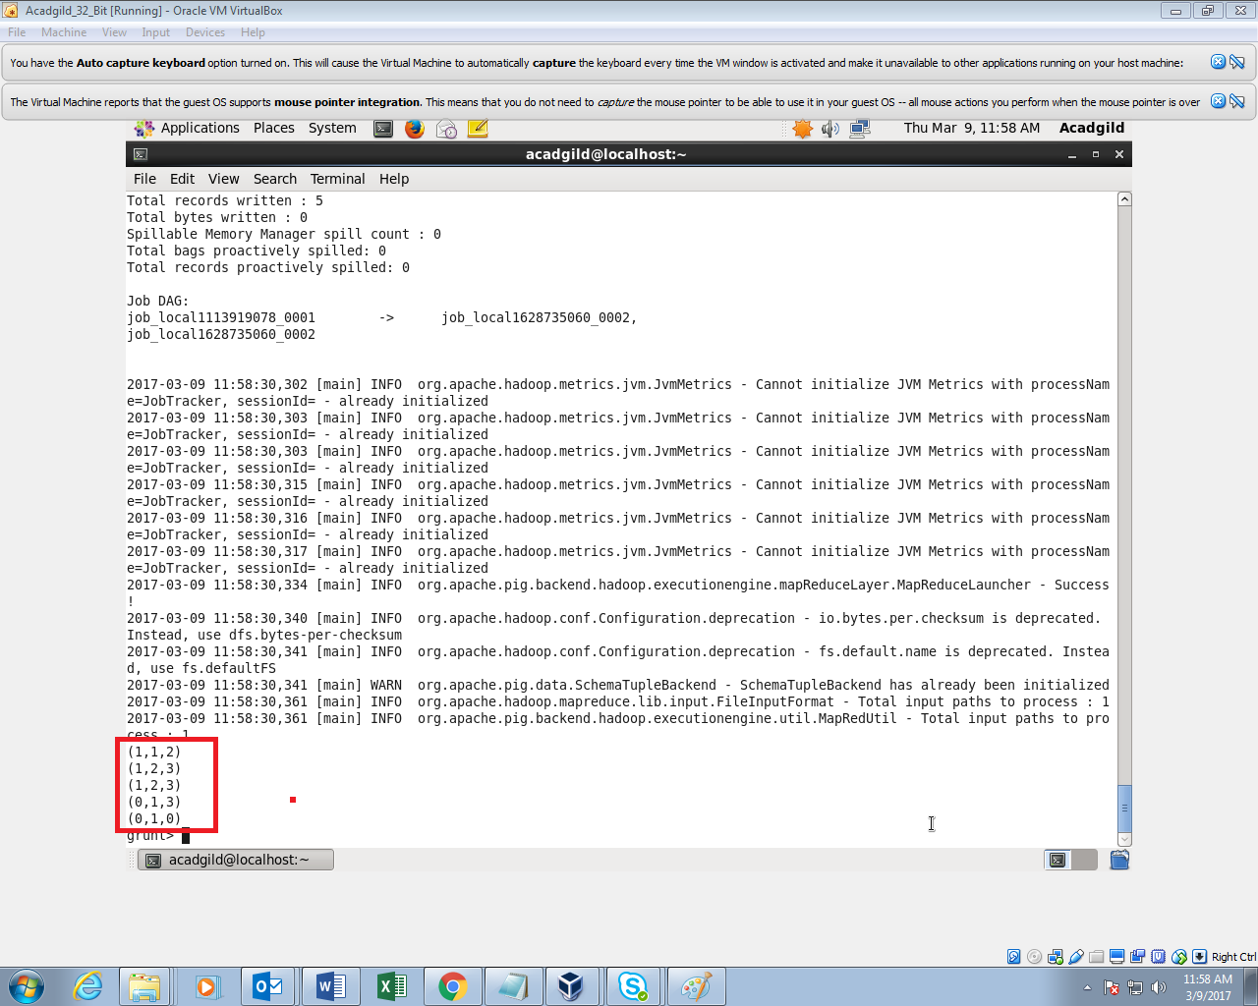

8. DESCRIBE

Describe command is used to describe the Schema.

