**Input Schema**

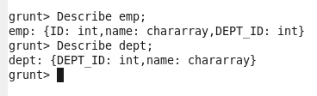

Self join

A self-join is a query in which a table is joined (compared) to itself.  Self-joins are used to compare values in a column with other values in the *same column in the same table*.  One practical use for self-joins.

1.I Load the same emp dataset into “emp and emp1”;2.I joined both Table based on Dept_Id .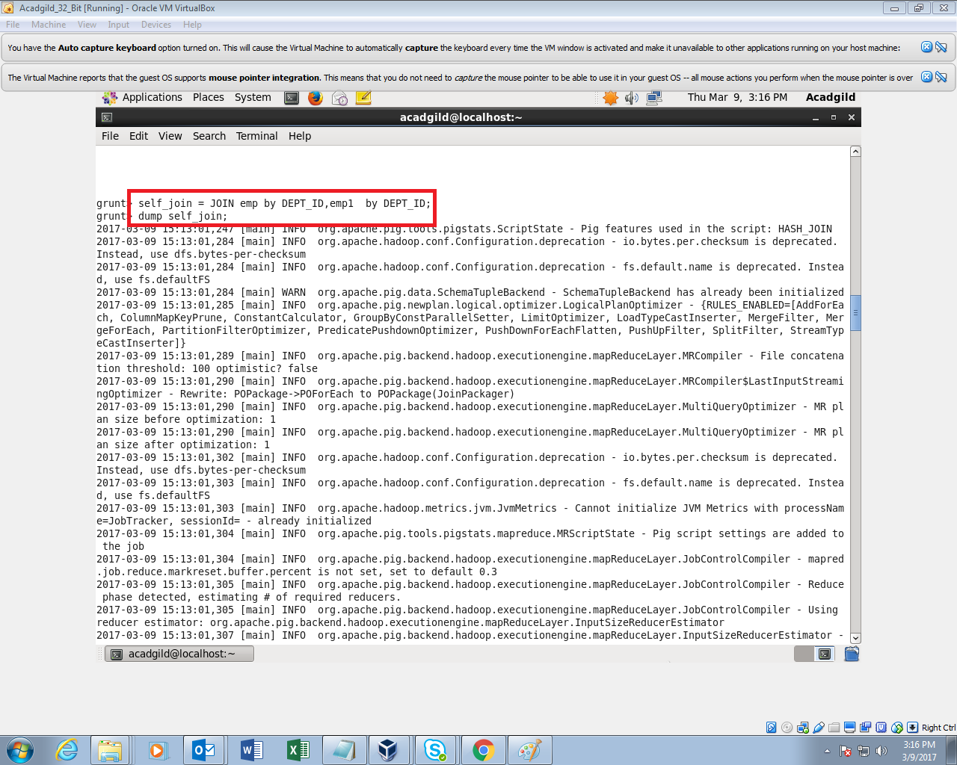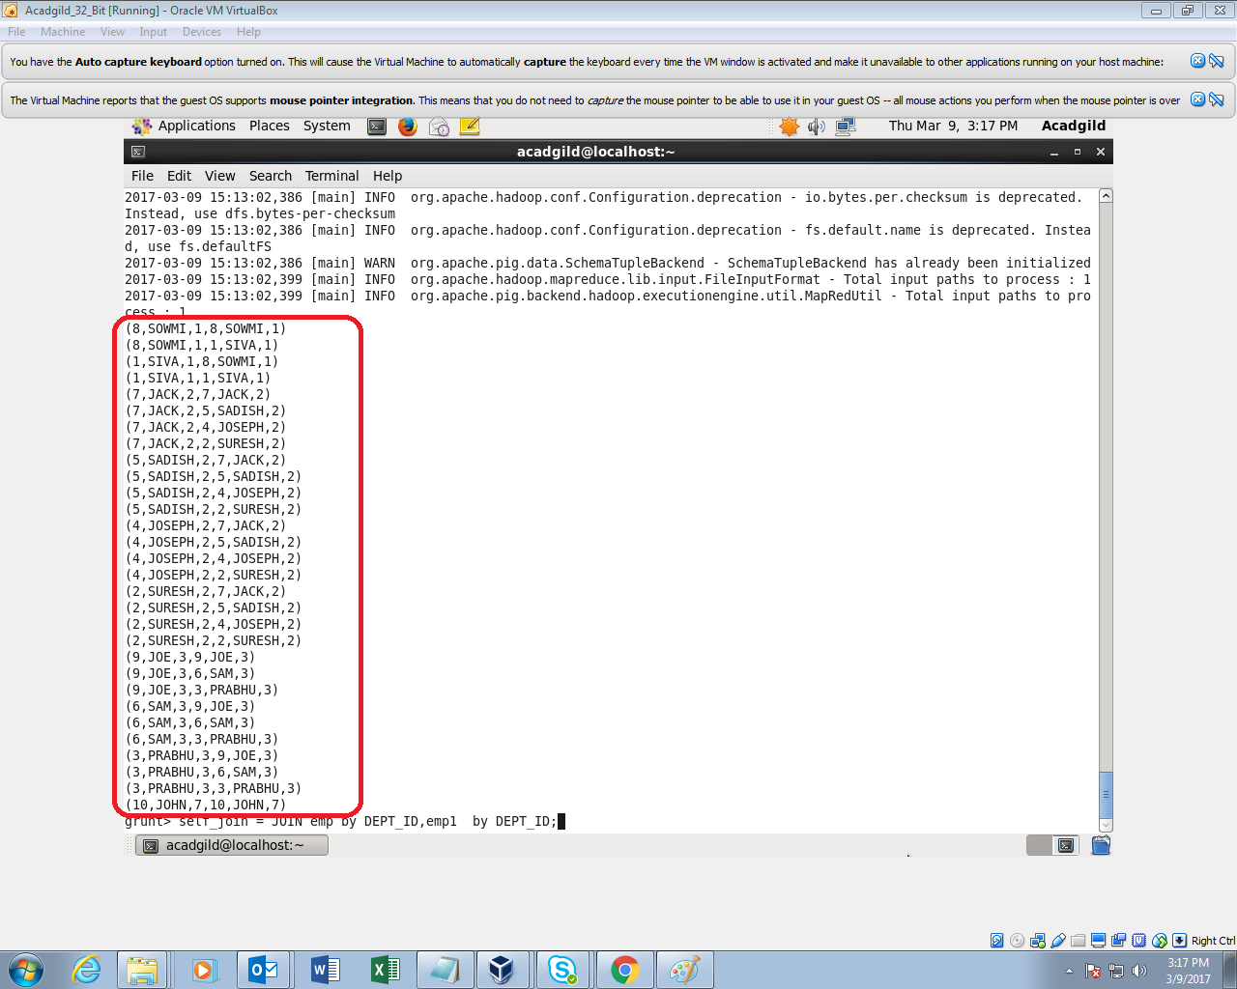

Inner join:

**Inner Join** is used quite frequently; it is also referred to as **equijoin**. An inner join returns rows when there is a match in both tables.

So In this example I want to find the employees who have dept assigned.So if I join both emp and dept relations by DEPT_ID only those who have DEPT_ID WILL ALONE COME IN OTPT

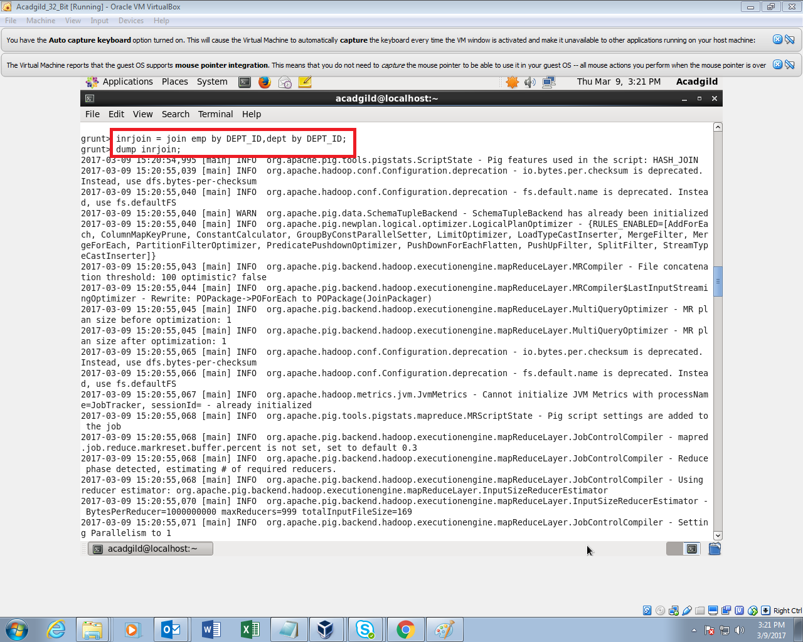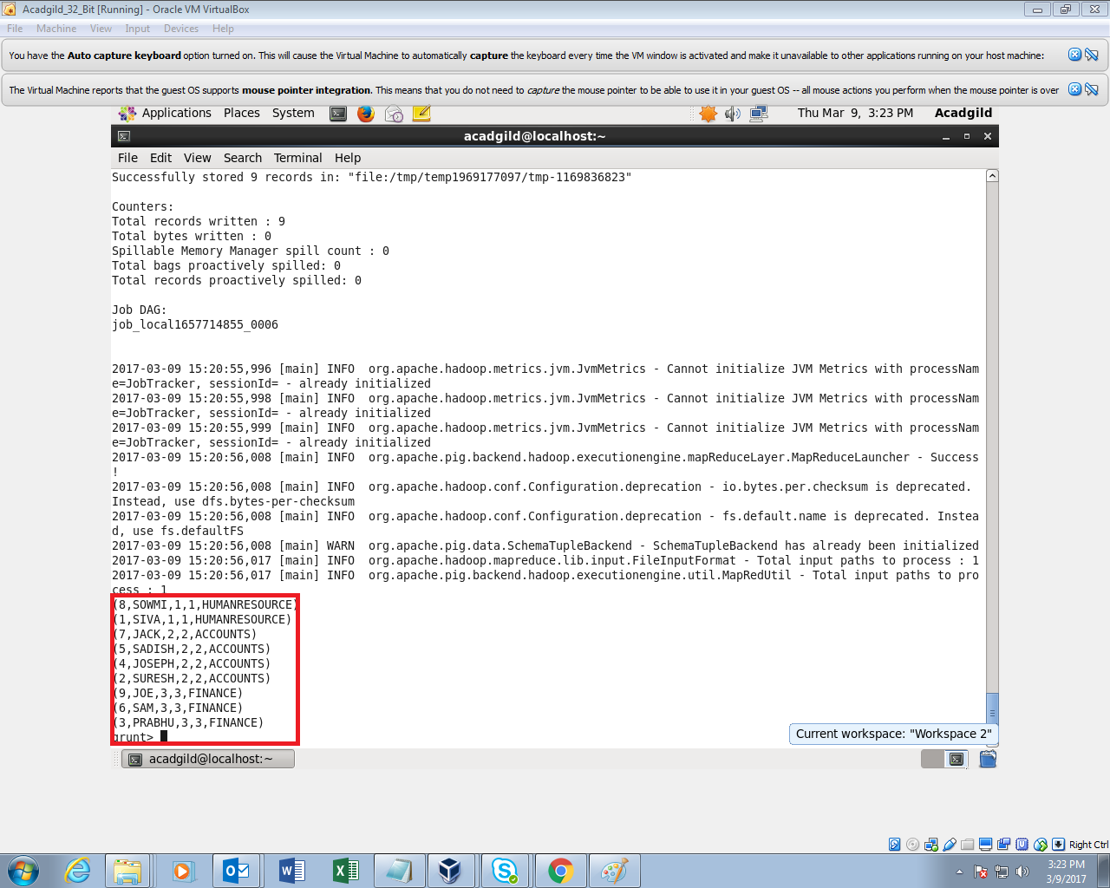

Left Outer Join

The **left outer Join** operation returns all rows from the left table, even if there are no matches in the right relation.

In my sample you can see that all records in the “emp” relation came if there is no corresponding dept_id it will just display nothing

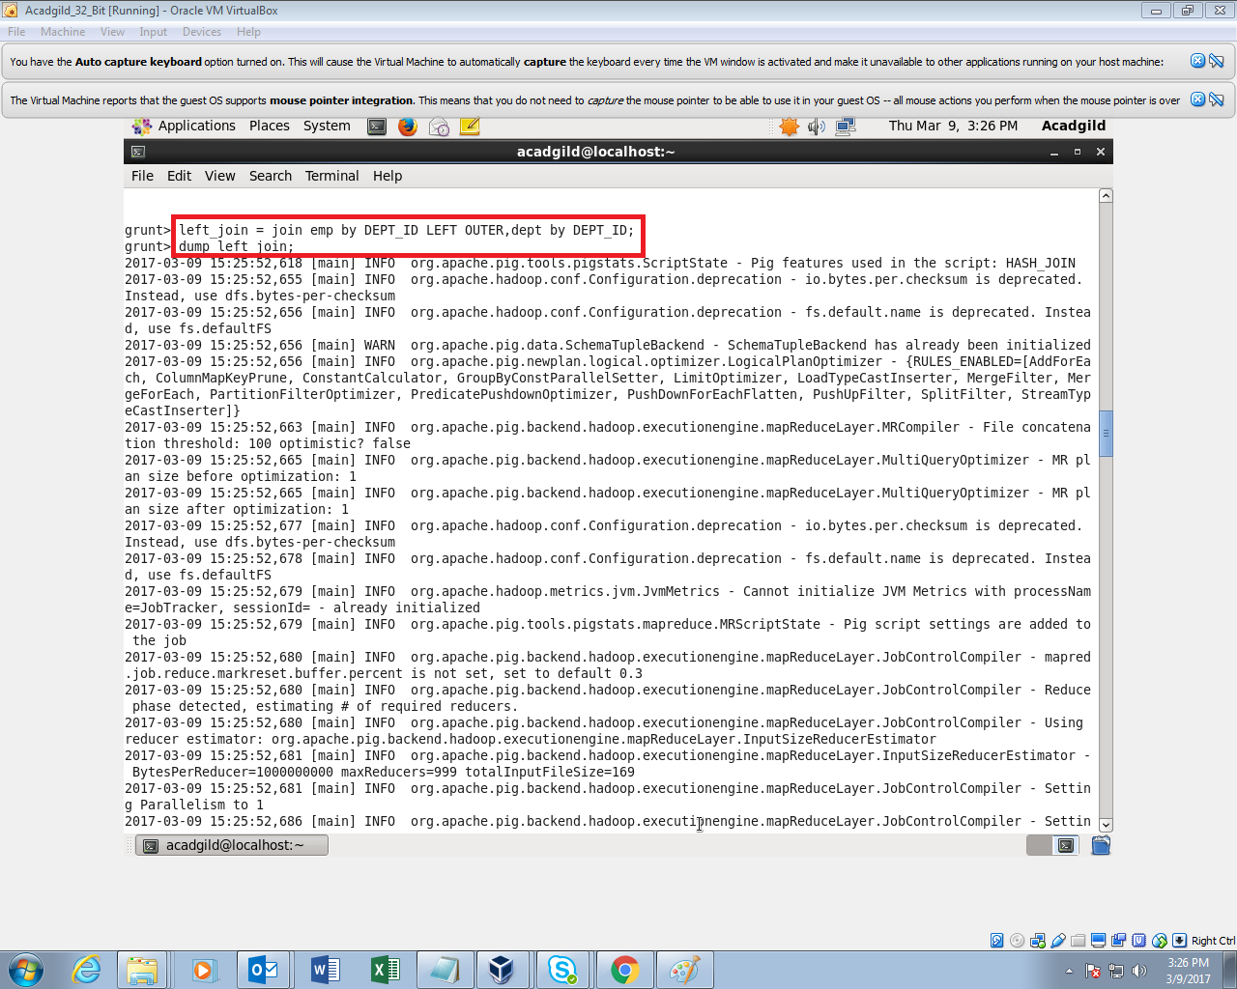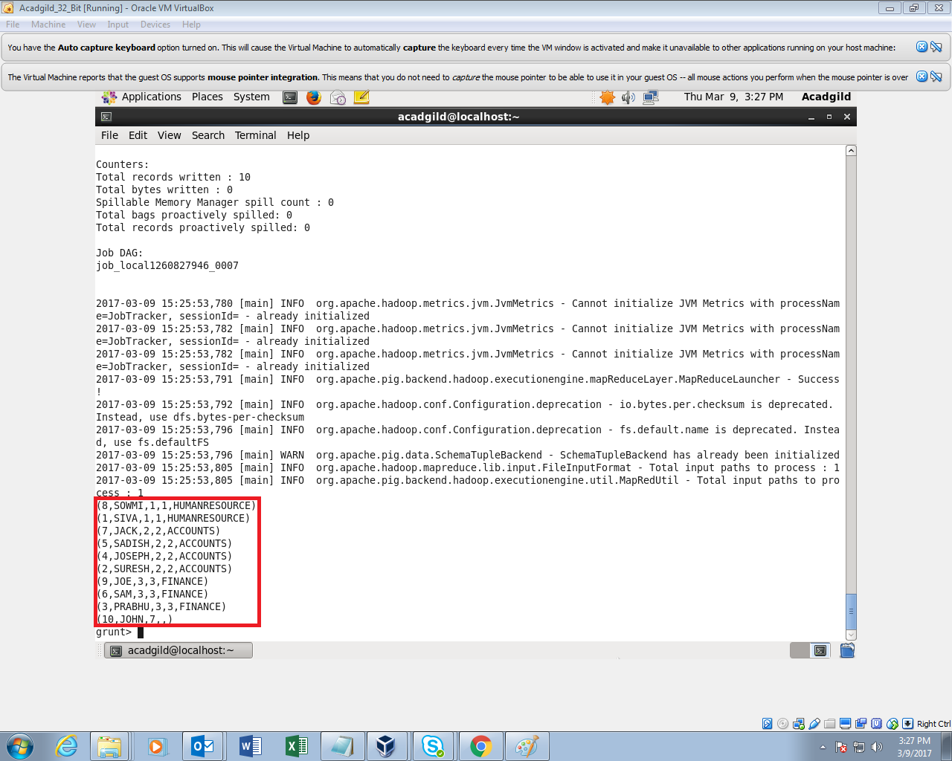

THOUGH JOHN IS NOT ASSIGNED A DEPT_ID.It also came.

Right Outer Join

It is just opposite to left outer join.

The **right outer join** operation returns all rows from the right table, even if there are no matches in the left table.

In my sample you can see that all records in the “Dept” relation came if there is no corresponding emp for a Dept_Id, it will just display nothing

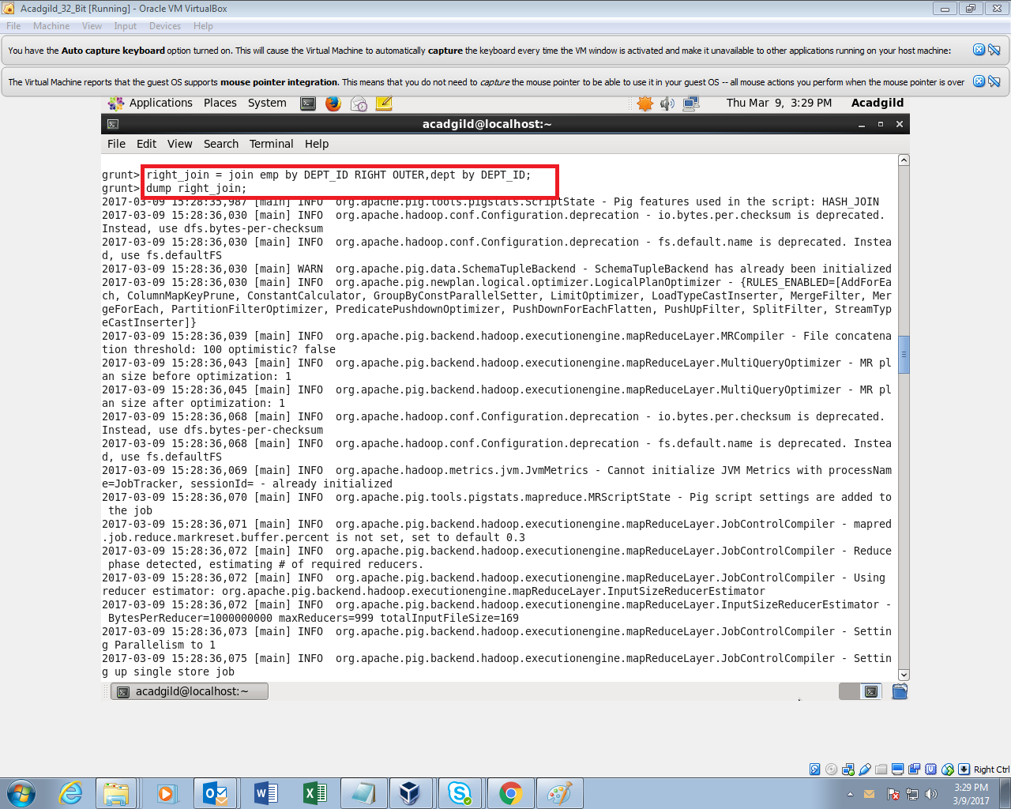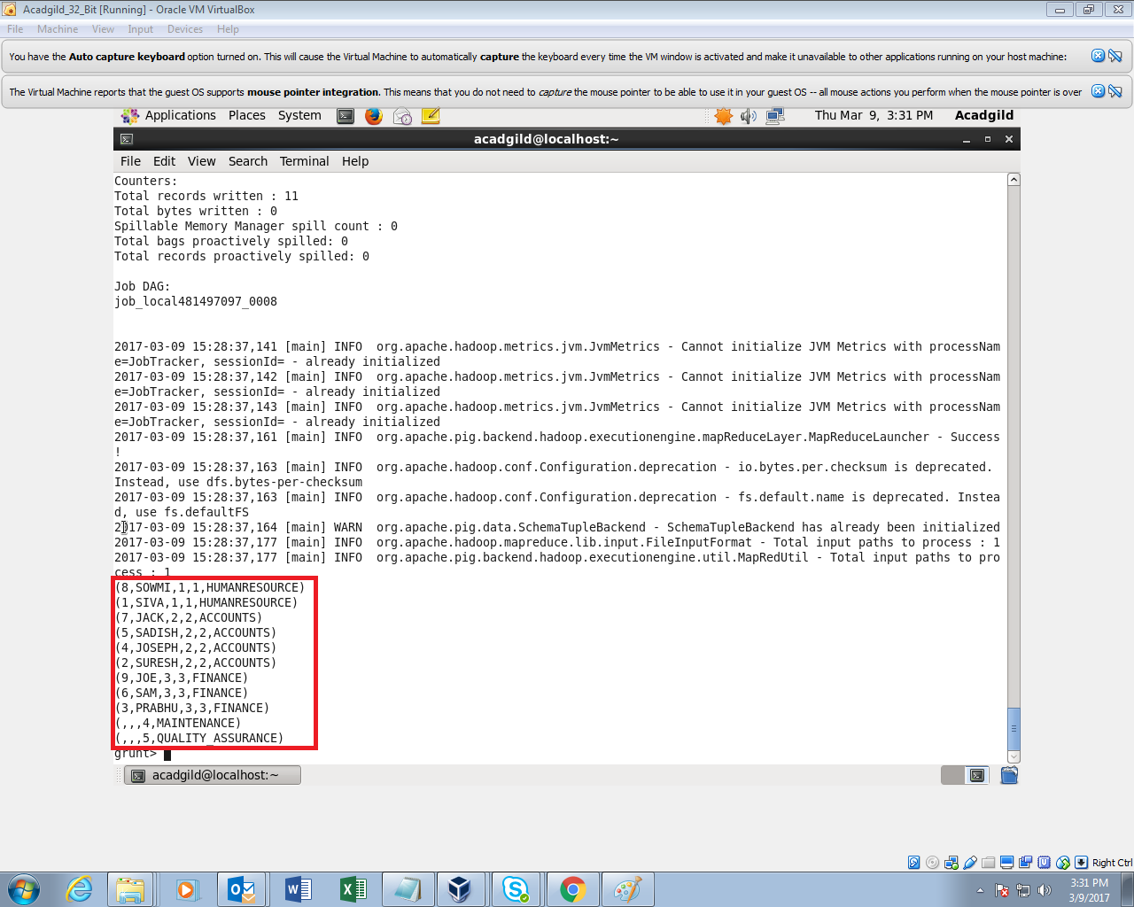

YOU CAN SEE ALL DEPTS IN THE DEPT TABLE CAME

FULL OUTER JOIN

The **full outer join** operation returns rows when there is a match in one of the relations.

In my example,all data from both left and right table came

