**QN.Write a mapreduce job that takes configuration from command line (min.word.count). Based on the configuration, it should perform count of words from a document and produce only those words in the output whose count is greater than or equal to the configuration.**

INPUT FILE

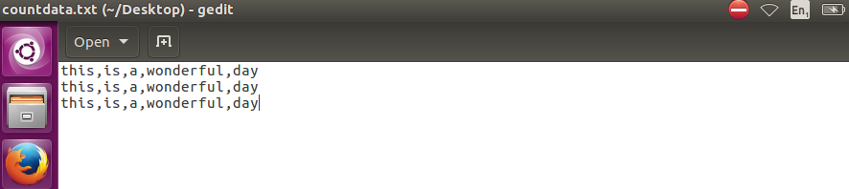

**DRIVER**

In driver we should make the class extends configured class and implement tool interface and toolrunner static method run cwhich creates a configuration object before the run method

And tool runner uses generic option parser to get input form command line

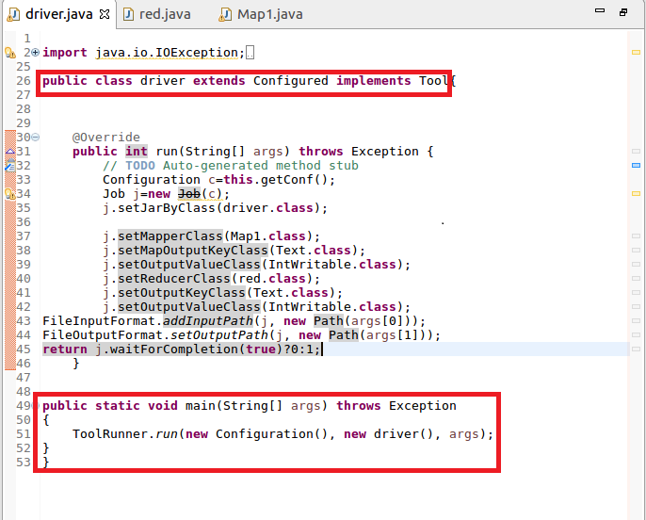

**MAPPER**

In Mapper ,I am using configuration’s get method to get value of key “name” dynamically and I am using the value of key “name” for filtering the length of those words greater than the given length

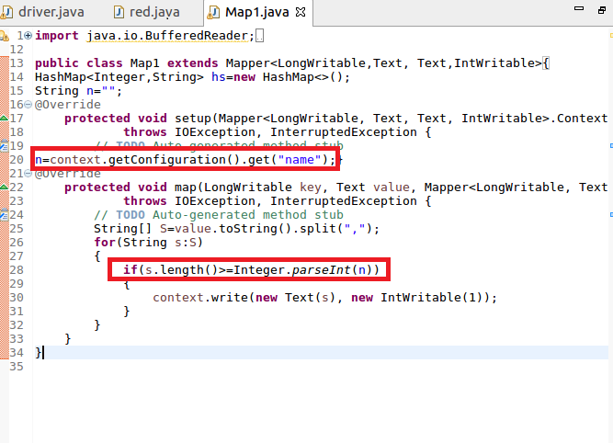

**REDUCER**

**Counting the words by iterating the values of key**

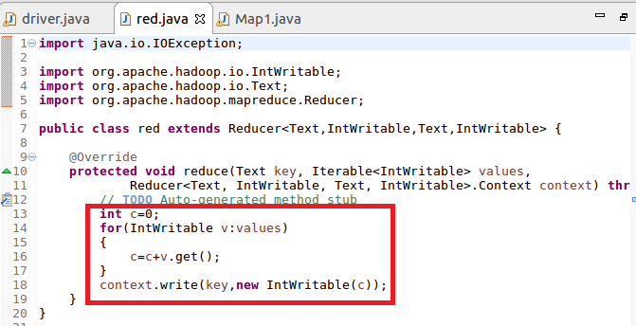

**RUNNING JAR**

**Here I have specified the length=3 by giving –D name=3 as highlighted below**

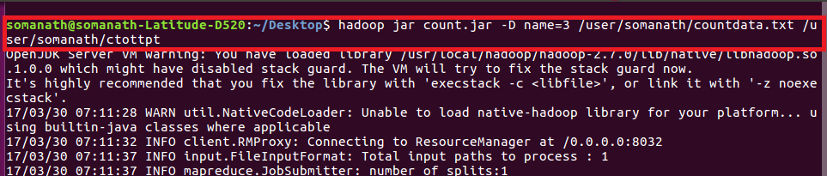

**OUTPUT**

**You can see the only words length >=3 is only counted**

