**Qn1.Fetch date and temperature from temperature_data where zip code is greater than 300000 and less than 399999.**

**Qn2.Calculate maximum temperature corresponding to every year from temperature_data table.**

**Select year from date by using substring function and gave alias name as Year and used max function to find maximum temperature and gave alias name as maximum_temperature and grouped by year**

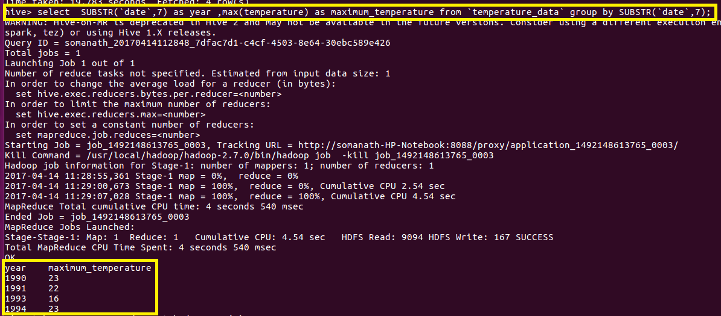

**Qn3.** **Calculate maximum temperature from temperature_data table corresponding to those years which have at least 2 entries in the table.**

**Select year from date by using substring function and gave alias name as Year and used max function to find maximum temperature and gave alias name as maximum_temperature and grouped by year**

**Filter by entries greater than 2 by using count in having clause**

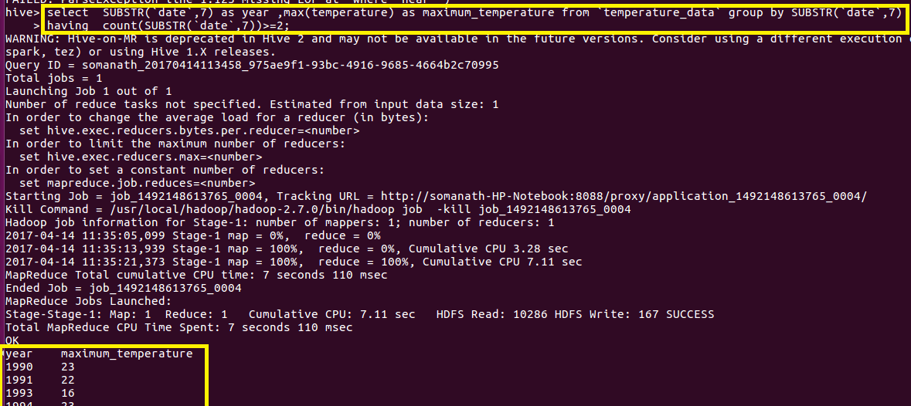

**Qn4. Create a view on the top of last query, name it temperature_data_vw.**

**Used create view to create view on last querry and displayed the data of view to check the output**

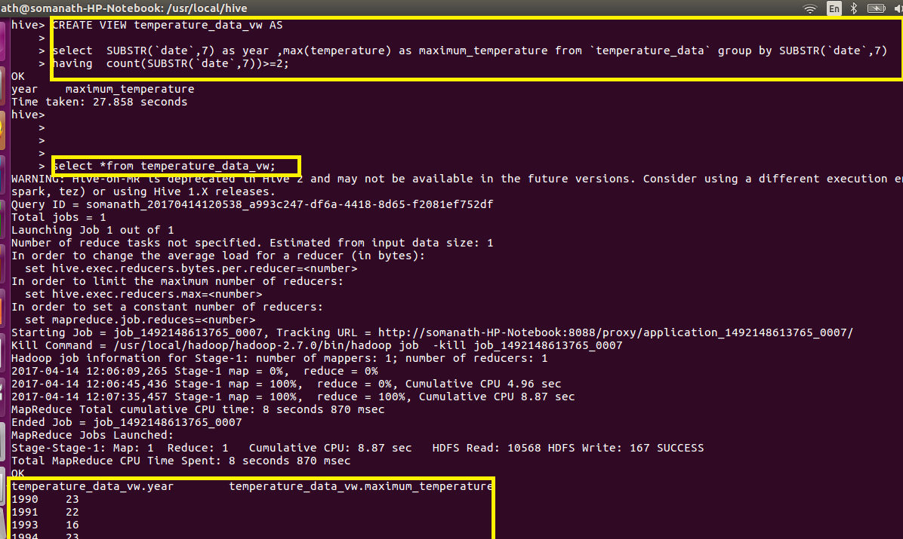

**Qn5.Export contents from temperature_data_vw to a file in local file system, such that each file is '|' delimited.**

**Used insert overwrite local directory to export contents**

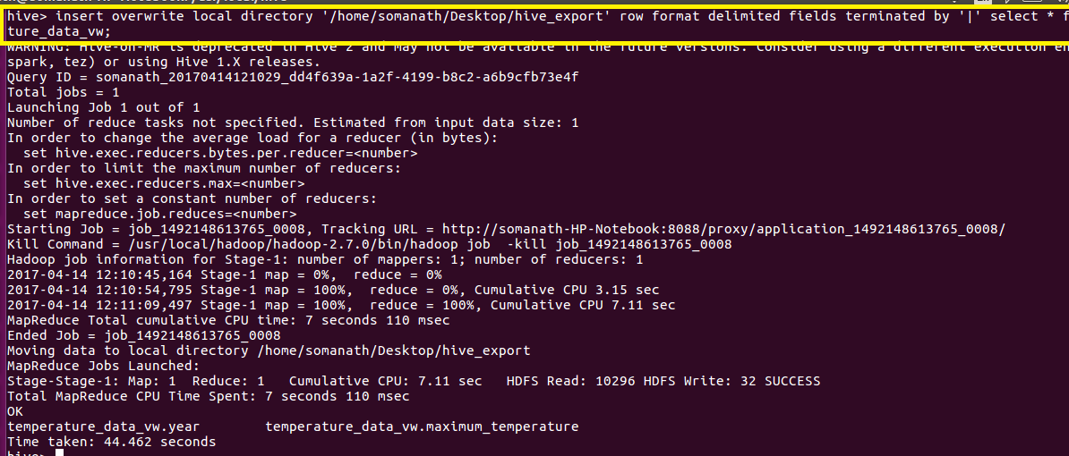

**Verification: The output delimited by | is written In hive_export**

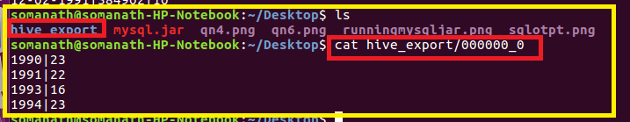

**Qn1.Fetch date and temperature from temperature_data where zip code is greater than 300000 and less than 399999.**

