**Creating Table and Loading data**

**Created table titanic_data and loaded Data**

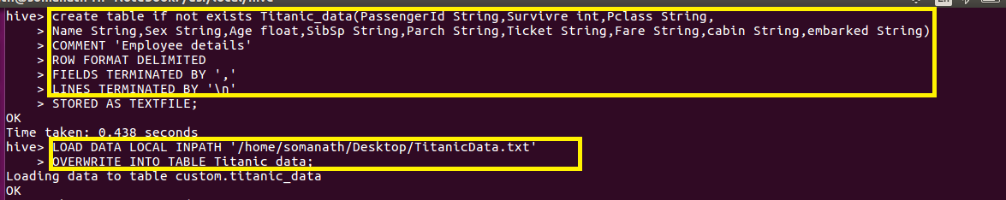

**1.Write a hive query find the average age of male and female persons died in the titanic tragedy**

**Find average age using avg() function filter by dead and grouped by sex as shown**

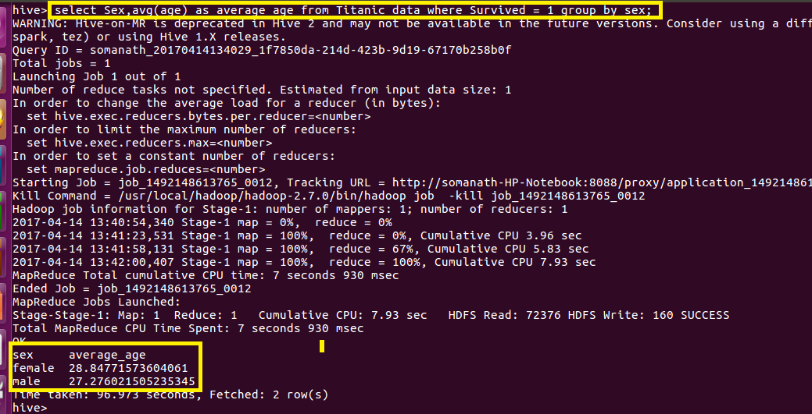

**2.Write a hive query to find the number of people died and survived in each class**

**Since we want number of people died and survived in each class I grouped by pclass and survived**

