**Loading Data**

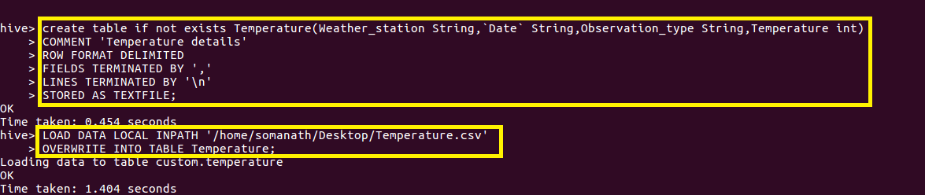

**qn1.Write a hive query to find the minimum temperature observed in a given weather station in a particular year.**

**Since we want minimum temperature in a particular year,weather station**

**I grouped by weather station and year part of date by using substr() function and used min() function to find minimum temperature**

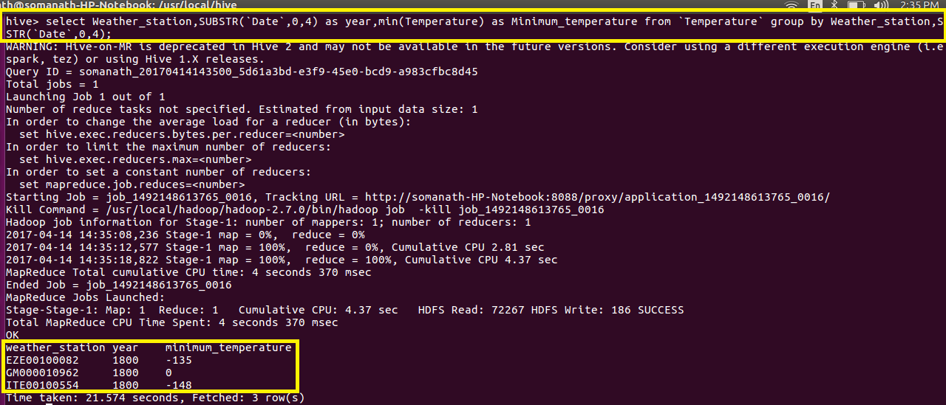

**2. Write a hive query to find the maximum temperature observed in a given weather station in a particular year.**

**Since we want maximum temperature in a particular year,weather station**

**I grouped by weather station and year part of date by using substr() function and used max() function to find minimum temperature**

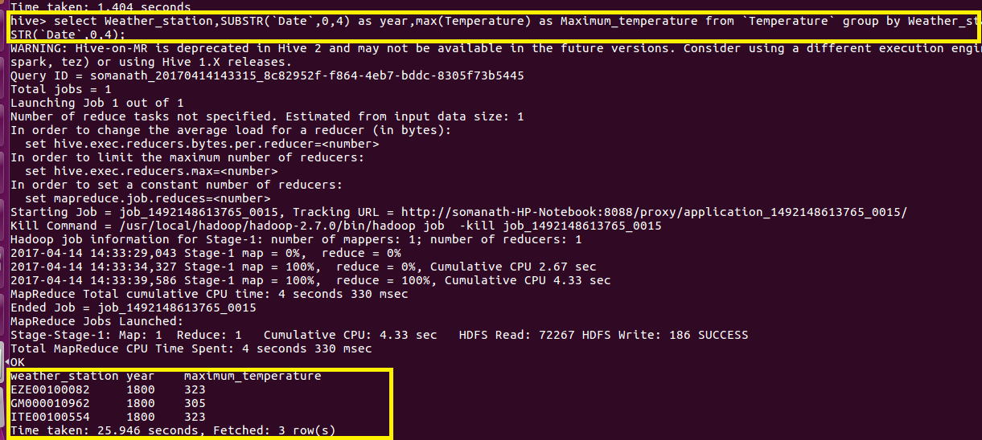

**3. Write a hive query to find the number of readings given by each weather station according to the dataset.**

**Since we want number of readings for each weather station group by weather station and made a count of reading**

