Perform wordcount operation in local mode

Local Mode :It means the map reduce task is done in your local system rather than in Hadoop cluster.It may be required as running even a small wordcount program consumes 128MB which may cause under utilization of Hadoop memory

To avoid this we may run the code in local Mode

**Execution Steps To run In local Mode**

**Step1:Add External Jar core-1.2.1 which contains all the dependencies required for running a Hadoop in local machine and all jars in Lib folder of common to your buid path of project**

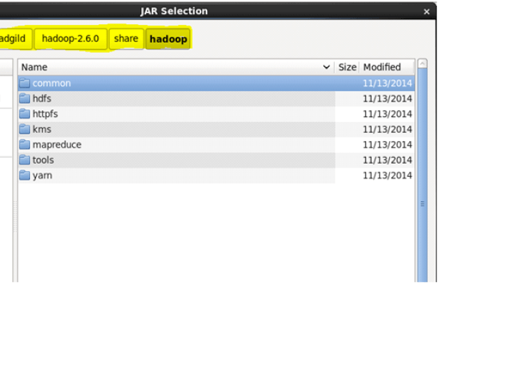

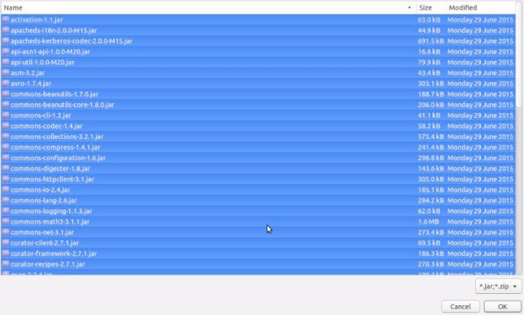

**Step 2: writer Mapper,Reducer and Driver class**

Driver:local mode main

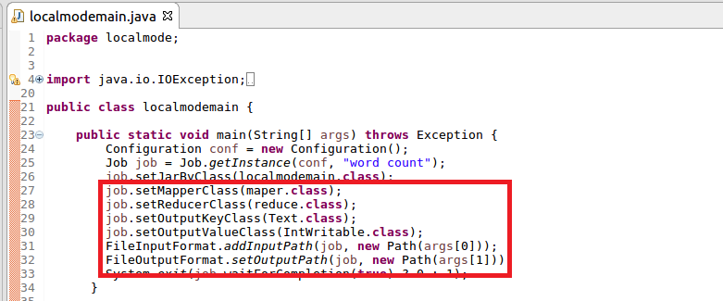

Mapper:Splitting the value by comma and sending word as key and a count of 1 as value

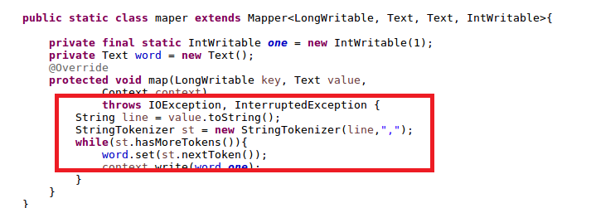

Reducer: adding the occurrence of each word and a total count is made

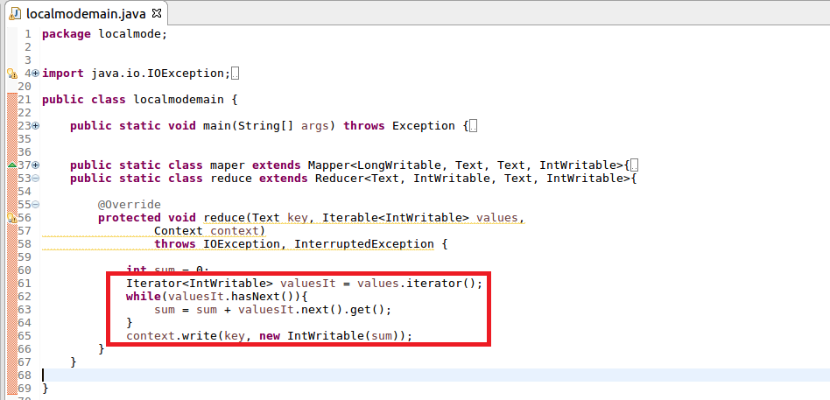

**Step3:To run in local mode right click project select run as🡪 run configuration🡪main**

**and select the project and corresponding main class of the project that you want to run**

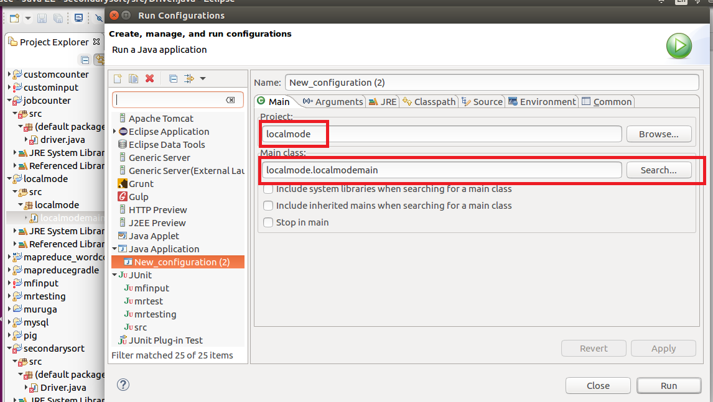

**Step4:give Input and Output Path in Argument tab and click run**

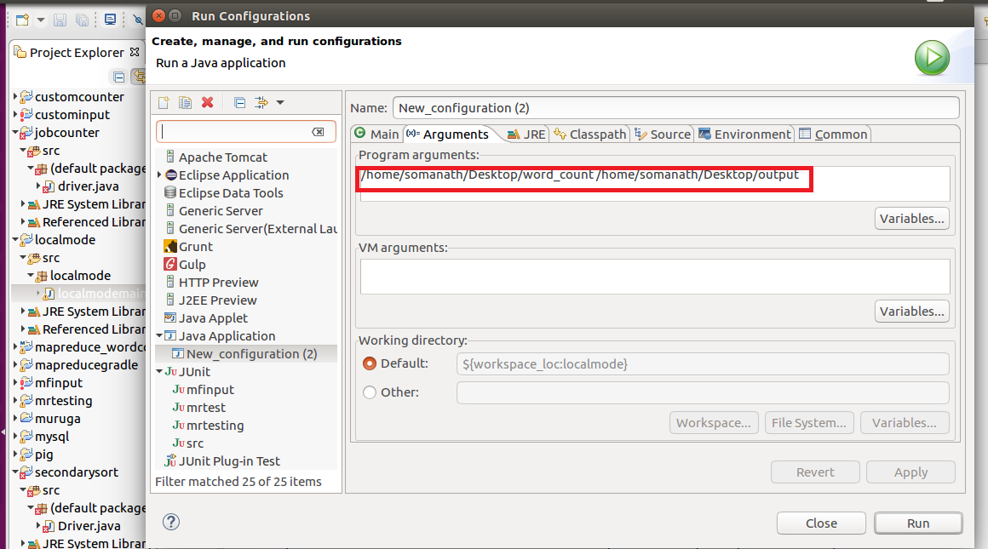

**Output:Mapreduce runs in the console and output gets saved in output path as highlighted in image**

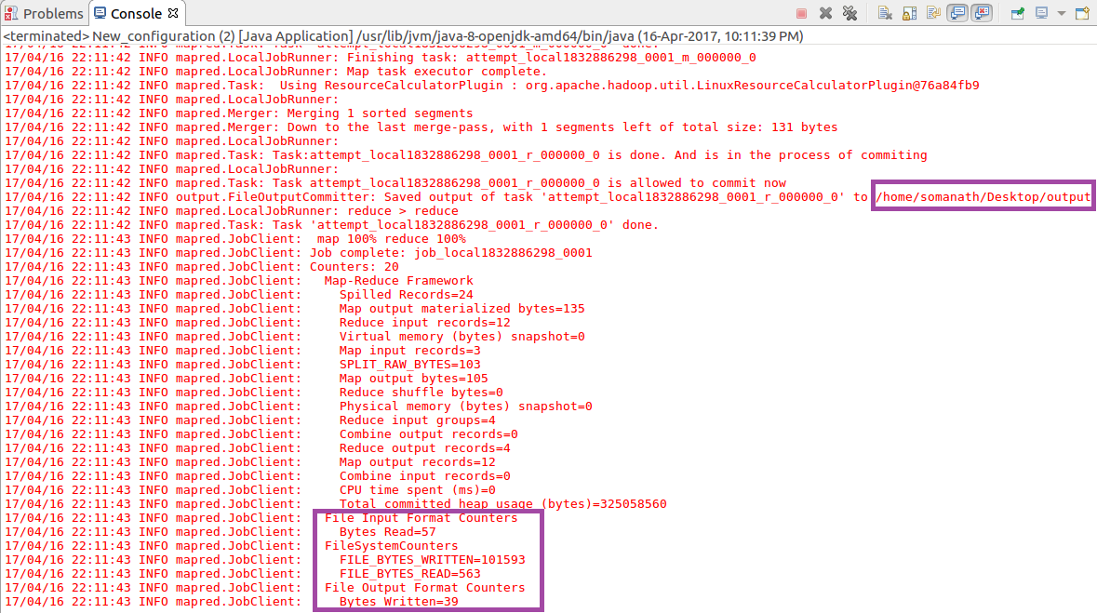

**INFERENCE :Output file is stored in specified directory and the contents is displayed in Gedit**

