**Loading Olympic Data**

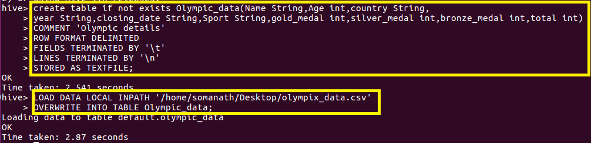

**Qn1.Write a Hive program to find the number of medals won by each country in swimming.**

**Since we want the number of medals won by each country in swimming group by country and filtered by swimming**

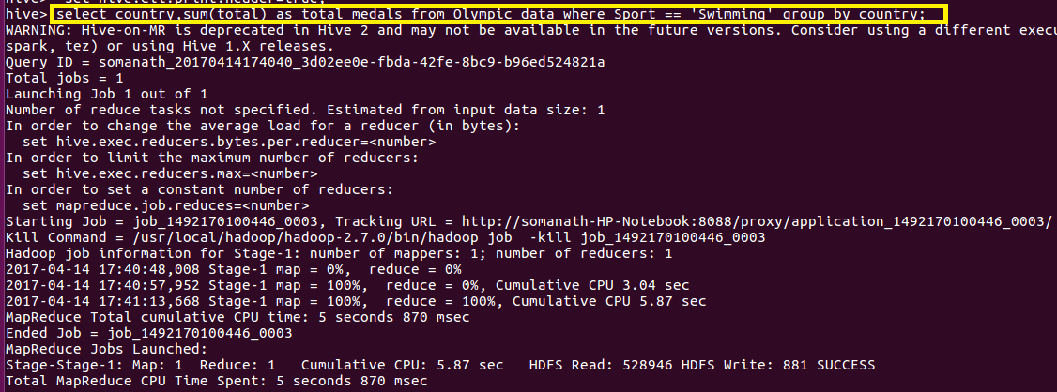

**Output**

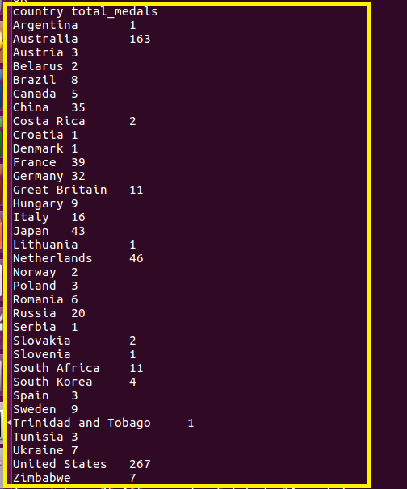

**Qn2. Write a Hive program to find the number of medals that India won year wise**

**Since we want medal won by india year wise ,group by year and filter by country equal to india**

