**Loading Olympic Data**

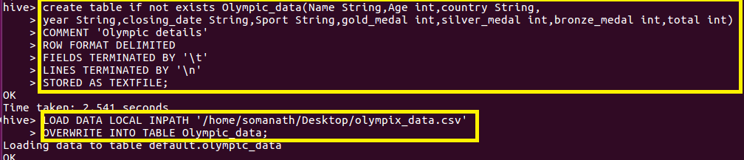

**Write a Hive Program to find the total number of medals each country won**

**Since we want to find the medals won by country ,sum the total medals and gave a alias name as total_medals and group by country**

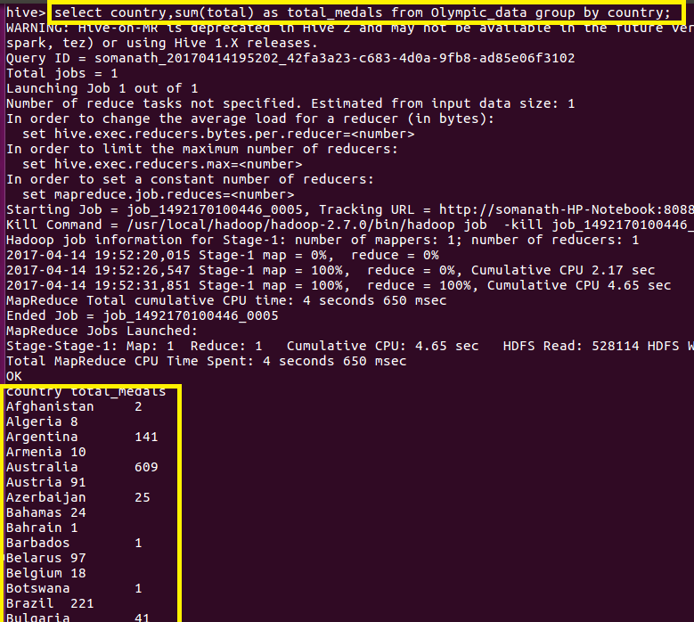

**Output**

**FULL OUTPUT AS COPIED FROM HIVE**

**Country total_medals**

|  |
| --- |
|  |
|  | **Afghanistan 2** |
|  | **Algeria 8** |
|  | **Argentina 141** |
|  | **Armenia 10** |
|  | **Australia 609** |
|  | **Austria 91** |
|  | **Azerbaijan 25** |
|  | **Bahamas 24** |
|  | **Bahrain 1** |
|  | **Barbados 1** |
|  | **Belarus 97** |
|  | **Belgium 18** |
|  | **Botswana 1** |
|  | **Brazil 221** |
|  | **Bulgaria 41** |
|  | **Cameroon 20** |
|  | **Canada 370** |
|  | **Chile 22** |
|  | **China 530** |
|  | **Chinese Taipei 20** |
|  | **Colombia 13** |
|  | **Costa Rica 2** |
|  | **Croatia 81** |
|  | **Cuba 188** |
|  | **Cyprus 1** |
|  | **Czech Republic 81** |
|  | **Denmark 89** |
|  | **Dominican Republic 5** |
|  | **Ecuador 1** |
|  | **Egypt 8** |
|  | **Eritrea 1** |
|  | **Estonia 18** |
|  | **Ethiopia 29** |
|  | **Finland 118** |
|  | **France 318** |
|  | **Gabon 1** |
|  | **Georgia 23** |
|  | **Germany 629** |
|  | **Great Britain 322** |
|  | **Greece 59** |
|  | **Grenada 1** |
|  | **Guatemala 1** |
|  | **Hong Kong 3** |
|  | **Hungary 145** |
|  | **Iceland 15** |
|  | **India 11** |
|  | **Indonesia 22** |
|  | **Iran 24** |
|  | **Ireland 9** |
|  | **Israel 4** |
|  | **Italy 331** |
|  | **Jamaica 80** |
|  | **Japan 282** |
|  | **Kazakhstan 42** |
|  | **Kenya 39** |
|  | **Kuwait 2** |
|  | **Kyrgyzstan 3** |
|  | **Latvia 17** |
|  | **Lithuania 30** |
|  | **Macedonia 1** |
|  | **Malaysia 3** |
|  | **Mauritius 1** |
|  | **Mexico 38** |
|  | **Moldova 5** |
|  | **Mongolia 10** |
|  | **Montenegro 14** |
|  | **Morocco 11** |
|  | **Mozambique 1** |
|  | **Netherlands 318** |
|  | **New Zealand 52** |
|  | **Nigeria 39** |
|  | **North Korea 21** |
|  | **Norway 192** |
|  | **Panama 1** |
|  | **Paraguay 17** |
|  | **Poland 80** |
|  | **Portugal 9** |
|  | **Puerto Rico 2** |
|  | **Qatar 3** |
|  | **Romania 123** |
|  | **Russia 768** |
|  | **Saudi Arabia 6** |
|  | **Serbia 31** |
|  | **Serbia and Montenegro 38** |
|  | **Singapore 7** |
|  | **Slovakia 35** |
|  | **Slovenia 25** |
|  | **South Africa 25** |
|  | **South Korea 308** |
|  | **Spain 205** |
|  | **Sri Lanka 1** |
|  | **Sudan 1** |
|  | **Sweden 181** |
|  | **Switzerland 93** |
|  | **Syria 1** |
|  | **Tajikistan 3** |
|  | **Thailand 18** |
|  | **Togo 1** |
|  | **Trinidad and Tobago 19** |
|  | **Tunisia 4** |
|  | **Turkey 28** |
|  | **Uganda 1** |
|  | **Ukraine 143** |
|  | **United Arab Emirates 1** |
|  | **United States 1312** |
|  | **Uruguay 1** |
|  | **Uzbekistan 19** |
|  | **Venezuela 4** |
|  | **Vietnam 2** |
|  | **Zimbabwe 7** |
|  | **Time taken: 31.882 seconds, Fetched: 110 row(s)** |
|  | **hive>** |

**Write a Hive program to find the number of gold medals each country won**

**Since we want to find the gold medals won by country ,sum the gold medals and gave a alias name as total_gold_medals and group by country**

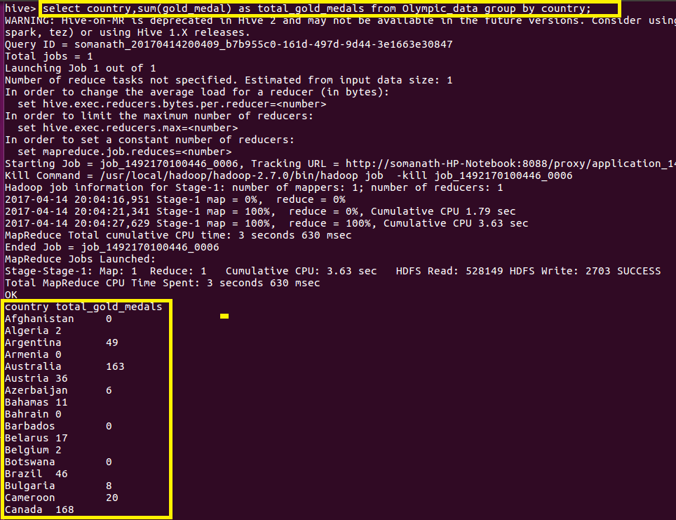

**Output**

**country total_gold_medals**

**Afghanistan 0**

**Algeria 2**

**Argentina 49**

**Armenia 0**

**Australia 163**

**Austria 36**

**Azerbaijan 6**

**Bahamas 11**

**Bahrain 0**

**Barbados 0**

**Belarus 17**

**Belgium 2**

**Botswana 0**

**Brazil 46**

**Bulgaria 8**

**Cameroon 20**

**Canada 168**

**Chile 3**

**China 234**

**Chinese Taipei 2**

**Colombia 2**

**Costa Rica 0**

**Croatia 35**

**Cuba 57**

**Cyprus 0**

**Czech Republic 14**

**Denmark 46**

**Dominican Republic 3**

**Ecuador 0**

**Egypt 1**

**Eritrea 0**

**Estonia 6**

**Ethiopia 13**

**Finland 11**

**France 108**

**Gabon 0**

**Georgia 6**

**Germany 223**

**Great Britain 124**

**Greece 12**

**Grenada 1**

**Guatemala 0**

**Hong Kong 0**

**Hungary 77**

**Iceland 0**

**India 1**

**Indonesia 5**

**Iran 10**

**Ireland 1**

**Israel 1**

**Italy 86**

**Jamaica 24**

**Japan 57**

**Kazakhstan 13**

**Kenya 11**

**Kuwait 0**

**Kyrgyzstan 0**

**Latvia 3**

**Lithuania 5**

**Macedonia 0**

**Malaysia 0**

**Mauritius 0**

**Mexico 19**

**Moldova 0**

**Mongolia 2**

**Montenegro 0**

**Morocco 2**

**Mozambique 1**

**Netherlands 101**

**New Zealand 18**

**Nigeria 6**

**North Korea 6**

**Norway 97**

**Panama 1**

**Paraguay 0**

**Poland 20**

**Portugal 1**

**Puerto Rico 0**

**Qatar 0**

**Romania 57**

**Russia 234**

**Saudi Arabia 0**

**Serbia 1**

**Serbia and Montenegro 11**

**Singapore 0**

**Slovakia 10**

**Slovenia 5**

**South Africa 10**

**South Korea 110**

**Spain 19**

**Sri Lanka 0**

**Sudan 0**

**Sweden 57**

**Switzerland 21**

**Syria 0**

**Tajikistan 0**

**Thailand 6**

**Togo 0**

**Trinidad and Tobago 1**

**Tunisia 2**

**Turkey 9**

**Uganda 1**

**Ukraine 31**

**United Arab Emirates 1**

**United States 552**

**Uruguay 0**

**Uzbekistan 5**

**Venezuela 1**

**Vietnam 0**

**Zimbabwe 2**

**Time taken: 18.848 seconds, Fetched: 110 row(s)**

**hive>**