**Loading Data**

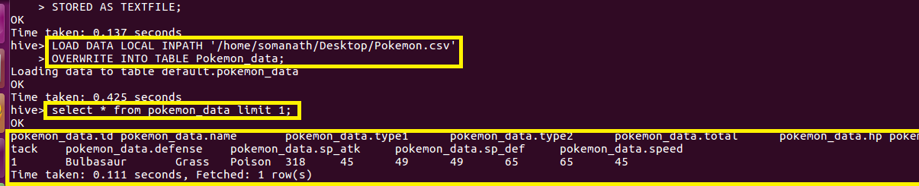

**QN1. Find out the average HP (Hit points) of all the Pokémons**

**Since we want the average of all pokemon use avg() function ON HP column and no grouping is needed as we want total average**

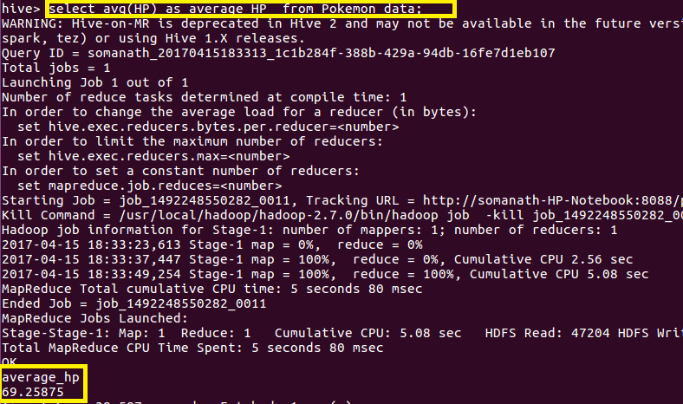

**QN2. Find out the average Defense of all the pokemon**

**Since we want the average of all pokemon use avg() function ON defense column and no grouping is needed as we want total average**

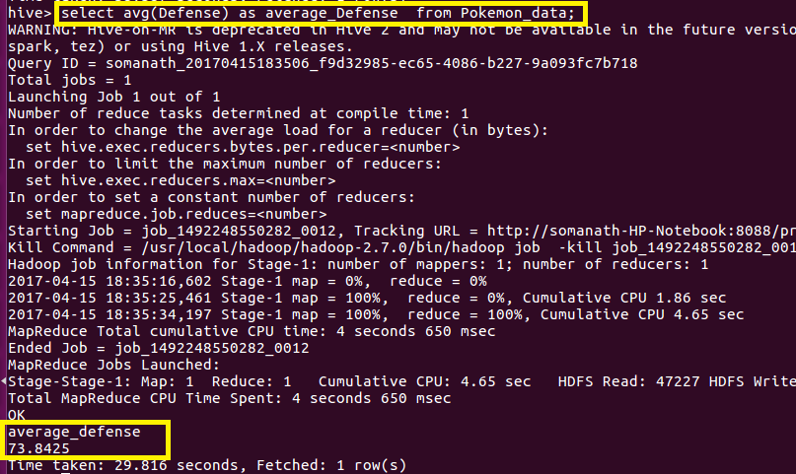

**Qn3. Find out the average Sp.Atk of all the pokemons**

**Since we want the average of all pokemon use avg() function ON Sp.Atk column and no grouping is needed as we want total average**

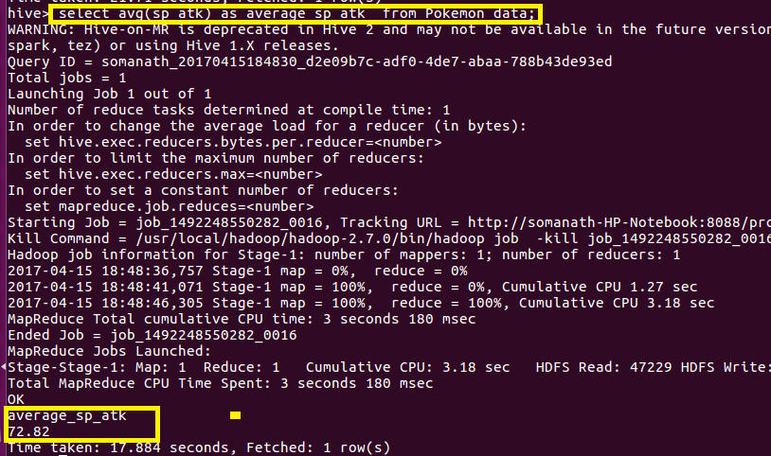

**Qn4. Find out the average sp.Def of all the pokemons**

**Since we want the average of all pokemon use avg() function ON Sp.Def column and no grouping is needed as we want total average**

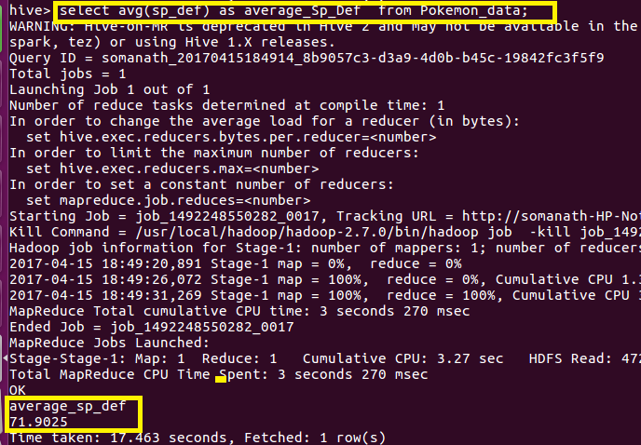

**Qn5. 5. Find out the average Speed of all the pokemon**

**Since we want the average of all pokemon use avg() function ON Speed column and no grouping is needed as we want total average**

