**Loading Data**

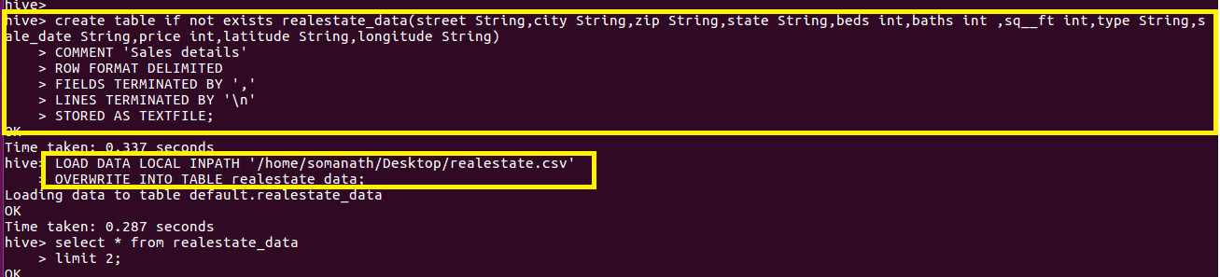

**1.Write a hive query to find the city wise list all the Condos which is not less than ten thousand.**

**Since we want city wise list of all condos which is not less than ten thousand,select city and fiter by type equal to condos and price greater than 10000**

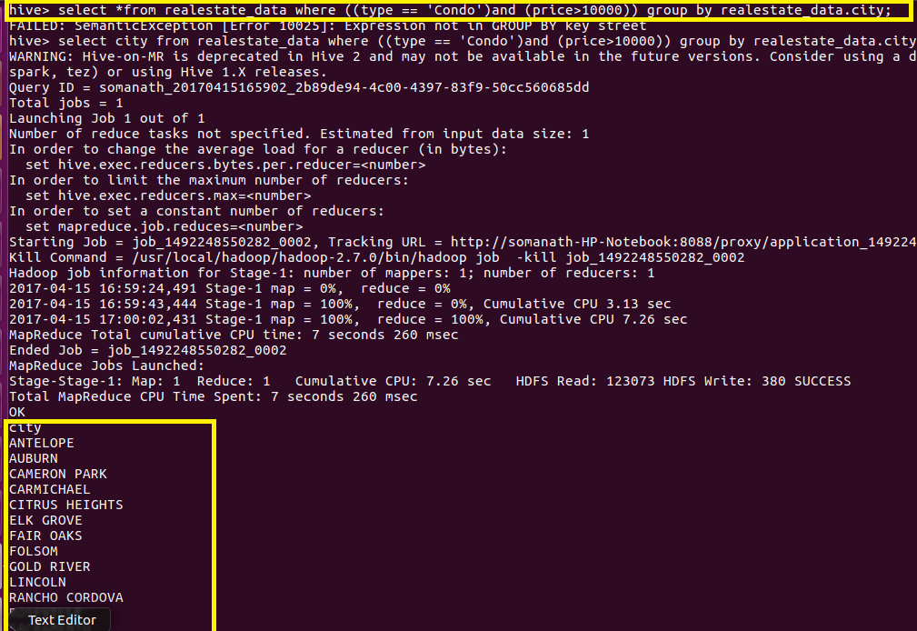

**2. Write a hive query to find which is the cheapest Condo in CA. name the city,street and price for the Condo.**

**Since we want cheapest condo in CA I will filter by state equal to CA and order the price and limit by 1 to get the minimum price**

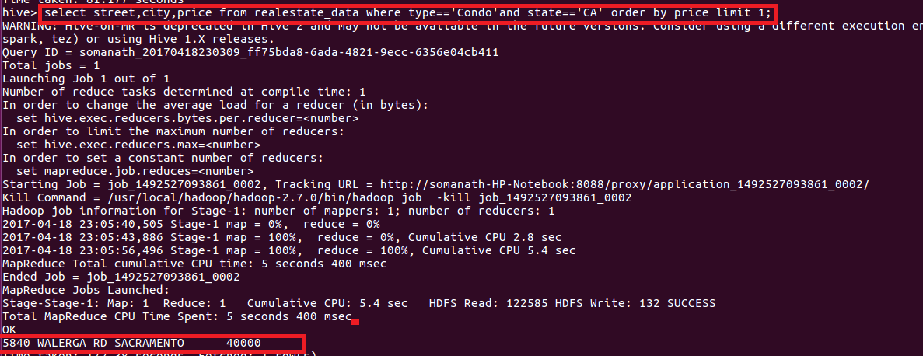

**3.Write a hive query to list top 5 residency details which lie in the budget of 60000-120000, an area more than 1450, sold after 17th may, min bedroom 3 and, min bathroom 2.**

**Since we want top 5 residential details,filter by type as residential and price between 60000 to 120000 and sqft > 1450 and since we want items sold after 17th may but we have taken date as string so used unix_timestamp function to convert to timestamp and used to_date function to convert to date and used datediff function which compares each date with the date 17 may and return positive value if sold after 17 may hence filter by datediff greater than 0 and ordered by price and limited by 5**

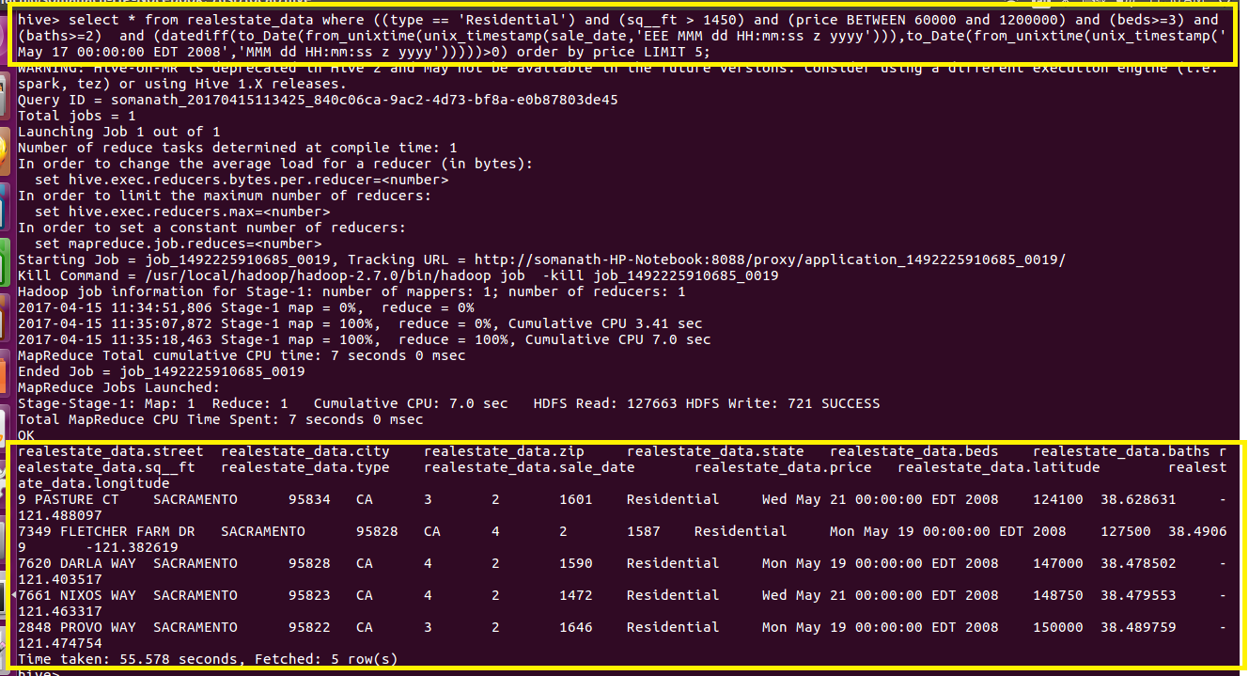

**4.Write a hive query to separate list of residential apartments with more than 2 beds. Also include columns in following order City,Baths,Sq_feet,Price,flat_type,Beds respectively**

**Create a table separate list with following g columns and used Insert function to insert the data from realestate_data table**

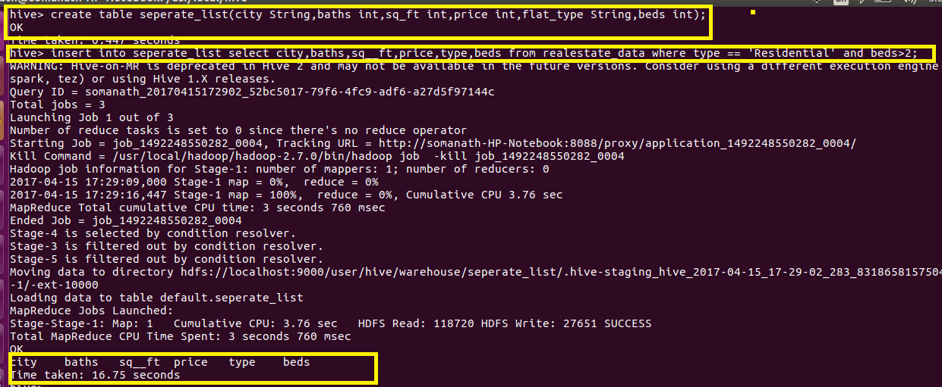

**Displaying output using select\***

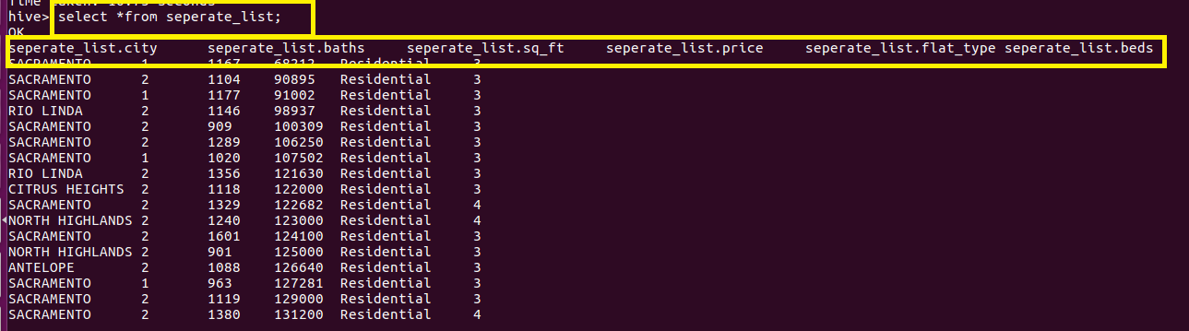

**Full out as copied from hive**

seperate_list.city seperate_list.baths seperate_list.sq_ft seperate_list.price seperate_list.flat_type seperate_list.beds

|  |
| --- |
|  |
|  |
|  | SACRAMENTO 1 1167 68212 Residential 3 |
|  | SACRAMENTO 2 1104 90895 Residential 3 |
|  | SACRAMENTO 1 1177 91002 Residential 3 |
|  | RIO LINDA 2 1146 98937 Residential 3 |
|  | SACRAMENTO 2 909 100309 Residential 3 |
|  | SACRAMENTO 2 1289 106250 Residential 3 |
|  | SACRAMENTO 1 1020 107502 Residential 3 |
|  | RIO LINDA 2 1356 121630 Residential 3 |
|  | CITRUS HEIGHTS 2 1118 122000 Residential 3 |
|  | SACRAMENTO 2 1329 122682 Residential 4 |
|  | NORTH HIGHLANDS 2 1240 123000 Residential 4 |
|  | SACRAMENTO 2 1601 124100 Residential 3 |
|  | NORTH HIGHLANDS 2 901 125000 Residential 3 |
|  | ANTELOPE 2 1088 126640 Residential 3 |
|  | SACRAMENTO 1 963 127281 Residential 3 |
|  | SACRAMENTO 2 1119 129000 Residential 3 |
|  | SACRAMENTO 2 1380 131200 Residential 4 |
|  | SACRAMENTO 2 1248 132000 Residential 3 |
|  | NORTH HIGHLANDS 2 1152 134555 Residential 3 |
|  | SACRAMENTO 2 1380 136500 Residential 3 |
|  | ELVERTA 2 1116 138750 Residential 3 |
|  | SACRAMENTO 2 1418 146250 Residential 3 |
|  | NORTH HIGHLANDS 2 1082 147308 Residential 3 |
|  | SACRAMENTO 2 1472 148750 Residential 4 |
|  | SACRAMENTO 2 1146 149593 Residential 4 |
|  | SACRAMENTO 2 1207 154000 Residential 3 |
|  | ELK GROVE 2 1056 156896 Residential 3 |
|  | NORTH HIGHLANDS 2 1587 161500 Residential 4 |
|  | SACRAMENTO 1 1120 164000 Residential 4 |
|  | SACRAMENTO 2 1580 165000 Residential 4 |
|  | SACRAMENTO 1 1955 166357 Residential 4 |
|  | SACRAMENTO 2 1656 166357 Residential 4 |
|  | SACRAMENTO 2 1477 168000 Residential 3 |
|  | ELK GROVE 2 1188 170000 Residential 3 |
|  | SACRAMENTO 2 1590 173000 Residential 4 |
|  | SACRAMENTO 2 1463 174250 Residential 3 |
|  | SACRAMENTO 2 1714 174313 Residential 4 |
|  | SACRAMENTO 2 1185 178480 Residential 3 |
|  | GALT 2 1406 178760 Residential 3 |
|  | SACRAMENTO 2 1172 181000 Residential 3 |
|  | CARMICHAEL 1 1152 181872 Residential 3 |
|  | SACRAMENTO 3 1851 182587 Residential 4 |
|  | ANTELOPE 2 1215 182716 Residential 3 |
|  | GALT 2 1130 182750 Residential 3 |
|  | ORANGEVALE 2 1603 183200 Residential 4 |
|  | GALT 1 1479 188741 Residential 3 |
|  | SACRAMENTO 2 1420 189000 Residential 3 |
|  | SACRAMENTO 2 1280 192067 Residential 3 |
|  | ELK GROVE 2 1586 194000 Residential 3 |
|  | ANTELOPE 2 1362 194818 Residential 3 |
|  | SACRAMENTO 2 1266 198000 Residential 3 |
|  | ELK GROVE 2 1715 199500 Residential 4 |
|  | FOLSOM 2 1820 200000 Residential 3 |
|  | CARMICHAEL 1 936 200000 Residential 3 |
|  | SACRAMENTO 2 1511 208000 Residential 3 |
|  | SACRAMENTO 2 1590 212864 Residential 4 |
|  | ELK GROVE 2 1596 221000 Residential 4 |
|  | ELK GROVE 3 2136 223058 Residential 5 |
|  | ELK GROVE 2 1616 227887 Residential 4 |
|  | SACRAMENTO 2 1478 231477 Residential 3 |
|  | RANCHO CORDOVA 2 1287 234697 Residential 3 |
|  | CITRUS HEIGHTS 2 1277 235000 Residential 4 |
|  | SACRAMENTO 2 1448 236000 Residential 4 |
|  | SACRAMENTO 3 2235 236685 Residential 4 |
|  | MATHER 2 2093 237800 Residential 3 |
|  | RIO LINDA 2 1193 240122 Residential 3 |
|  | ELK GROVE 2 2163 242638 Residential 3 |
|  | SACRAMENTO 2 1269 244000 Residential 3 |
|  | SACRAMENTO 1 958 244960 Residential 3 |
|  | ELK GROVE 3 2508 245918 Residential 5 |
|  | CITRUS HEIGHTS 2 1305 250000 Residential 3 |
|  | ELK GROVE 2 1591 250000 Residential 4 |
|  | ELK GROVE 2 1843 254200 Residential 3 |
|  | SACRAMENTO 2 1921 254200 Residential 4 |
|  | ELK GROVE 3 2790 258000 Residential 5 |
|  | SACRAMENTO 2 1541 260000 Residential 3 |
|  | SACRAMENTO 1 1018 260014 Residential 3 |
|  | POLLOCK PINES 2 1380 265000 Residential 3 |
|  | SACRAMENTO 1 975 271742 Residential 3 |
|  | SACRAMENTO 3 2372 273750 Residential 4 |
|  | SACRAMENTO 2 1446 275086 Residential 3 |
|  | SACRAMENTO 3 3009 280987 Residential 4 |
|  | ELK GROVE 2 2056 285000 Residential 4 |
|  | ELK GROVE 2 1993 287417 Residential 4 |
|  | ELK GROVE 2 1857 291000 Residential 3 |
|  | ELK GROVE 3 2494 297000 Residential 5 |
|  | ELK GROVE 2 1843 298000 Residential 3 |
|  | SACRAMENTO 3 2800 304037 Residential 5 |
|  | ELK GROVE 2 2309 311000 Residential 4 |
|  | SACRAMENTO 3 2367 315537 Residential 5 |
|  | RANCHO CORDOVA 4 3516 320000 Residential 5 |
|  | SACRAMENTO 3 1914 328360 Residential 4 |
|  | ELK GROVE 3 2725 335750 Residential 3 |
|  | ELK GROVE 3 2354 335750 Residential 4 |
|  | FOLSOM 2 2185 344250 Residential 3 |
|  | ELK GROVE 2 1801 346210 Residential 4 |
|  | SACRAMENTO 3 1961 347029 Residential 3 |
|  | ELK GROVE 2 3134 347650 Residential 4 |
|  | SACRAMENTO 3 1915 351300 Residential 4 |
|  | EL DORADO HILLS 2 0 352000 Residential 3 |
|  | RANCHO MURIETA 3 2734 370500 Residential 4 |
|  | WILTON 2 2110 372000 Residential 3 |
|  | ELK GROVE 3 3164 375000 Residential 5 |
|  | SACRAMENTO 3 3599 381300 Residential 5 |
|  | SACRAMENTO 2 2054 381942 Residential 4 |
|  | ANTELOPE 2 1830 387731 Residential 4 |
|  | SACRAMENTO 3 1627 391000 Residential 3 |
|  | ELK GROVE 3 3440 394470 Residential 4 |
|  | GREENWOOD 2 2846 395000 Residential 3 |
|  | ELK GROVE 3 2359 400186 Residential 4 |
|  | SACRAMENTO 3 2052 415000 Residential 3 |
|  | ELK GROVE 3 3433 425000 Residential 5 |
|  | RANCHO CORDOVA 3 3615 430000 Residential 5 |
|  | FOLSOM 3 2687 460000 Residential 5 |
|  | ELK GROVE 3 2724 461000 Residential 4 |
|  | ELK GROVE 3 3440 489332 Residential 4 |
|  | ELK GROVE 4 3508 510000 Residential 5 |
|  | FOLSOM 2 2462 539000 Residential 4 |
|  | EL DORADO HILLS 3 0 600000 Residential 4 |
|  | EL DORADO HILLS 3 0 606238 Residential 4 |
|  | SACRAMENTO 3 2325 660000 Residential 3 |
|  | EL DORADO HILLS 5 0 830000 Residential 6 |
|  | SACRAMENTO 2 1099 70000 Residential 4 |
|  | SACRAMENTO 1 1067 80000 Residential 3 |
|  | SACRAMENTO 2 1316 89000 Residential 4 |
|  | SACRAMENTO 1 1337 90000 Residential 3 |
|  | SACRAMENTO 1 924 92000 Residential 3 |
|  | SACRAMENTO 1 1643 99000 Residential 3 |
|  | GALT 1 1080 106716 Residential 3 |
|  | SACRAMENTO 1 1039 111000 Residential 3 |
|  | NORTH HIGHLANDS 1 1051 111000 Residential 3 |
|  | RANCHO CORDOVA 1 1098 120108 Residential 3 |
|  | SACRAMENTO 1 1050 123225 Residential 3 |
|  | SACRAMENTO 2 1110 123750 Residential 3 |
|  | NORTH HIGHLANDS 1 888 125000 Residential 3 |
|  | SACRAMENTO 2 1120 125000 Residential 3 |
|  | ELVERTA 2 1080 126000 Residential 3 |
|  | NORTH HIGHLANDS 1 957 129000 Residential 3 |
|  | SACRAMENTO 2 1211 135000 Residential 3 |
|  | SACRAMENTO 2 1264 135500 Residential 3 |
|  | SACRAMENTO 1 1080 140000 Residential 3 |
|  | GALT 2 1266 140000 Residential 3 |
|  | SACRAMENTO 2 1202 143500 Residential 3 |
|  | SACRAMENTO 2 1448 145000 Residential 4 |
|  | SACRAMENTO 2 1188 145000 Residential 3 |
|  | NORTH HIGHLANDS 2 1183 146000 Residential 4 |
|  | SACRAMENTO 1 1320 148500 Residential 3 |
|  | SACRAMENTO 2 1117 149000 Residential 3 |
|  | SACRAMENTO 2 1364 150000 Residential 3 |
|  | SACRAMENTO 2 1310 150000 Residential 4 |
|  | CITRUS HEIGHTS 2 1104 156000 Residential 3 |
|  | CITRUS HEIGHTS 2 1156 161653 Residential 3 |
|  | ANTELOPE 2 1392 165000 Residential 3 |
|  | SACRAMENTO 2 1439 168000 Residential 3 |
|  | SACRAMENTO 2 1159 169000 Residential 3 |
|  | RANCHO CORDOVA 2 1671 175000 Residential 3 |
|  | SACRAMENTO 2 1740 176250 Residential 3 |
|  | SACRAMENTO 2 1265 179000 Residential 3 |
|  | ELK GROVE 2 1716 180400 Residential 3 |
|  | ELK GROVE 2 1685 182000 Residential 4 |
|  | RANCHO CORDOVA 2 1829 184500 Residential 4 |
|  | ELK GROVE 2 1555 185000 Residential 3 |
|  | CARMICHAEL 2 1120 189000 Residential 4 |
|  | CITRUS HEIGHTS 2 1137 194000 Residential 3 |
|  | SACRAMENTO 1 1174 195000 Residential 3 |
|  | ANTELOPE 2 1393 200000 Residential 3 |
|  | CAMERON PARK 1 0 201000 Residential 3 |
|  | LINCOLN 2 0 202500 Residential 4 |
|  | SACRAMENTO 2 1289 205000 Residential 3 |
|  | SACRAMENTO 2 1799 205000 Residential 4 |
|  | PLACERVILLE 2 0 205000 Residential 3 |
|  | SACRAMENTO 3 1953 205000 Residential 4 |
|  | CITRUS HEIGHTS 2 1578 215000 Residential 4 |
|  | CITRUS HEIGHTS 2 1317 215000 Residential 3 |
|  | SACRAMENTO 1 1360 222381 Residential 3 |
|  | SACRAMENTO 2 1522 225000 Residential 3 |
|  | SACRAMENTO 2 1751 225000 Residential 4 |
|  | ELK GROVE 2 1465 225000 Residential 3 |
|  | SACRAMENTO 2 1605 228000 Residential 4 |
|  | RIO LINDA 2 1475 229665 Residential 4 |
|  | MEADOW VISTA 1 1216 230000 Residential 3 |
|  | ELK GROVE 2 1567 230000 Residential 3 |
|  | SACRAMENTO 2 1776 234000 Residential 3 |
|  | SACRAMENTO 2 2187 235000 Residential 3 |
|  | SACRAMENTO 1 1291 236250 Residential 3 |
|  | SACRAMENTO 2 1503 245000 Residential 3 |
|  | SACRAMENTO 3 2491 245000 Residential 4 |
|  | ORANGEVALE 2 1176 250000 Residential 3 |
|  | ORANGEVALE 2 1456 250000 Residential 4 |
|  | ROSEVILLE 2 1498 250000 Residential 3 |
|  | ANTELOPE 2 1574 255000 Residential 3 |
|  | SACRAMENTO 2 2170 257729 Residential 3 |
|  | ELK GROVE 2 1595 260000 Residential 4 |
|  | ANTELOPE 2 1567 261000 Residential 3 |
|  | LINCOLN 2 0 261800 Residential 4 |
|  | SACRAMENTO 2 1253 264469 Residential 4 |
|  | ANTELOPE 3 1768 265000 Residential 4 |
|  | SACRAMENTO 3 2030 270000 Residential 4 |
|  | SACRAMENTO 2 1531 270000 Residential 3 |
|  | ELK GROVE 3 1653 275000 Residential 4 |
|  | ELK GROVE 2 2056 275000 Residential 4 |
|  | ELK GROVE 3 2494 280000 Residential 4 |
|  | FAIR OAKS 2 1450 286013 Residential 3 |
|  | SACRAMENTO 2 2169 292000 Residential 4 |
|  | ROSEVILLE 2 1440 292000 Residential 3 |
|  | FAIR OAKS 2 1527 293993 Residential 3 |
|  | ROSEVILLE 2 1401 294000 Residential 3 |
|  | SACRAMENTO 2 1411 296769 Residential 3 |
|  | LINCOLN 4 0 297500 Residential 4 |
|  | RIO LINDA 1 1284 300000 Residential 3 |
|  | GALT 3 2307 300000 Residential 4 |
|  | PLACERVILLE 2 1329 300000 Residential 3 |
|  | SACRAMENTO 2 1910 300500 Residential 4 |
|  | GOLD RIVER 2 1981 305000 Residential 3 |
|  | LINCOLN 3 0 315000 Residential 5 |
|  | SACRAMENTO 2 2205 319789 Residential 4 |
|  | FOLSOM 2 1258 330000 Residential 3 |
|  | ELK GROVE 2 2575 331000 Residential 3 |
|  | RANCHO CORDOVA 3 2208 336000 Residential 4 |
|  | SACRAMENTO 1 1108 339000 Residential 3 |
|  | FOLSOM 2 1595 339000 Residential 4 |
|  | GALT 2 2159 345000 Residential 4 |
|  | PLACERVILLE 3 2295 350000 Residential 4 |
|  | ROSEVILLE 2 1838 356000 Residential 3 |
|  | SACRAMENTO 2 1900 361745 Residential 4 |
|  | SACRAMENTO 2 1718 361948 Residential 4 |
|  | ELK GROVE 3 3389 370000 Residential 5 |
|  | ROCKLIN 2 0 380000 Residential 4 |
|  | ELK GROVE 4 3260 385000 Residential 5 |
|  | CAMERON PARK 2 2016 399000 Residential 3 |
|  | ROCKLIN 2 2607 402000 Residential 4 |
|  | ELK GROVE 3 2724 406026 Residential 4 |
|  | GALT 4 3746 420000 Residential 5 |
|  | RANCHO MURIETA 2 3192 425000 Residential 4 |
|  | LINCOLN 3 0 436746 Residential 4 |
|  | EL DORADO HILLS 3 0 438700 Residential 5 |
|  | FOLSOM 2 2581 450000 Residential 4 |
|  | SACRAMENTO 1 2068 460000 Residential 3 |
|  | EL DORADO HILLS 2 0 460000 Residential 3 |
|  | ELK GROVE 3 3992 460000 Residential 4 |
|  | SACRAMENTO 4 3397 465000 Residential 4 |
|  | SACRAMENTO 3 3881 471750 Residential 5 |
|  | ROCKLIN 3 0 480000 Residential 5 |
|  | PLACERVILLE 3 1929 485000 Residential 4 |
|  | ELK GROVE 3 3070 495000 Residential 4 |
|  | AUBURN 3 0 504000 Residential 3 |
|  | SACRAMENTO 3 3984 572500 Residential 5 |
|  | CARMICHAEL 2 2222 582000 Residential 4 |
|  | ROSEVILLE 3 3838 613401 Residential 4 |
|  | ROSEVILLE 2 0 614000 Residential 4 |
|  | FAIR OAKS 5 2846 680000 Residential 5 |
|  | SACRAMENTO 2 2484 699000 Residential 5 |
|  | LOOMIS 4 1624 839000 Residential 4 |
|  | SACRAMENTO 1 970 61500 Residential 3 |
|  | SACRAMENTO 1 1250 84000 Residential 3 |
|  | SACRAMENTO 1 1013 85000 Residential 3 |
|  | SACRAMENTO 1 1012 90000 Residential 3 |
|  | SACRAMENTO 1 1082 95000 Residential 3 |
|  | SACRAMENTO 2 1120 102750 Residential 4 |
|  | NORTH HIGHLANDS 1 1331 112500 Residential 3 |
|  | SACRAMENTO 1 1014 113000 Residential 3 |
|  | SACRAMENTO 2 1448 114000 Residential 4 |
|  | SACRAMENTO 1 966 114000 Residential 3 |
|  | SACRAMENTO 1 1174 116100 Residential 3 |
|  | NORTH HIGHLANDS 2 1207 119250 Residential 3 |
|  | SACRAMENTO 2 1366 120108 Residential 3 |
|  | SACRAMENTO 1 696 121725 Residential 3 |
|  | GALT 2 1080 122000 Residential 3 |
|  | SACRAMENTO 2 1104 123000 Residential 3 |
|  | SACRAMENTO 2 1390 125573 Residential 4 |
|  | ELVERTA 2 1354 126714 Residential 4 |
|  | SACRAMENTO 2 1587 127500 Residential 4 |
|  | NORTH HIGHLANDS 2 1209 130000 Residential 3 |
|  | ELVERTA 2 1416 140000 Residential 3 |
|  | SACRAMENTO 2 1300 140800 Residential 3 |
|  | SACRAMENTO 2 1120 145000 Residential 3 |
|  | SACRAMENTO 2 1590 147000 Residential 4 |
|  | SACRAMENTO 2 1407 149600 Residential 3 |
|  | SACRAMENTO 2 1516 150000 Residential 5 |
|  | SACRAMENTO 2 1646 150000 Residential 3 |
|  | SACRAMENTO 2 1676 155000 Residential 3 |
|  | SACRAMENTO 2 1370 155435 Residential 3 |
|  | SACRAMENTO 2 1370 155500 Residential 3 |
|  | CITRUS HEIGHTS 2 1351 158000 Residential 4 |
|  | NORTH HIGHLANDS 2 1152 158000 Residential 3 |
|  | SACRAMENTO 2 1452 160000 Residential 3 |
|  | RIO LINDA 2 1182 164000 Residential 3 |
|  | GALT 2 1100 167000 Residential 3 |
|  | CITRUS HEIGHTS 2 1280 167293 Residential 4 |
|  | CITRUS HEIGHTS 2 1280 167293 Residential 4 |
|  | SACRAMENTO 1 1039 168000 Residential 3 |
|  | SACRAMENTO 2 1159 170000 Residential 3 |
|  | SACRAMENTO 2 1917 170000 Residential 4 |
|  | SACRAMENTO 2 1520 170000 Residential 3 |
|  | GALT 2 1204 174000 Residential 3 |
|  | SACRAMENTO 2 1120 178000 Residential 3 |
|  | SACRAMENTO 2 1436 180000 Residential 3 |
|  | SACRAMENTO 2 1451 180000 Residential 3 |
|  | SACRAMENTO 2 1638 180000 Residential 4 |
|  | ROSEVILLE 1 1152 188325 Residential 3 |
|  | ROSEVILLE 2 1154 191500 Residential 3 |
|  | SACRAMENTO 2 1353 192000 Residential 3 |
|  | CITRUS HEIGHTS 2 1329 192700 Residential 3 |
|  | SACRAMENTO 1 1356 195000 Residential 3 |
|  | SACRAMENTO 2 1505 197654 Residential 3 |
|  | SACRAMENTO 1 1009 198000 Residential 3 |
|  | SACRAMENTO 2 1144 200345 Residential 3 |
|  | SACRAMENTO 2 1766 207000 Residential 4 |
|  | SACRAMENTO 3 1940 208000 Residential 4 |
|  | ELK GROVE 2 1776 210000 Residential 4 |
|  | CITRUS HEIGHTS 1 1258 212000 Residential 3 |
|  | SACRAMENTO 2 1872 213675 Residential 4 |
|  | SACRAMENTO 2 1856 215000 Residential 4 |
|  | SACRAMENTO 3 1939 215000 Residential 4 |
|  | ROSEVILLE 1 998 215100 Residential 3 |
|  | ROSEVILLE 2 1758 217500 Residential 3 |
|  | SACRAMENTO 2 2142 218000 Residential 3 |
|  | ELK GROVE 3 1739 221000 Residential 4 |
|  | ELK GROVE 2 1516 222900 Residential 3 |
|  | ANTELOPE 1 988 223139 Residential 3 |
|  | GALT 2 1555 225500 Residential 4 |
|  | SACRAMENTO 2 1212 228327 Residential 3 |
|  | SACRAMENTO 2 1871 230000 Residential 4 |
|  | SACRAMENTO 2 1302 230000 Residential 3 |
|  | ANTELOPE 3 2026 231200 Residential 4 |
|  | SACRAMENTO 2 1375 232000 Residential 3 |
|  | SACRAMENTO 1 1058 233641 Residential 3 |
|  | ANTELOPE 2 1187 234000 Residential 3 |
|  | SACRAMENTO 3 1936 235000 Residential 4 |
|  | FOLSOM 2 1427 236073 Residential 3 |
|  | GALT 2 1798 238861 Residential 4 |
|  | ANTELOPE 3 2652 239700 Residential 4 |
|  | SACRAMENTO 2 1816 240000 Residential 4 |
|  | SACRAMENTO 3 3076 240000 Residential 5 |
|  | ELK GROVE 2 1844 241000 Residential 4 |
|  | SACRAMENTO 2 1306 245000 Residential 3 |
|  | SACRAMENTO 3 2447 246000 Residential 4 |
|  | SACRAMENTO 2 1176 247234 Residential 4 |
|  | RIO LINDA 2 1182 247480 Residential 4 |
|  | RIO LINDA 1 1160 249862 Residential 3 |
|  | SACRAMENTO 2 1424 251000 Residential 3 |
|  | ORANGEVALE 2 1574 252155 Residential 4 |
|  | ANTELOPE 2 1830 254172 Residential 3 |
|  | ELK GROVE 2 1724 258000 Residential 4 |
|  | SACRAMENTO 3 2175 261000 Residential 4 |
|  | SACRAMENTO 2 1904 261000 Residential 4 |
|  | EL DORADO HILLS 2 1808 262500 Residential 4 |
|  | RANCHO CORDOVA 2 2711 266000 Residential 4 |
|  | CARMICHAEL 1 1713 266000 Residential 3 |
|  | ELK GROVE 2 1457 270000 Residential 3 |
|  | ELK GROVE 3 2724 274425 Residential 4 |
|  | SACRAMENTO 2 1468 275336 Residential 3 |
|  | SACRAMENTO 3 2550 277980 Residential 4 |
|  | GALT 2 1928 280000 Residential 4 |
|  | SACRAMENTO 3 1922 284686 Residential 3 |
|  | CITRUS HEIGHTS 2 1343 284893 Residential 3 |
|  | ROCKLIN 2 1510 285000 Residential 3 |
|  | CARMICHAEL 2 1559 285000 Residential 4 |
|  | EL DORADO 2 1624 289000 Residential 3 |
|  | SACRAMENTO 3 2992 295000 Residential 5 |
|  | ELK GROVE 2 2109 296000 Residential 4 |
|  | RANCHO CORDOVA 2 1524 296056 Residential 4 |
|  | SACRAMENTO 2 1248 297359 Residential 3 |
|  | SACRAMENTO 2 1876 299940 Residential 4 |
|  | LINCOLN 3 0 304000 Residential 5 |
|  | RANCHO CORDOVA 3 1851 305000 Residential 4 |
|  | SACRAMENTO 2 2218 311328 Residential 4 |
|  | SACRAMENTO 2 1394 313138 Residential 3 |
|  | SACRAMENTO 2 1410 316630 Residential 3 |
|  | ELK GROVE 3 3468 320000 Residential 5 |
|  | ANTELOPE 3 2346 320000 Residential 5 |
|  | ANTELOPE 3 2347 325000 Residential 5 |
|  | SACRAMENTO 2 1659 328578 Residential 4 |
|  | ELK GROVE 3 2442 331000 Residential 3 |
|  | SACRAMENTO 2 2155 340000 Residential 4 |
|  | SACRAMENTO 2 1810 345746 Residential 3 |
|  | ELK GROVE 2 2789 351000 Residential 4 |
|  | GALT 2 1606 353767 Residential 4 |
|  | SACRAMENTO 2 2166 356035 Residential 4 |
|  | SACRAMENTO 2 1871 360552 Residential 4 |
|  | SACRAMENTO 2 1800 362305 Residential 3 |
|  | SACRAMENTO 1 1683 365000 Residential 3 |
|  | ROSEVILLE 2 0 367554 Residential 3 |
|  | PLACERVILLE 2 0 371086 Residential 4 |
|  | ELK GROVE 2 1179 378000 Residential 3 |
|  | SACRAMENTO 1 1639 388000 Residential 3 |
|  | RANCHO CORDOVA 3 3281 395100 Residential 5 |
|  | SACRAMENTO 2 1697 400000 Residential 3 |
|  | EL DORADO HILLS 2 0 400000 Residential 3 |
|  | ANTELOPE 3 2085 408431 Residential 4 |
|  | EL DORADO HILLS 3 0 420000 Residential 4 |
|  | FOLSOM 3 1939 423000 Residential 4 |
|  | CAMERON PARK 2 0 423000 Residential 4 |
|  | ROCKLIN 2 1691 430922 Residential 3 |
|  | ELK GROVE 2 2002 445000 Residential 4 |
|  | ELK GROVE 4 4303 450000 Residential 4 |
|  | SACRAMENTO 3 4246 452000 Residential 5 |
|  | ROSEVILLE 2 2274 470000 Residential 3 |
|  | EL DORADO HILLS 3 0 471000 Residential 4 |
|  | ORANGEVALE 4 3056 475000 Residential 4 |
|  | ELK GROVE 3 2503 484500 Residential 3 |
|  | EL DORADO HILLS 3 0 487500 Residential 5 |
|  | ROCKLIN 3 0 488750 Residential 3 |
|  | FOLSOM 2 1905 500000 Residential 3 |
|  | PENRYN 2 1320 506688 Residential 3 |
|  | ROSEVILLE 3 0 520000 Residential 5 |
|  | GOLD RIVER 2 3037 528000 Residential 4 |
|  | WILTON 2 3741 579093 Residential 5 |
|  | FOLSOM 3 2660 636000 Residential 4 |
|  | CARMICHAEL 3 3357 668365 Residential 4 |
|  | GRANITE BAY 3 2896 676200 Residential 5 |
|  | PLACERVILLE 2 2025 677048 Residential 3 |
|  | WILTON 3 3788 691659 Residential 5 |
|  | GRANITE BAY 3 3670 760000 Residential 5 |
|  | LINCOLN 2 0 4897 Residential 4 |
|  | LINCOLN 2 0 4897 Residential 3 |
|  | LINCOLN 2 0 4897 Residential 3 |
|  | CITRUS HEIGHTS 2 1166 30000 Residential 3 |
|  | SACRAMENTO 2 1089 95625 Residential 3 |
|  | SACRAMENTO 2 1292 105000 Residential 4 |
|  | SACRAMENTO 2 1064 109000 Residential 4 |
|  | SACRAMENTO 2 1320 115500 Residential 3 |
|  | SACRAMENTO 2 1410 115620 Residential 3 |
|  | RANCHO CORDOVA 2 1115 116000 Residential 3 |
|  | SACRAMENTO 2 1169 122000 Residential 3 |
|  | SACRAMENTO 2 1164 122500 Residential 3 |
|  | SACRAMENTO 2 1341 123000 Residential 4 |
|  | SACRAMENTO 2 1219 124000 Residential 3 |
|  | SACRAMENTO 2 1127 124000 Residential 4 |
|  | NORTH HIGHLANDS 2 1272 124413 Residential 3 |
|  | SACRAMENTO 2 1253 125000 Residential 4 |
|  | SACRAMENTO 2 1120 130000 Residential 3 |
|  | SACRAMENTO 3 1890 137721 Residential 4 |
|  | SACRAMENTO 2 1260 137760 Residential 3 |
|  | SACRAMENTO 2 1400 138000 Residential 3 |
|  | SACRAMENTO 1 1264 140000 Residential 3 |
|  | SACRAMENTO 1 1060 145000 Residential 3 |
|  | SACRAMENTO 2 1466 150000 Residential 3 |
|  | SACRAMENTO 2 1092 150000 Residential 3 |
|  | SACRAMENTO 2 1628 151000 Residential 4 |
|  | SACRAMENTO 2 960 155000 Residential 3 |
|  | CITRUS HEIGHTS 2 1075 155800 Residential 3 |
|  | SACRAMENTO 2 1428 156142 Residential 3 |
|  | SACRAMENTO 2 1358 158000 Residential 4 |
|  | CITRUS HEIGHTS 2 1410 160000 Residential 3 |
|  | ANTELOPE 2 1711 161500 Residential 3 |
|  | SACRAMENTO 2 1483 161600 Residential 4 |
|  | GALT 2 1140 162000 Residential 3 |
|  | SACRAMENTO 2 1549 165000 Residential 4 |
|  | SACRAMENTO 2 1410 165000 Residential 3 |
|  | ELK GROVE 2 1240 167293 Residential 3 |
|  | SACRAMENTO 2 1712 168000 Residential 5 |
|  | SACRAMENTO 2 1580 168000 Residential 4 |
|  | ANTELOPE 2 1669 168750 Residential 3 |
|  | SACRAMENTO 1 1029 168750 Residential 3 |
|  | CITRUS HEIGHTS 1 1103 170000 Residential 3 |
|  | SACRAMENTO 2 2161 170250 Residential 3 |
|  | SACRAMENTO 2 1650 173000 Residential 3 |
|  | POLLOCK PINES 1 1320 175000 Residential 3 |
|  | SACRAMENTO 2 1200 176095 Residential 3 |
|  | SACRAMENTO 2 1170 176250 Residential 3 |
|  | CITRUS HEIGHTS 2 1199 178000 Residential 3 |
|  | SACRAMENTO 2 1695 179000 Residential 4 |
|  | RANCHO CORDOVA 2 1157 180000 Residential 3 |
|  | SACRAMENTO 2 1410 180000 Residential 3 |
|  | ROSEVILLE 2 1174 180000 Residential 3 |
|  | SACRAMENTO 2 1593 181000 Residential 3 |
|  | RIO LINDA 2 1093 182000 Residential 3 |
|  | ROSEVILLE 2 1770 182587 Residential 3 |
|  | SACRAMENTO 2 1436 185074 Residential 4 |
|  | SACRAMENTO 2 1124 185833 Residential 3 |
|  | SACRAMENTO 2 1139 186785 Residential 4 |
|  | SACRAMENTO 2 1638 187000 Residential 3 |
|  | SACRAMENTO 2 1328 188335 Residential 3 |
|  | ELK GROVE 2 1273 190000 Residential 3 |
|  | SACRAMENTO 1 1082 190000 Residential 3 |
|  | SACRAMENTO 2 1578 190000 Residential 4 |
|  | SACRAMENTO 2 1386 191250 Residential 3 |
|  | RANCHO CORDOVA 2 1452 193000 Residential 3 |
|  | SACRAMENTO 2 1513 193500 Residential 3 |
|  | SACRAMENTO 2 1578 195000 Residential 4 |
|  | CITRUS HEIGHTS 3 1736 195000 Residential 4 |
|  | SACRAMENTO 1 1473 195000 Residential 3 |
|  | SACRAMENTO 1 1150 198000 Residential 3 |
|  | SACRAMENTO 2 1127 199900 Residential 3 |
|  | FAIR OAKS 1 1144 200000 Residential 3 |
|  | CARMICHAEL 1 972 201000 Residential 3 |
|  | ELK GROVE 2 2306 204918 Residential 4 |
|  | ANTELOPE 2 1479 205000 Residential 3 |
|  | SACRAMENTO 2 1430 205878 Residential 3 |
|  | SACRAMENTO 2 1800 207000 Residential 4 |
|  | ANTELOPE 2 1953 207744 Residential 4 |
|  | SACRAMENTO 2 1120 209000 Residential 3 |
|  | SACRAMENTO 2 1232 210000 Residential 3 |
|  | ELK GROVE 2 2329 213750 Residential 4 |
|  | ELK GROVE 2 1351 215000 Residential 3 |
|  | ROSEVILLE 1 1376 215000 Residential 4 |
|  | DIAMOND SPRINGS 2 1300 216033 Residential 3 |
|  | SACRAMENTO 2 1566 220000 Residential 4 |
|  | CITRUS HEIGHTS 2 1419 220000 Residential 4 |
|  | ELK GROVE 2 1261 220000 Residential 3 |
|  | ELK GROVE 2 1338 222000 Residential 3 |
|  | ELK GROVE 2 2254 222750 Residential 5 |
|  | SACRAMENTO 2 1441 225000 Residential 3 |
|  | SACRAMENTO 2 1991 225000 Residential 4 |
|  | SACRAMENTO 3 2126 228750 Residential 4 |
|  | ELK GROVE 2 1094 229000 Residential 3 |
|  | ROCKLIN 2 1462 230095 Residential 3 |
|  | SACRAMENTO 3 2258 232500 Residential 5 |
|  | RANCHO CORDOVA 2 1074 233000 Residential 3 |
|  | ELK GROVE 2 2111 233500 Residential 4 |
|  | SACRAMENTO 2 1686 239000 Residential 3 |
|  | ANTELOPE 3 1915 240000 Residential 4 |
|  | ELK GROVE 2 2367 240000 Residential 4 |
|  | SACRAMENTO 2 1962 240971 Residential 3 |
|  | SACRAMENTO 2 1789 243450 Residential 3 |
|  | SACRAMENTO 2 1876 243500 Residential 4 |
|  | ANTELOPE 2 1235 246544 Residential 3 |
|  | ANTELOPE 2 2504 246750 Residential 4 |
|  | CARMICHAEL 2 1676 247000 Residential 3 |
|  | CITRUS HEIGHTS 2 1367 249000 Residential 3 |
|  | ELK GROVE 3 1899 249000 Residential 4 |
|  | ELK GROVE 2 1636 250000 Residential 3 |
|  | SACRAMENTO 2 1828 250000 Residential 3 |
|  | SACRAMENTO 2 1438 252000 Residential 4 |
|  | ELK GROVE 2 1451 255000 Residential 3 |
|  | SACRAMENTO 1 1520 255000 Residential 3 |
|  | ROSEVILLE 2 1506 255000 Residential 3 |
|  | SACRAMENTO 2 2605 257200 Residential 4 |
|  | ORANGEVALE 2 1196 260000 Residential 3 |
|  | LINCOLN 2 1621 260000 Residential 3 |
|  | SACRAMENTO 2 1811 263500 Residential 3 |
|  | ELK GROVE 2 1540 266510 Residential 3 |
|  | LINCOLN 2 0 267750 Residential 4 |
|  | EL DORADO HILLS 2 0 272700 Residential 4 |
|  | ELK GROVE 2 1543 275000 Residential 3 |
|  | SACRAMENTO 3 2494 276000 Residential 5 |
|  | LINCOLN 2 1650 276500 Residential 3 |
|  | GALT 3 2214 278000 Residential 4 |
|  | SACRAMENTO 3 2280 279000 Residential 5 |
|  | CARMICHAEL 2 1443 280000 Residential 3 |
|  | CITRUS HEIGHTS 2 1582 280000 Residential 4 |
|  | ELK GROVE 2 1857 285000 Residential 3 |
|  | ELK GROVE 2 1735 288000 Residential 3 |
|  | ELK GROVE 3 2096 289000 Residential 4 |
|  | SACRAMENTO 2 1720 290000 Residential 3 |
|  | ANTELOPE 2 2160 290000 Residential 4 |
|  | SACRAMENTO 2 1382 293996 Residential 4 |
|  | PLACERVILLE 2 0 294000 Residential 3 |
|  | ELK GROVE 2 1721 294173 Residential 4 |
|  | LOOMIS 2 1328 295000 Residential 4 |
|  | ELK GROVE 2 1982 298000 Residential 4 |
|  | COOL 2 1457 300000 Residential 3 |
|  | ELK GROVE 3 2555 300000 Residential 6 |
|  | ROCKLIN 2 1577 300567 Residential 3 |
|  | ELK GROVE 3 2592 303000 Residential 5 |
|  | CITRUS HEIGHTS 2 1401 305000 Residential 3 |
|  | LINCOLN 2 0 306000 Residential 4 |
|  | CARMICHAEL 2 1502 310000 Residential 3 |
|  | FOLSOM 2 1327 310000 Residential 3 |
|  | ROSEVILLE 3 1800 310000 Residential 4 |
|  | SACRAMENTO 2 2169 311518 Residential 4 |
|  | LINCOLN 3 2457 312000 Residential 5 |
|  | ORANGEVALE 2 2004 315000 Residential 4 |
|  | ROSEVILLE 3 2212 315000 Residential 4 |
|  | ANTELOPE 3 3134 315000 Residential 5 |
|  | SACRAMENTO 2 1360 315000 Residential 3 |
|  | ROCKLIN 2 0 315000 Residential 4 |
|  | SACRAMENTO 2 1276 320000 Residential 3 |
|  | SACRAMENTO 3 2962 322000 Residential 4 |
|  | ROCKLIN 2 1888 325000 Residential 4 |
|  | ROSEVILLE 2 0 326951 Residential 3 |
|  | GALT 2 1548 328370 Residential 3 |
|  | RANCHO CORDOVA 3 2109 330000 Residential 4 |
|  | SACRAMENTO 2 2484 331200 Residential 4 |
|  | SACRAMENTO 3 2258 332000 Residential 4 |
|  | SACRAMENTO 3 2212 334000 Residential 3 |
|  | ORANGEVALE 2 1616 335000 Residential 3 |
|  | SACRAMENTO 2 2372 341000 Residential 4 |
|  | ROCKLIN 3 2606 346375 Residential 5 |
|  | ROSEVILLE 3 0 347225 Residential 5 |
|  | ELK GROVE 3 2877 349000 Residential 5 |
|  | ANTELOPE 2 2960 350000 Residential 3 |
|  | ROSEVILLE 2 2172 350000 Residential 3 |
|  | SACRAMENTO 2 1795 351000 Residential 3 |
|  | EL DORADO HILLS 2 0 356200 Residential 3 |
|  | ROSEVILLE 2 2295 360000 Residential 4 |
|  | ROSEVILLE 3 2577 367463 Residential 4 |
|  | WALNUT GROVE 1 1727 380000 Residential 3 |
|  | ELK GROVE 2 1485 380578 Residential 3 |
|  | CARMICHAEL 2 1655 386222 Residential 3 |
|  | ROSEVILLE 2 2049 395500 Residential 3 |
|  | ELK GROVE 3 2875 397000 Residential 5 |
|  | EL DORADO HILLS 2 2199 400000 Residential 4 |
|  | ROSEVILLE 3 0 412500 Residential 4 |
|  | CARMICHAEL 2 2334 415000 Residential 3 |
|  | AUBURN 3 2278 420454 Residential 4 |
|  | SACRAMENTO 1 1493 425000 Residential 3 |
|  | CAMERON PARK 2 0 425000 Residential 3 |
|  | ROSEVILLE 3 0 438000 Residential 5 |
|  | FOLSOM 3 2787 441000 Residential 5 |
|  | SACRAMENTO 3 2824 445000 Residential 5 |
|  | FOLSOM 3 3261 446000 Residential 4 |
|  | SACRAMENTO 2 2053 450000 Residential 4 |
|  | ROSEVILLE 3 2379 455000 Residential 4 |
|  | EL DORADO HILLS 2 0 460000 Residential 3 |
|  | PLACERVILLE 2 0 475000 Residential 3 |
|  | GARDEN VALLEY 2 0 490000 Residential 3 |
|  | EL DORADO HILLS 2 0 493000 Residential 4 |
|  | EL DORADO HILLS 4 0 508000 Residential 5 |
|  | FAIR OAKS 2 3173 525000 Residential 3 |
|  | EL DORADO HILLS 3 0 533000 Residential 4 |
|  | SACRAMENTO 1 1348 545000 Residential 3 |
|  | AUBURN 3 0 560000 Residential 4 |
|  | FOLSOM 3 3229 575000 Residential 4 |
|  | SACRAMENTO 4 3863 598695 Residential 5 |
|  | ROSEVILLE 3 0 600000 Residential 5 |
|  | ROCKLIN 3 0 600000 Residential 4 |
|  | GRANITE BAY 3 2356 600000 Residential 4 |
|  | ROSEVILLE 3 3579 610000 Residential 5 |
|  | EL DORADO HILLS 3 0 879000 Residential 4 |
|  | WILTON 3 4400 884790 Residential 4 |
|  | LINCOLN 3 0 1551 Residential 3 |
|  | SLOUGHHOUSE 4 5822 2000 Residential 3 |
|  | SACRAMENTO 2 1512 56950 Residential 4 |
|  | SACRAMENTO 2 1158 80000 Residential 4 |
|  | SACRAMENTO 2 1092 85500 Residential 3 |
|  | SACRAMENTO 1 1058 95000 Residential 3 |
|  | SACRAMENTO 2 1040 97750 Residential 3 |
|  | SACRAMENTO 2 1354 104000 Residential 3 |
|  | NORTH HIGHLANDS 1 1051 105000 Residential 3 |
|  | SACRAMENTO 1 1161 109000 Residential 3 |
|  | SACRAMENTO 1 1004 110000 Residential 3 |
|  | NORTH HIGHLANDS 1 1229 110000 Residential 3 |
|  | SACRAMENTO 2 1249 112500 Residential 3 |
|  | SACRAMENTO 2 1161 114800 Residential 3 |
|  | SACRAMENTO 1 1010 116000 Residential 3 |
|  | SACRAMENTO 2 1462 121500 Residential 4 |
|  | SACRAMENTO 2 1269 122000 Residential 3 |
|  | SACRAMENTO 2 1570 126854 Residential 4 |
|  | SACRAMENTO 2 1093 127059 Residential 3 |
|  | SACRAMENTO 1 962 128687 Residential 3 |
|  | SACRAMENTO 2 1089 129500 Residential 3 |
|  | SACRAMENTO 2 1127 130000 Residential 3 |
|  | SACRAMENTO 2 1309 131750 Residential 4 |
|  | SACRAMENTO 2 1144 134000 Residential 3 |
|  | RANCHO CORDOVA 1 1000 134000 Residential 3 |
|  | ANTELOPE 2 1206 142000 Residential 3 |
|  | SACRAMENTO 1 1285 143012 Residential 3 |
|  | SACRAMENTO 2 1543 145846 Residential 3 |
|  | SACRAMENTO 1 1019 148750 Residential 3 |
|  | SACRAMENTO 2 1392 150000 Residential 4 |
|  | SACRAMENTO 2 1217 151087 Residential 3 |
|  | ANTELOPE 2 1670 157296 Residential 3 |
|  | SACRAMENTO 2 1302 157500 Residential 3 |
|  | SACRAMENTO 2 1488 160000 Residential 3 |
|  | NORTH HIGHLANDS 2 1373 160000 Residential 3 |
|  | CITRUS HEIGHTS 2 1381 161250 Residential 4 |
|  | SACRAMENTO 2 1265 164000 Residential 3 |
|  | SACRAMENTO 2 1608 165750 Residential 4 |
|  | CITRUS HEIGHTS 1 1344 166000 Residential 3 |
|  | SACRAMENTO 2 1202 169000 Residential 3 |
|  | LINCOLN 2 1104 170000 Residential 3 |
|  | SACRAMENTO 2 1232 170000 Residential 3 |
|  | SACRAMENTO 1 1638 170725 Residential 3 |
|  | SACRAMENTO 2 1582 172000 Residential 3 |
|  | ELK GROVE 2 1340 174000 Residential 3 |
|  | SACRAMENTO 2 1204 174250 Residential 3 |
|  | ELK GROVE 2 1477 176850 Residential 4 |
|  | SACRAMENTO 2 1497 179500 Residential 4 |
|  | FAIR OAKS 1 960 185000 Residential 3 |
|  | SACRAMENTO 2 1428 188700 Residential 3 |
|  | SACRAMENTO 1 1039 189000 Residential 3 |
|  | FAIR OAKS 1 1529 189000 Residential 3 |
|  | CITRUS HEIGHTS 3 1892 189836 Residential 4 |
|  | SACRAMENTO 2 1887 190000 Residential 4 |
|  | ORANGEVALE 2 1294 191250 Residential 3 |
|  | SACRAMENTO 2 1638 191675 Residential 3 |
|  | SACRAMENTO 2 1677 195500 Residential 3 |
|  | CITRUS HEIGHTS 1 1073 198000 Residential 3 |
|  | SACRAMENTO 2 1231 200000 Residential 3 |
|  | ELK GROVE 2 1175 200000 Residential 3 |
|  | ELK GROVE 2 1416 200000 Residential 3 |
|  | SACRAMENTO 2 1358 201528 Residential 3 |
|  | ELK GROVE 2 1609 204750 Residential 4 |
|  | SACRAMENTO 3 1968 205000 Residential 4 |
|  | CARMICHAEL 2 1296 205900 Residential 3 |
|  | ROSEVILLE 2 1371 208250 Residential 3 |
|  | NORTH HIGHLANDS 1 1310 208318 Residential 3 |
|  | GALT 2 1262 209347 Residential 3 |
|  | ELK GROVE 2 1740 211500 Residential 4 |
|  | ANTELOPE 2 1517 212000 Residential 3 |
|  | SACRAMENTO 2 1450 213000 Residential 3 |
|  | ELK GROVE 2 1416 216000 Residential 3 |
|  | SACRAMENTO 1 888 216021 Residential 3 |
|  | CITRUS HEIGHTS 2 1882 219000 Residential 3 |
|  | ELK GROVE 2 1302 219794 Residential 3 |
|  | ELK GROVE 2 1418 220000 Residential 3 |
|  | CARMICHAEL 2 1319 220000 Residential 4 |
|  | GALT 2 1770 220000 Residential 4 |
|  | SACRAMENTO 2 1627 223000 Residential 4 |
|  | SACRAMENTO 1 1040 224000 Residential 3 |
|  | NORTH HIGHLANDS 1 960 224252 Residential 3 |
|  | CAMERON PARK 2 0 224500 Residential 3 |
|  | ORANGEVALE 1 1456 225000 Residential 3 |
|  | ELK GROVE 2 1450 228000 Residential 3 |
|  | LINCOLN 2 1358 229027 Residential 3 |
|  | SACRAMENTO 2 1329 229500 Residential 4 |
|  | SACRAMENTO 2 1715 230000 Residential 4 |
|  | ELK GROVE 2 1262 230000 Residential 3 |
|  | SACRAMENTO 3 2280 232425 Residential 4 |
|  | SACRAMENTO 2 1477 234000 Residential 3 |
|  | CITRUS HEIGHTS 2 1216 235000 Residential 3 |
|  | ELK GROVE 2 1685 235301 Residential 4 |
|  | EL DORADO HILLS 2 1362 235738 Residential 3 |
|  | Time taken: 0.307 seconds, Fetched: 715 row(s) |
|  |  |