**Create table RealEstate in Hive database, with all the columns present in dataset.**



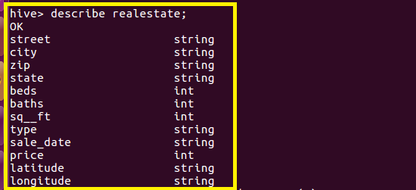

**Creating Partitioned Table**

**Here a partitioned table Sep_list is created where partition is made based on type,Beds as Shown**



**Using Dynamic partition get separate lists of residential apartments with more than 2 beds and include columns in following order City,Baths,Sq_feet,Price,flat_type,Beds respectively**

**In dynamic Partitioning we want to enter the bedrooms greater than 2,so we load data into the partitioned table by using select statement from realEstate Table where Beds>2 and type as residential**

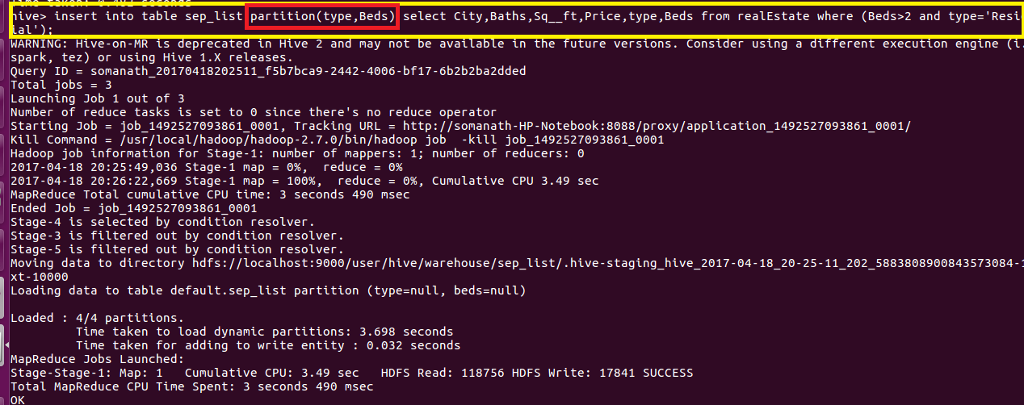

**Output:**

**In hive warehouse separate directories will be created for each beds dynamically by hive**

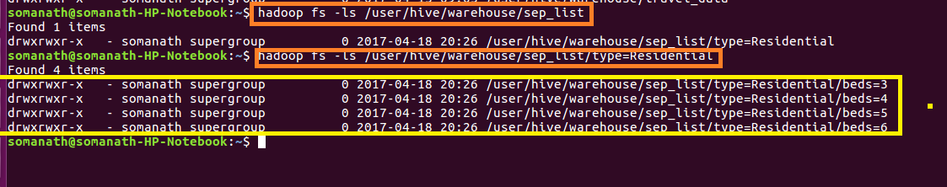

**Inside the folder we have a file which contains all the records where bed-3 and type-Residential**

**Sample Output**

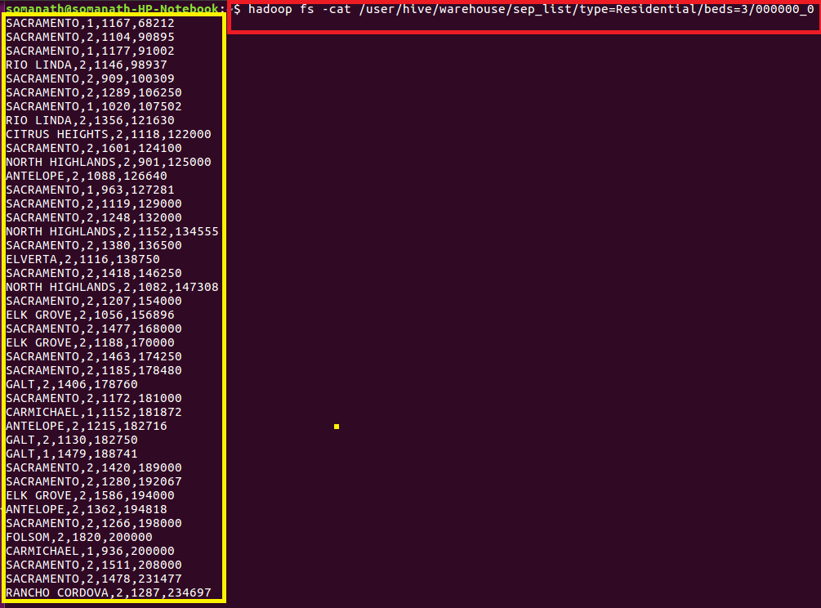

**Complete output files are attached**