**1.Write a hive query to find the top 20 destination people travel the most: Based on the given data**

**Since top 20 destination depends on amount of people travelling ,I made a count of adults,senior,children,youth and infant and gave a alias name as Total and then order by total descending and then limit to 20**

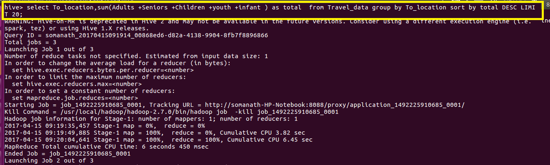

**Output**

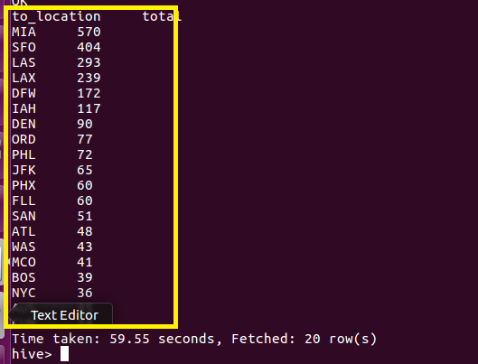

**2. Write a hive query to find the top 20 locations from where people travel the most**

**Since top 20 location depends on amount of people travelling ,I made a count of adults,senior,children,youth and infant and gave a alias name as Total and then order by total descending and then limit to 20**

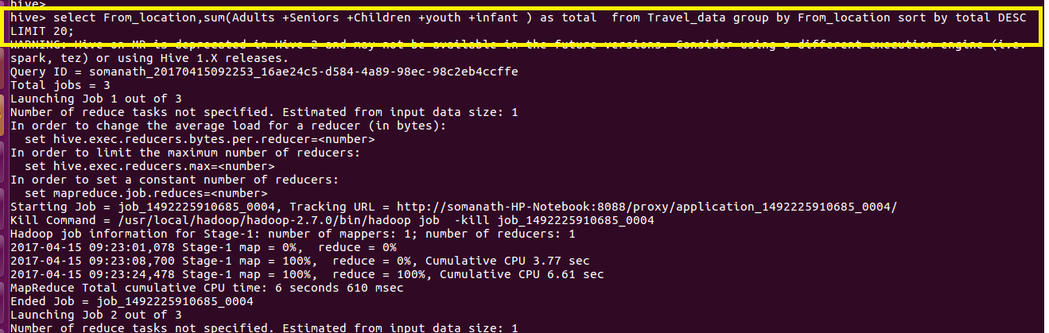

**Output**

