Additional features in the python code

Libraries:
- Mysql and pymongo libraries to connect to the data stores and to handle errors
- Pandas library to display and handle data
- Tabulate to display data in the table format

Menu Display and Choice 1 (View 15 Cities):
- Python format function is used to display results in an orderly and readable format.
- Python map and lamda functions are used to store the results in a list format.
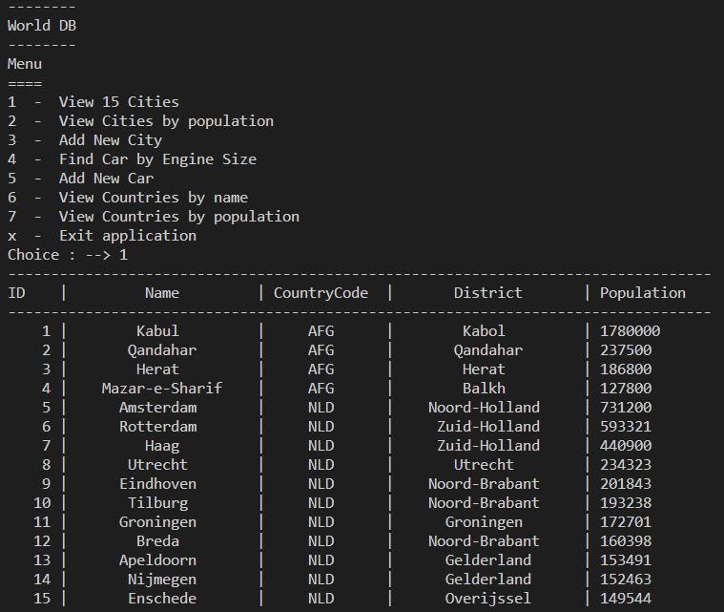

Choice 2 (View cities by population):

- While loop used to ensure the correct values are entered as an input
- format function is used to display results in an orderly and readable format.
- map and lamda functions are used to store the results in a list format.

Screenshot of the incorrect choice:
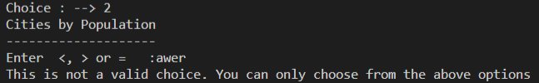

Screenshot of the system forcing the user to enter the correct choice and displaying the DB results
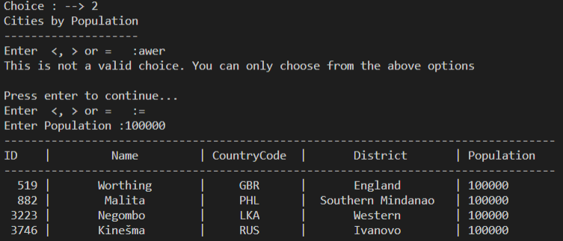

Choice 3 (Add New City):

Program displays the error if the correct country code (foreign key) is missing in the input value.

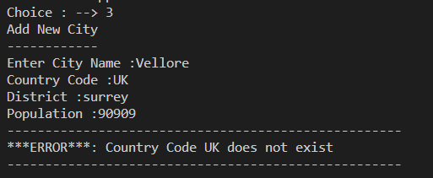

Program displays the successful addition if the record is added into the database table

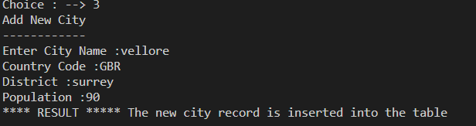

Choice 4 (Find car by Engine Size):
Connect to the mongo DB database if no services are running display the error message
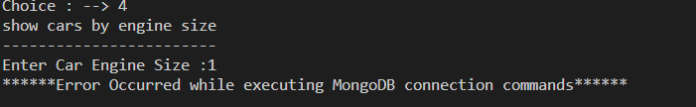
Results after establishing connections
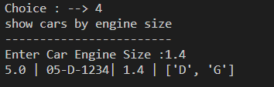

Choice 5 (Find car by Engine Size):
Adding new car details as part of choice 5 and displaying the results

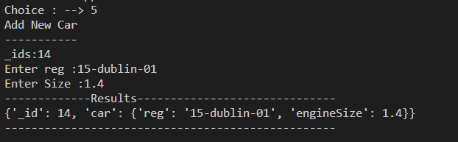

Choice 6 and 7 (view countries by name and view countries by population):

- Use pandas library to create a dataframe from the database data
- Use tabulate library to display the output in tabular format

