INTRODUCTION

The provided code outlines the implementation of a **Facial Attendance System** using Python and various libraries for real-time facial recognition and attendance tracking. This system is designed to automate the attendance process in institutional settings, leveraging facial recognition technology to enhance accuracy and efficiency.

**Key Features of the System:**

1. **Real-Time Facial Recognition**: The system utilizes OpenCV's face detection and recognition capabilities to capture and identify faces from live video feeds. It uses the Haar Cascade Classifier for face detection and the LBPH (Local Binary Patterns Histogram) algorithm for face recognition, ensuring accurate identification.
2. **User Interface**: The application features a graphical user interface (GUI) built with Tkinter. The GUI allows users to interact with the system, manage attendance, and perform administrative tasks such as changing passwords. It includes functionalities for capturing facial images, training the recognition model, and tracking attendance.
3. **Password Protection**: To safeguard access to the system, it includes functionality for changing and verifying passwords. The password is required to initiate the training of the facial recognition model, ensuring that only authorized personnel can modify or update the system.
4. **Image Capture and Training**: Users can register new individuals by capturing their facial images. These images are stored and used to train the facial recognition model, which is essential for accurate attendance tracking. The system handles image capture, storage, and model training seamlessly.
5. **Attendance Tracking**: During operation, the system continuously monitors the video feed to identify individuals and record their attendance. It generates and updates attendance records in real time, which are stored in CSV files for easy access and reporting.
6. **Data Management and Reporting**: The system manages student details and attendance records efficiently. It maintains a CSV file for student details and another for daily attendance logs. Users can view and export these records for analysis and reporting purposes.
7. **System Administration**: The application includes features for system administration, such as clearing input fields and updating attendance records. The menu bar provides options for changing passwords, contacting support, and exiting the application.

**Scope and Objectives**

1. **Automated Attendance Tracking:**
   * **Objective:** Replace traditional manual attendance systems with an automated facial recognition approach.
   * **Scope:** Utilize real-time facial recognition to log attendance accurately and efficiently.
2. **User Registration and Management:**
   * **Objective:** Allow new users to register by capturing their facial images and details.
   * **Scope:** Include functionality for image capture, profile saving, and updating user information.
3. **Real-Time Facial Recognition:**
   * **Objective:** Recognize and identify individuals in real-time during attendance tracking.
   * **Scope:** Implement face detection and recognition using Haar Cascade Classifier and LBPH algorithms.
4. **Data Security and Management:**
   * **Objective:** Ensure secure access to system functionalities and protect sensitive data.
   * **Scope:** Include password protection for system access and secure storage of user data and attendance records.
5. **User Interface and Experience:**
   * **Objective:** Provide a user-friendly interface for interaction with the system.
   * **Scope:** Develop a graphical user interface (GUI) using Tkinter, featuring intuitive controls for system operations.
6. **Reporting and Analysis:**
   * **Objective:** Generate and manage attendance records for analysis and reporting.
   * **Scope:** Store attendance data in CSV files, enabling easy access for review and reporting.
7. **System Administration:**
   * **Objective:** Allow administrative tasks such as password changes and contact support.
   * **Scope:** Include functionalities for managing system settings and user support.
8. **Integration and Scalability:**
   * **Objective:** Ensure the system can be integrated into existing institutional processes and scaled as needed.
   * **Scope:** Design the system to be adaptable to different institutional needs and user volumes

LITERATURE SURVEY

|  |  |  |  |  |
| --- | --- | --- | --- | --- |
| SL No. | Authors | Title | Published In | Published In |
| 1. | Ainampudi Kumari Sirivarshitha | Face recognition on using OpenCV and Python | IEEE | 2023 |
| 2. | Jaehoon Paul Jeong | Implementation of Smart Attendance System using IoT and Face Recognition | IEEE | 2020 |
| 3. | Universitas Muhammadiyah Yogyakarta | Smart Attendance System Based on Facial Recognition | International Journal of Computer Applications | 2019 |
| 4. | V. K. N. Kamlesh Pai | Face recognition using Convolutional NeuralNetworks | IEEE | 2018 |
| 5. | M.V. Raghunadh | A Real-Time Automated Attendance System Based on Face Recognition | IEEE | 2013 |
| 6. | Matthew Turk and Alex Pentland | Face Recognition Using Eigenfaces | IEEE | 1991 |

**Proposed Model for Enhancing the Face Recognition-Based Attendance System**

**Overview**

The proposed model aims to address the existing challenges and improve the face recognition-based attendance system by incorporating advanced techniques and features. This model focuses on enhancing accuracy, security, and user experience while maintaining system efficiency.

**1. Enhanced Face Recognition**

* **Algorithm Upgrade:**
  + **Deep Learning Models:** Integrate state-of-the-art deep learning models like FaceNet or MTCNN (Multi-task Cascaded Convolutional Networks) for better accuracy and robustness in face recognition.
  + **Transfer Learning:** Use pre-trained models and fine-tune them with the specific dataset to improve recognition performance and handle diverse face conditions.
* **Data Augmentation:**
  + **Synthetic Data:** Implement data augmentation techniques such as rotation, scaling, and lighting adjustments to increase the robustness of the recognition system.
  + **Synthetic Faces:** Use synthetic face generation techniques to create diverse training data, especially for underrepresented demographics.

**2. Improved Real-Time Processing**

* **Efficient Computing:**
  + **Hardware Acceleration:** Utilize GPU acceleration or edge computing devices to handle real-time image processing more efficiently.
  + **Optimized Algorithms:** Implement optimized versions of face detection and recognition algorithms to reduce processing time and latency.
* **Multi-Camera Integration:**
  + **Camera Fusion:** Use multiple cameras to cover different angles and improve face detection accuracy in diverse environments.
  + **Distributed Processing:** Distribute processing tasks across multiple cameras or servers to enhance real-time performance.

**3. Advanced Security Measures**

* **Biometric Security:**
  + **Multi-Factor Authentication:** Implement additional security measures like two-factor authentication (2FA) for accessing sensitive features such as password changes.
  + **Encryption:** Use encryption techniques to secure stored facial data and communication between the client and server.
* **Spoof Detection:**
  + **Liveness Detection:** Integrate liveness detection methods to differentiate between real faces and photos or videos used for spoofing attacks.
  + **Behavioral Analysis:** Monitor and analyze user behavior to detect and prevent fraudulent activities.

**4. Enhanced User Experience**

* **User Interface (UI) Improvements:**
  + **Responsive Design:** Improve the UI to be more responsive and intuitive, ensuring ease of use across various devices and screen sizes.
  + **User Feedback:** Implement real-time feedback mechanisms to guide users through the process and provide instant notifications or errors.
* **Customization Options:**
  + **User Profiles:** Allow users to customize their profiles and settings, including notification preferences and display options.
  + **Accessibility Features:** Include accessibility features to support users with disabilities, such as screen readers and high-contrast modes.

**5. Scalable and Maintainable Architecture**

* **Modular Design:**
  + **Component-Based Architecture:** Design the system with a modular approach to facilitate easy updates and maintenance. Each component (e.g., face recognition, data storage, user management) should be independent and easily replaceable.
  + **Microservices:** Use microservices architecture for better scalability and manageability, especially for large-scale deployments.
* **Cloud Integration:**
  + **Cloud Storage:** Utilize cloud storage solutions for data management, backup, and disaster recovery.
  + **Cloud Services:** Leverage cloud-based machine learning services to offload intensive computations and benefit from scalable resources.

**6. Compliance and Privacy**

* **Regulatory Compliance:**
  + **GDPR and CCPA:** Ensure the system complies with data protection regulations such as GDPR (General Data Protection Regulation) and CCPA (California Consumer Privacy Act).
  + **User Consent:** Implement mechanisms for obtaining and managing user consent for collecting and processing facial data.
* **Privacy Controls:**
  + **Data Anonymization:** Apply data anonymization techniques to protect user identities and ensure privacy.
  + **Access Controls:** Implement strict access controls to prevent unauthorized access to sensitive data and system components.

**7. Enhanced Reporting and Analytics**

* **Analytics Dashboard:**
  + **Real-Time Analytics:** Provide an analytics dashboard with real-time data visualization for attendance tracking, system performance, and user activity.
  + **Custom Reports:** Allow users to generate custom reports and export data for further analysis.
* **Automated Alerts:**
  + **Notification System:** Set up automated alerts and notifications for system events, such as unauthorized access attempts or system errors.

## **Architecture Diagram**

* **GUI (Tkinter)**: This is the front-end of the application, where users interact with the system. It includes various frames for different functionalities such as taking images, saving profiles, tracking attendance, etc.
* **Face Recognition (OpenCV)**: Handles the core functionality of face recognition. It uses Haarcascades for face detection and LBPHFaceRecognizer for recognizing faces. It also manages video capture from the webcam.
* **File Operations**: Manages reading and writing CSV files for storing student details and attendance records. Ensures that the data is properly saved and loaded.
* **Data Management**: Responsible for organizing and storing image data and attendance records. This includes managing the directories for images and training data.
* **Image Processing**: Includes functionality for capturing images, processing them for face recognition, and saving them to disk

**Requirement Specifications for Face Recognition Based Attendance System**

**Functional Requirements**

**User Interface**

* **Login/Authentication:** The system should require a password for accessing certain features like training images or managing profiles.
* **Main Dashboard:** Display the current date, time, and allow access to registration and attendance tracking functionalities.
* **Registration Interface:**
* ID Input: The user must enter a unique ID.
* Name Input: The user must enter their full name.
* Image Capture: The system must capture multiple images of the user's face for training.
* Profile Saving: After capturing images, the system must save the profile data and images.
* **Attendance Interface:**
* Display attendance logs in a tabular format with columns for ID, Name, Date, and Time.
* Show live video feed for face recognition.

**Image Processing**

* **Face Detection:** The system should detect and crop faces from the video stream using the Haar Cascade classifier.
* **Face Recognition:** Recognize faces using the LBPH (Local Binary Patterns Histograms) algorithm.

**Data Management**

* **Data Storage:**
* **Student Details**: Save user data (ID, Name) in a CSV file.
* **Training Data:** Save captured images in a directory and train a model on this data.
* **Attendance Logs:** Save attendance records in a CSV file with details such as ID, Name, Date, and Time.
* **File Management:**
* Check for the existence of necessary files like the Haar Cascade XML, CSV files for student details, and training data.
* Create directories as needed.

**Security**

* **Password Protection:**
* Password required for accessing certain functionalities like training new images and changing settings.
* Allow users to set and change passwords securely.

**Error Handling**

* **File Missing:** Notify the user if essential files are missing.
* **Incorrect Password:** Notify the user if the password entered is incorrect.
* **Invalid Input:** Validate user inputs (e.g., Name should only contain alphabets).

**Non-Functional Requirements**

**Performance**

* **Processing Speed:** The system should process and recognize faces in real-time.
* **Storage Efficiency:** Efficient storage management to avoid redundancy.

**Usability**

* **User-Friendly Interface:** The system should have a simple and intuitive user interface for non-technical users.
* **Error Messages:** Clear and concise error messages to guide users.

**Reliability**

* **Data Integrity:** Ensure that attendance logs and profiles are accurately saved and retrievable.
* **System Stability:** The system should handle multiple registrations and attendance logging without crashing.

**Security**

* **Data Security:** Protect sensitive data such as passwords and personal information.
* **System Access:** Restrict access to system functionalities based on user roles or password protection.

**Maintainability**

* **Code Modularity:** The code should be organized into functions and modules for easy maintenance and updates.
* **Documentation:** Provide adequate comments and documentation within the codebase.

**Portability**

* **Platform Independence:** The system should be compatible with different operating systems (Windows, Linux, etc.).

**System Architecture**

* Software Components
* Frontend: Tkinter for GUI.
* Backend: OpenCV for image processing, CSV for data management, and PIL for handling images.

**Hardware Requirements**

* **Camera:** Webcam for capturing images and recognizing faces.
* **Storage:** Local disk storage for saving images and logs.

**Assumptions and Dependencies**

* The system assumes a stable camera feed for accurate face recognition.
* The system depends on external libraries such as OpenCV, Tkinter, and PIL, which need to be correctly installed.
* User data will be stored locally; the system assumes no need for cloud storage or online databases.

**Limitations**

* Lighting Conditions: The system may not perform well under poor lighting conditions.
* Multiple Faces: The system may struggle with identifying multiple faces simultaneously.
* High-Fidelity Recognition: The system may not be as accurate as commercial-grade face recognition systems.

**Future Enhancements**

* **Integration with Cloud:** Store and manage data in the cloud for better accessibility.
* **Mobile Compatibility:** Develop a mobile version of the system.
* **Advanced Recognition Algorithms:** Implement more sophisticated algorithms for better accuracy.

## **Testing and Results**

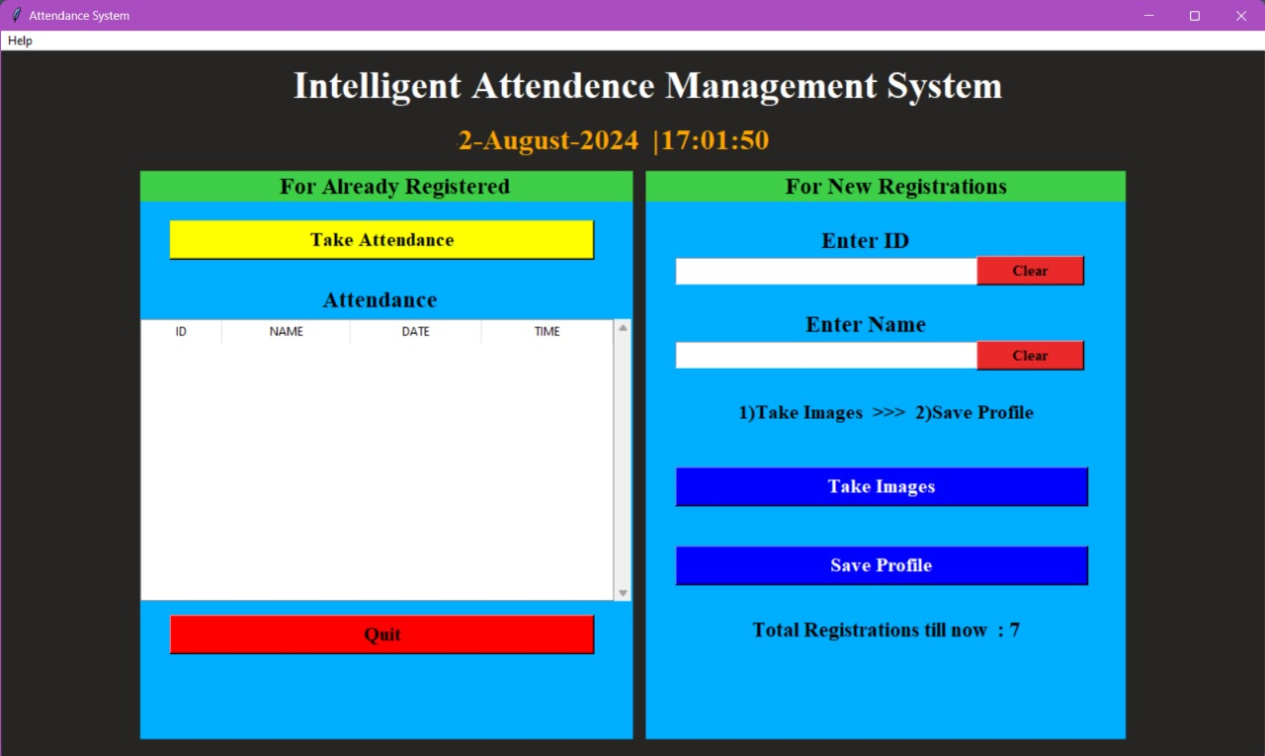

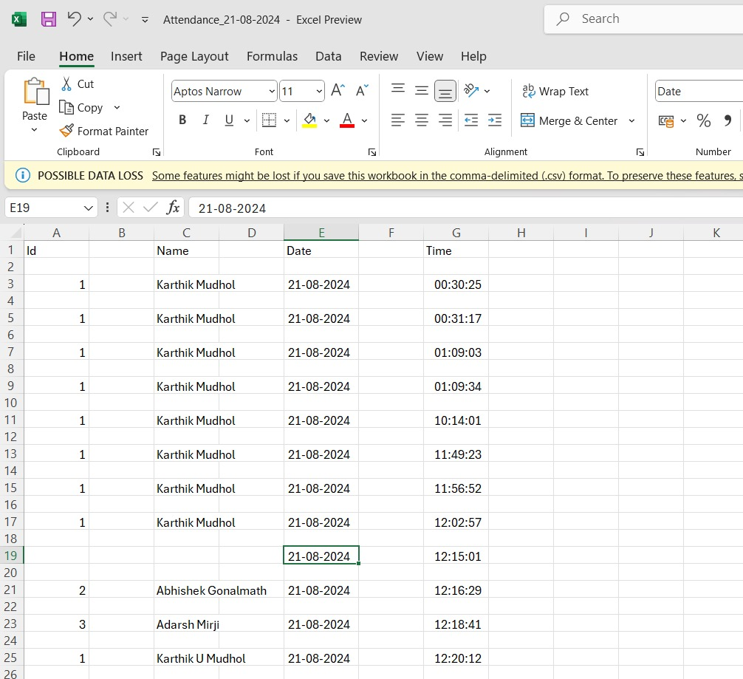

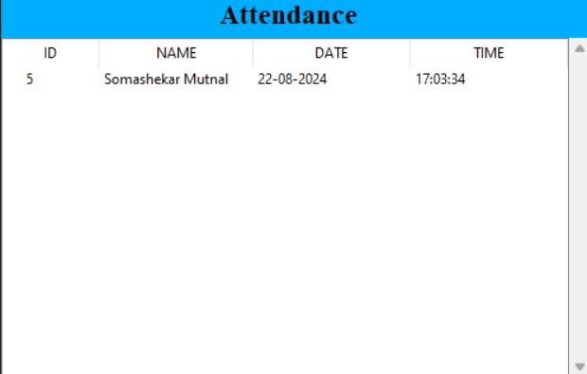

Conclusion

The Face Recognition Based Attendance System is designed to streamline and automate the process of attendance tracking using advanced image processing techniques. By leveraging face recognition technology, this system offers a more efficient, secure, and user-friendly alternative to traditional attendance methods. The system's comprehensive requirements, including functional and non-functional specifications, ensure that it meets the needs of users while maintaining high standards of performance, security, and usability.

While the current design focuses on core functionalities such as face detection, recognition, and data management, it also outlines potential limitations and areas for future enhancement. These include improvements in recognition accuracy under varying conditions, expanding the system’s capabilities through cloud integration, and developing a mobile-friendly version.

In conclusion, the Face Recognition Based Attendance System provides a robust solution that not only simplifies attendance management but also lays the groundwork for further technological advancements. By implementing this system, institutions can achieve greater efficiency, accuracy, and security in managing attendance records, ultimately contributing to more effective operational processes.

Reference

* Turk, Matthew A., and Alex P. Pentland. "Face recognition using eigenfaces." Proceedings. 1991 IEEE computer society conference on computer vision and pattern recognition. IEEE Computer Society, 1991.
* Omonboy, Khalmuratov, and Jumaniyazov Bobirbek. "FACIAL RECOGNITION METHOD FROM IMAGES." Innovations in Technology and Science Education 2.10 (2023): 439-451.
* Dang, Thai-Viet. "Smart attendance system based on improved facial recognition." Journal of Robotics and Control (JRC) 4.1 (2023): 46-53.
* Sawhney, Shreyak, et al. "Real-time smart attendance system using face recognition techniques." 2019 9th international conference on cloud computing, data science & engineering (Confluence). IEEE, 2019.
* Chintalapati, Shireesha, and M. V. Raghunadh. "Automated attendance management system based on face recognition algorithms." 2013 IEEE International conference on computational intelligence and computing research. IEEE, 2013.