**ANALYSIS ON SUPERMART DATABASE USING POSTGRESQL**

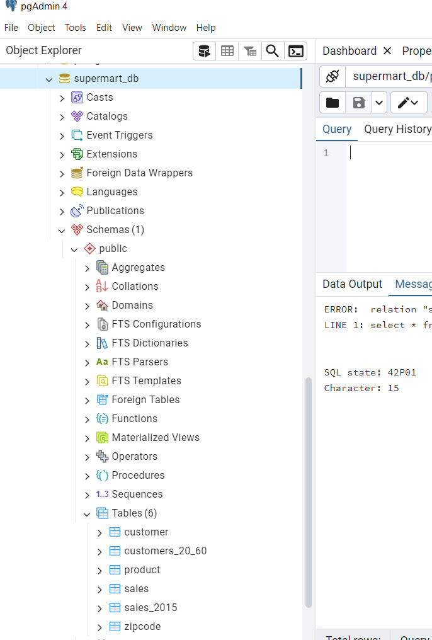

**INTRODUCTION**: In this project, we will analyze the supermart database by performing SQL query statements and answering the questions.

**TOOL USED**: POSTGRESQL SOFTWARE- Pg Admin Application

**SYSTEM**: x64-based PC WINDOWS 10, 12 GB RAM

1. Sales Performance by Region

● Question: What is the total sales amount by region?

OUTPUT:

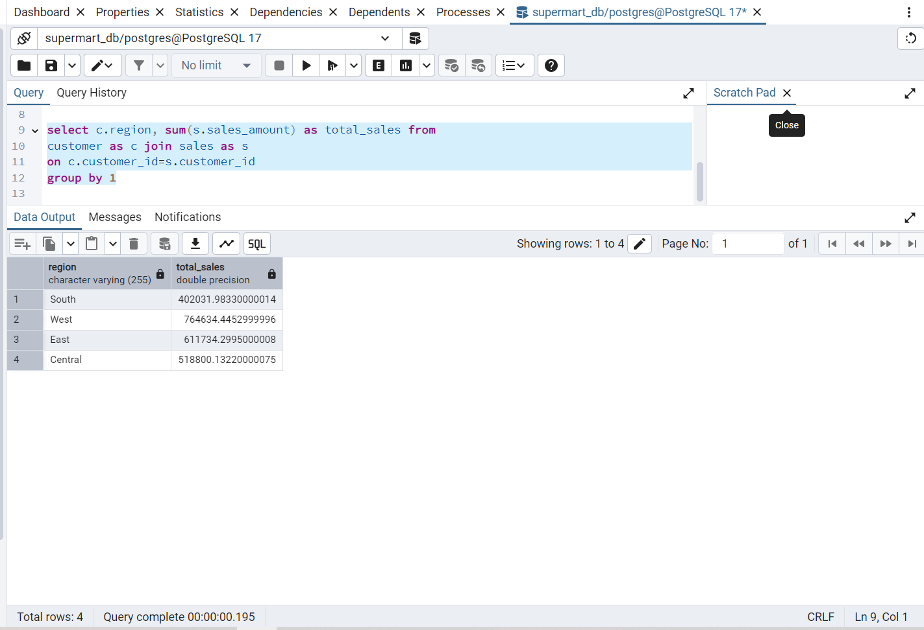

2. Top-Selling Products

● Question: Which products generated the most sales?

OUTPUT:

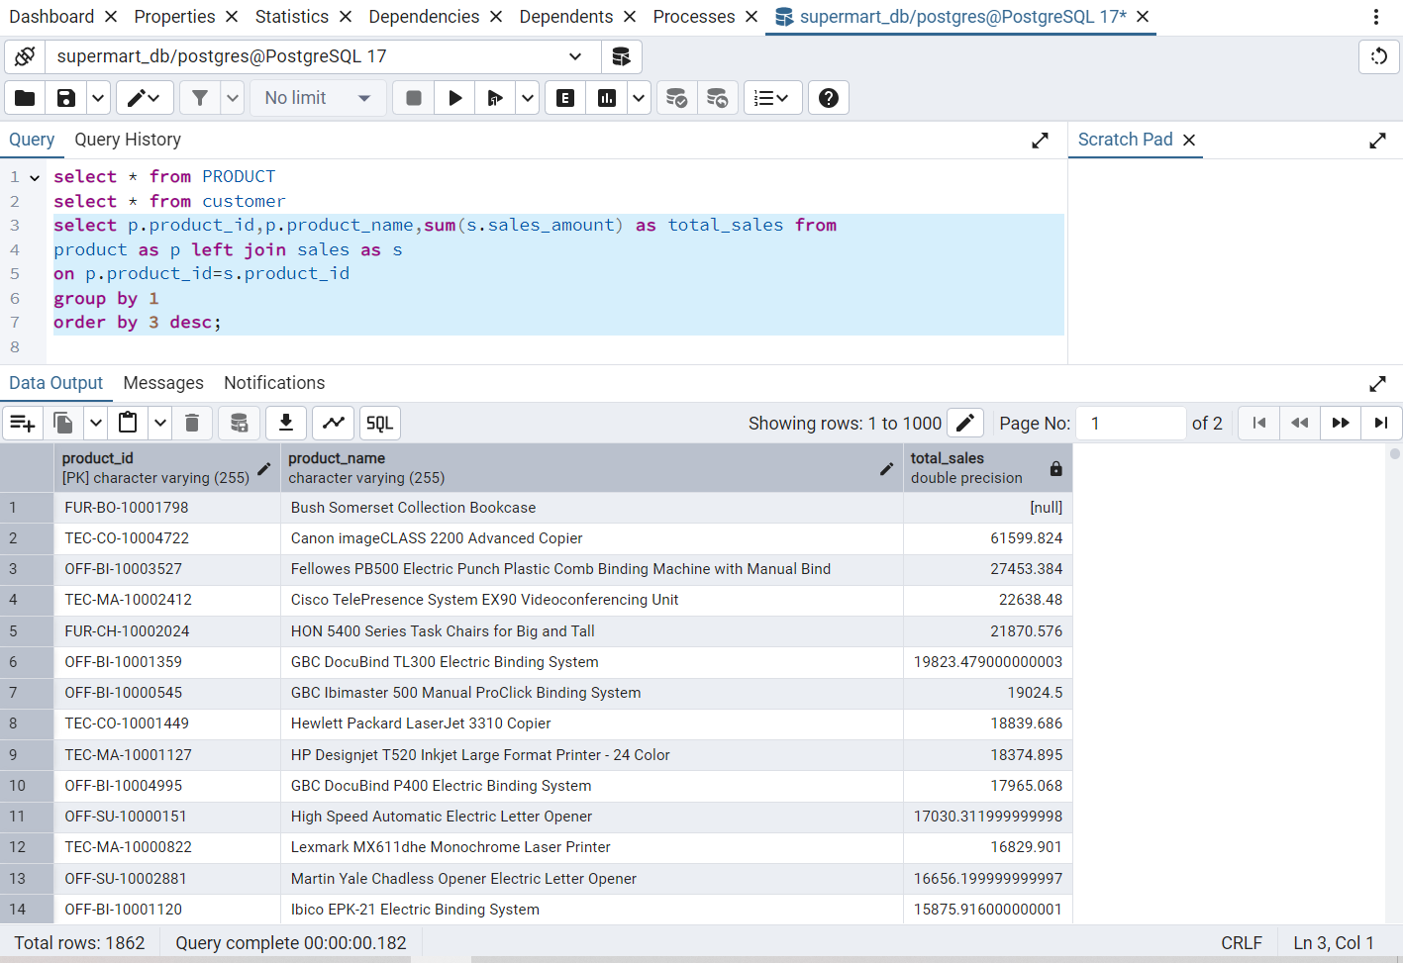

3. Discount Impact on Profit

● Question: How does the discount affect profit?

OUTPUT:

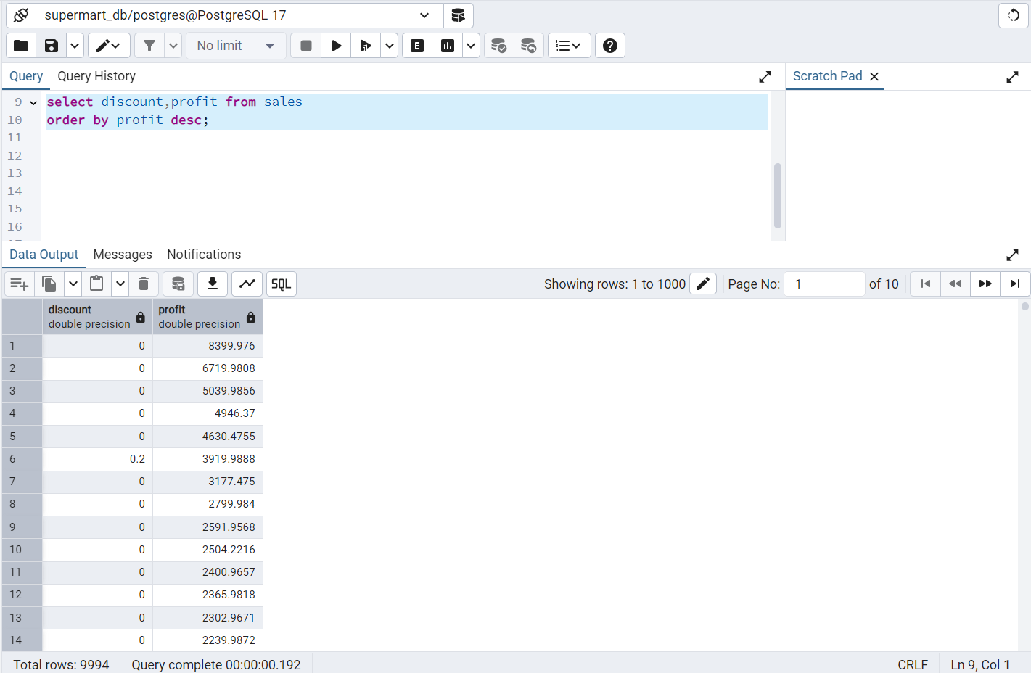

4. Sales by Customer Segment

● Question: How much sales does each customer segment contribute?

OUTPUT:

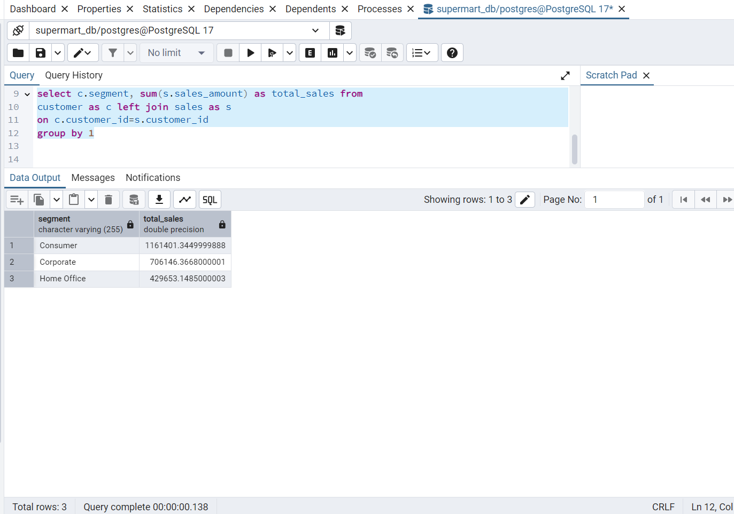

5. Product Category Sales

● Question: What are the total sales for each product category?

OUTPUT:

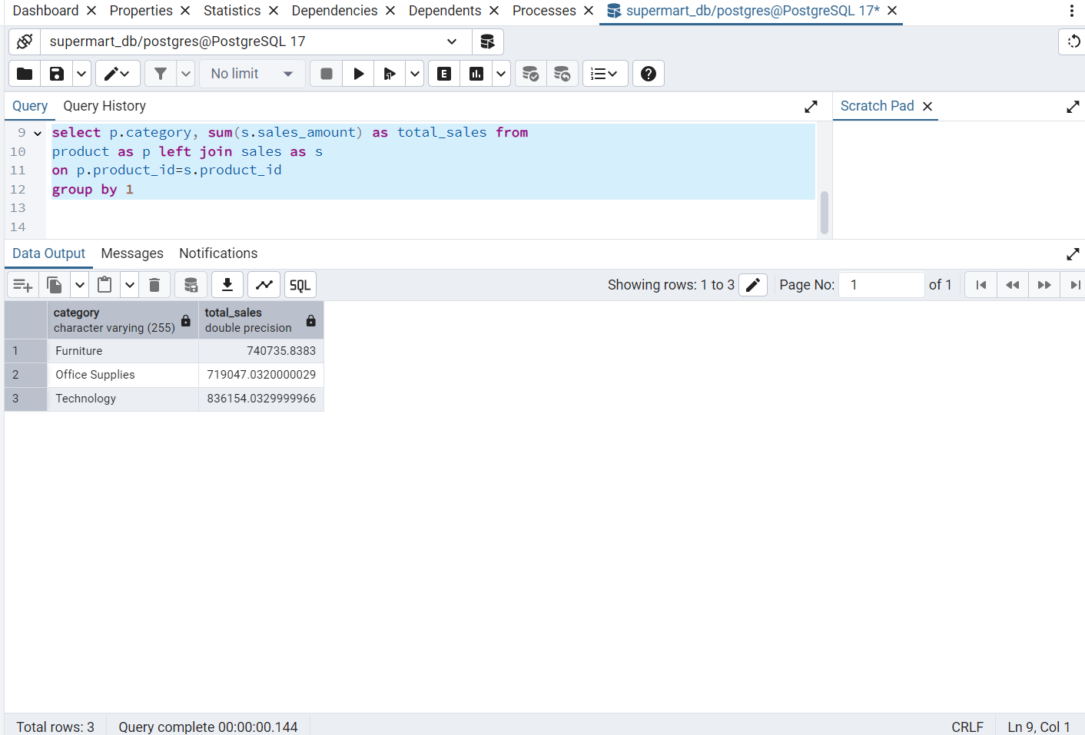

6. Customer Orders by Ship Mode

● Question: How many orders were shipped by each shipping mode?

OUTPUT:

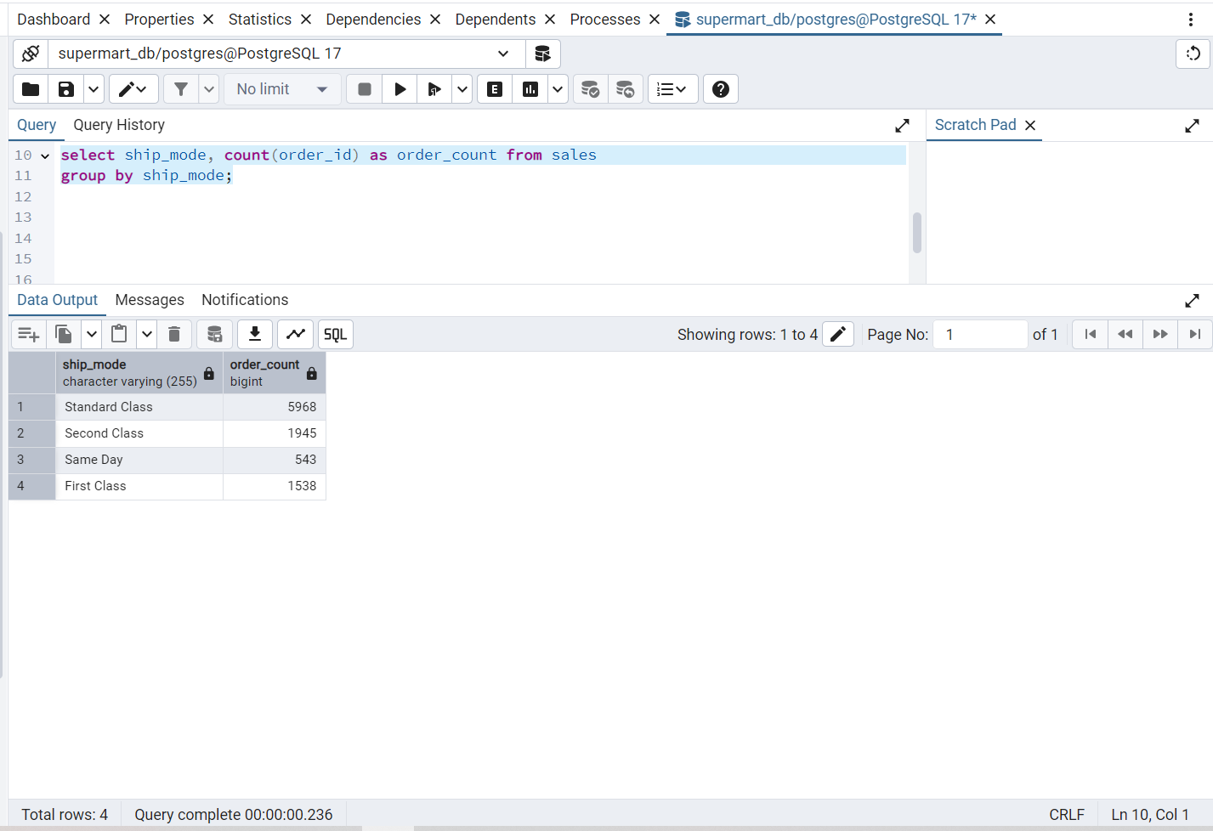

7. Sales by Date

● Question: What are the total sales for each month?

OUTPUT:

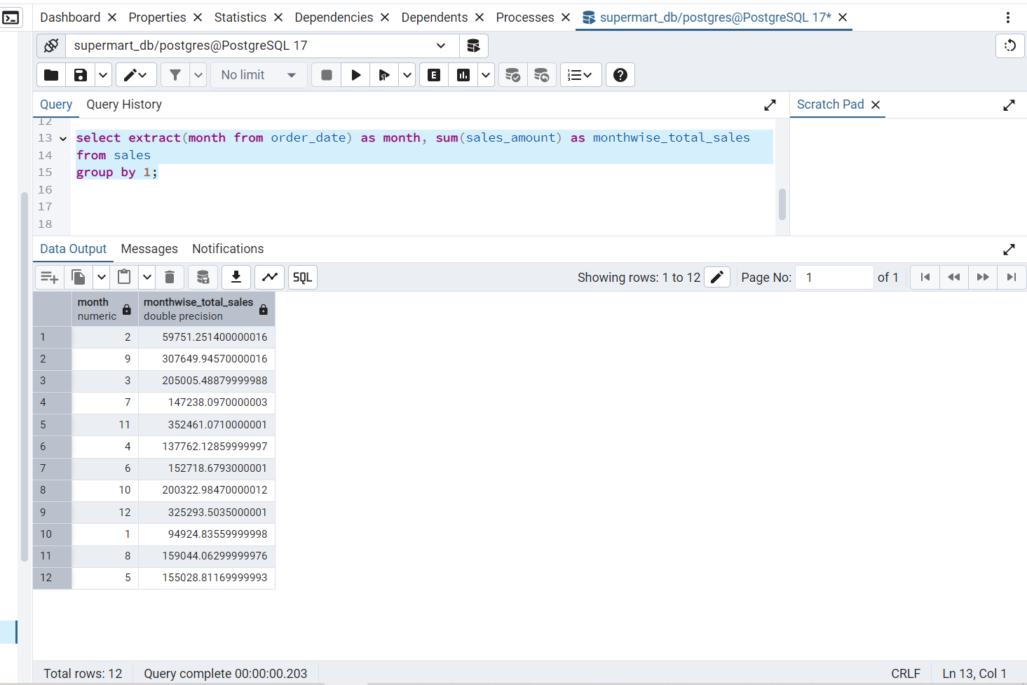

8. Customer Distribution by State

● Question: How many customers are there in each state?

OUTPUT:

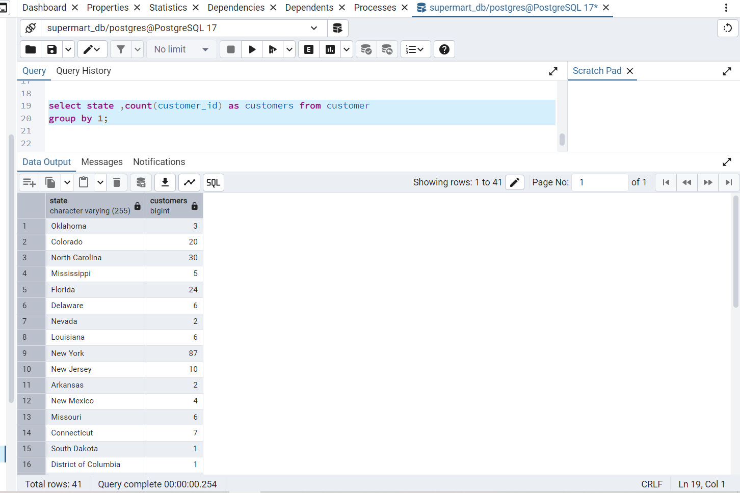

9. Top 5 Customers by Sales

● Question: Who are the top 5 customers in terms of total sales?

OUTPUT:

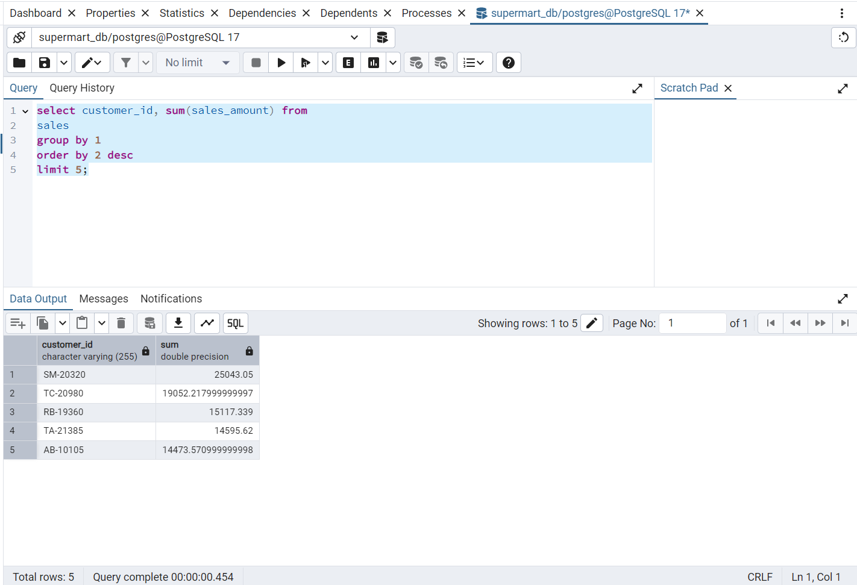

10. Product Performance in Subcategories

● Question: What is the total sales for each product subcategory?

OUTPUT:

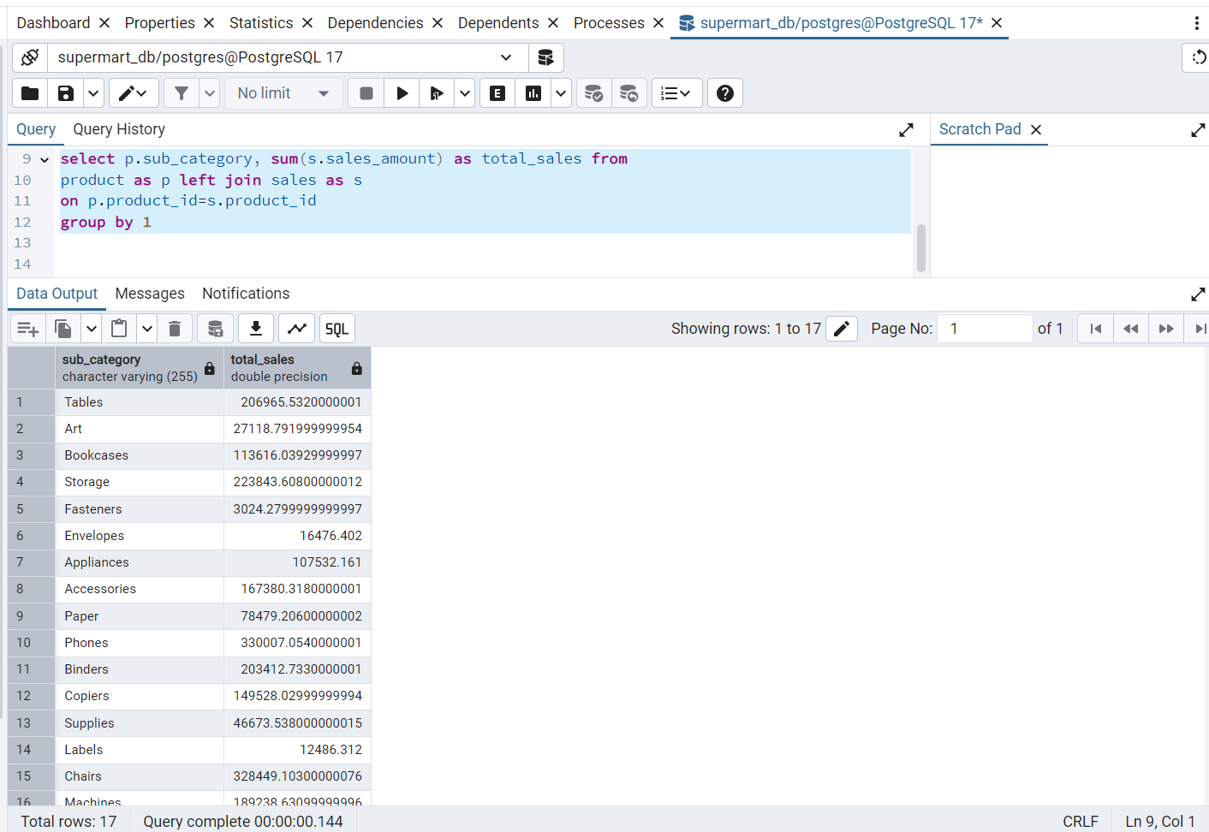

11. Rank Products by Sales

● Question: How can we rank products by their total sales within each product category?

OUTPUT:

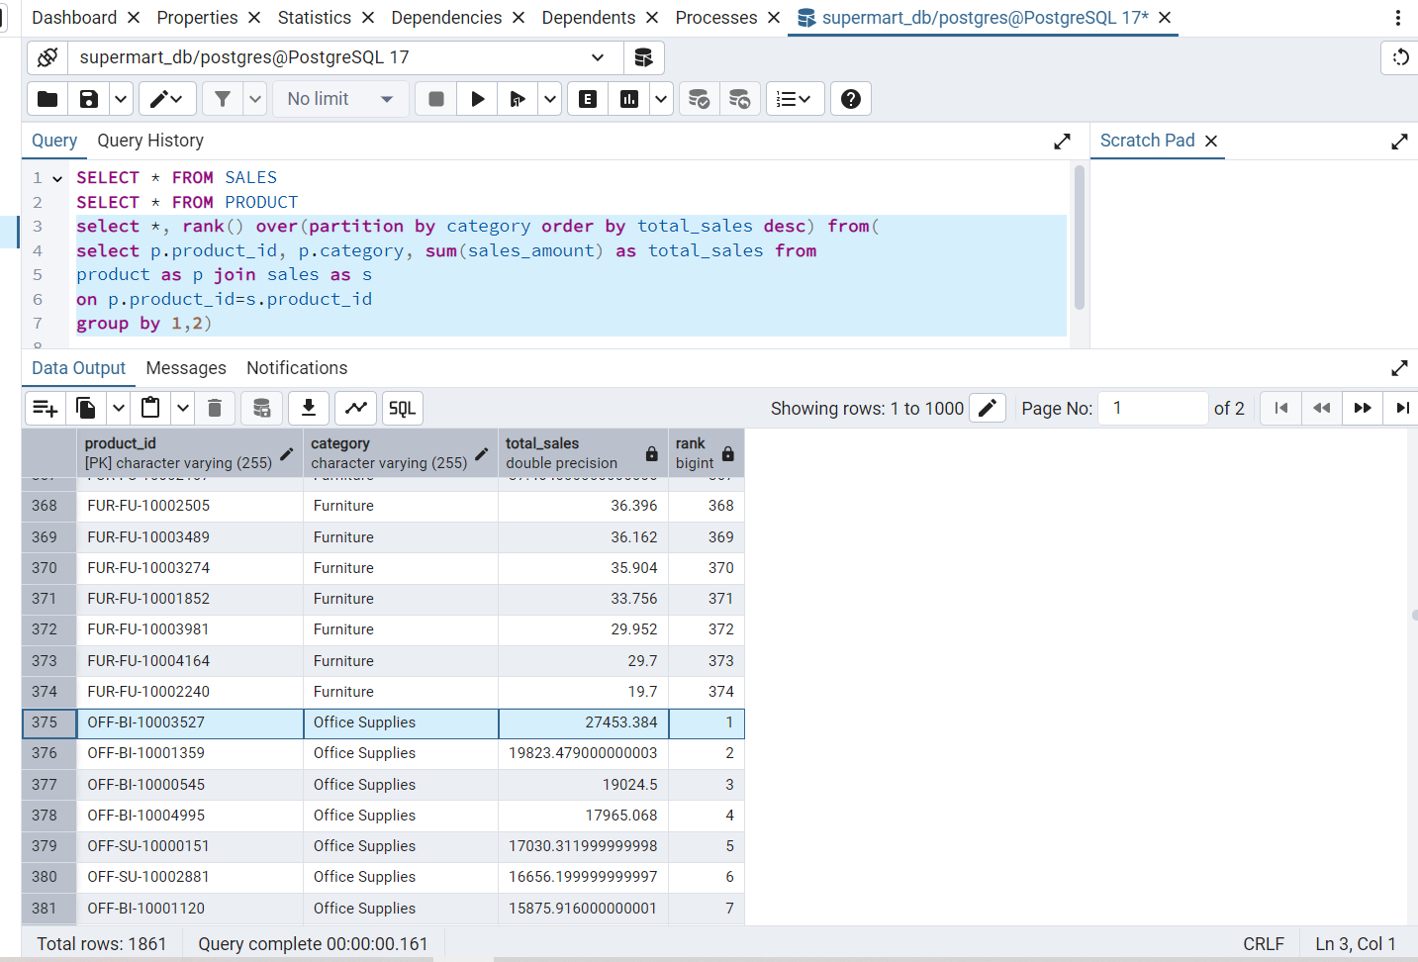

12. Cumulative Sales by Date

● Question: How can we calculate cumulative sales over time (running total) for each product?

OUTPUT:

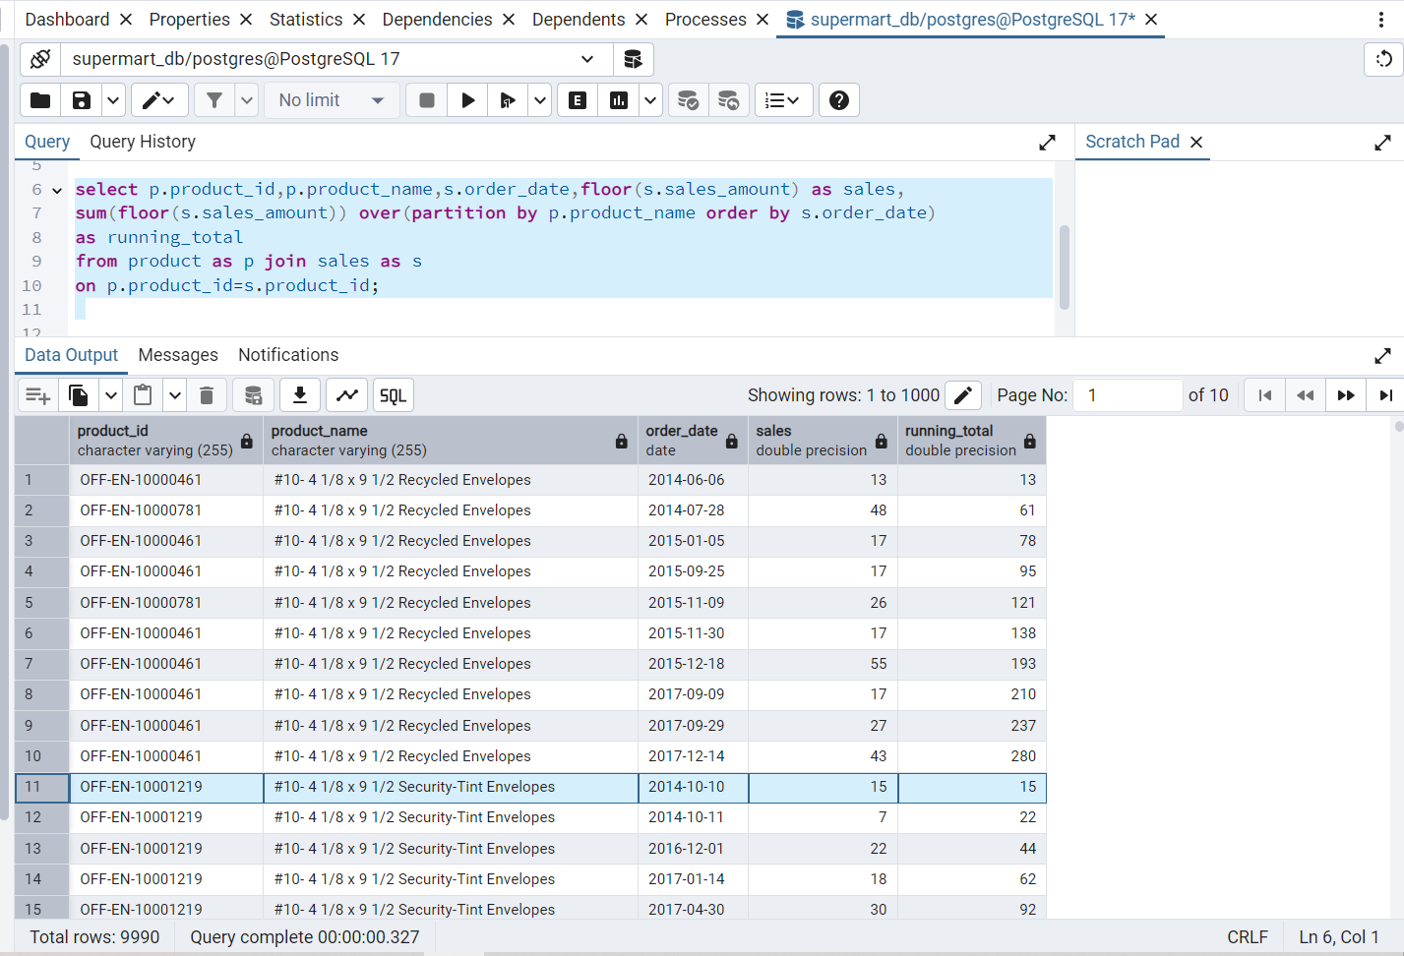

13. Find Top 3 Customers by Profit

● Question: How can we find the top 3 customers based on profit within each region?

OUTPUT:

(try—wrong output)

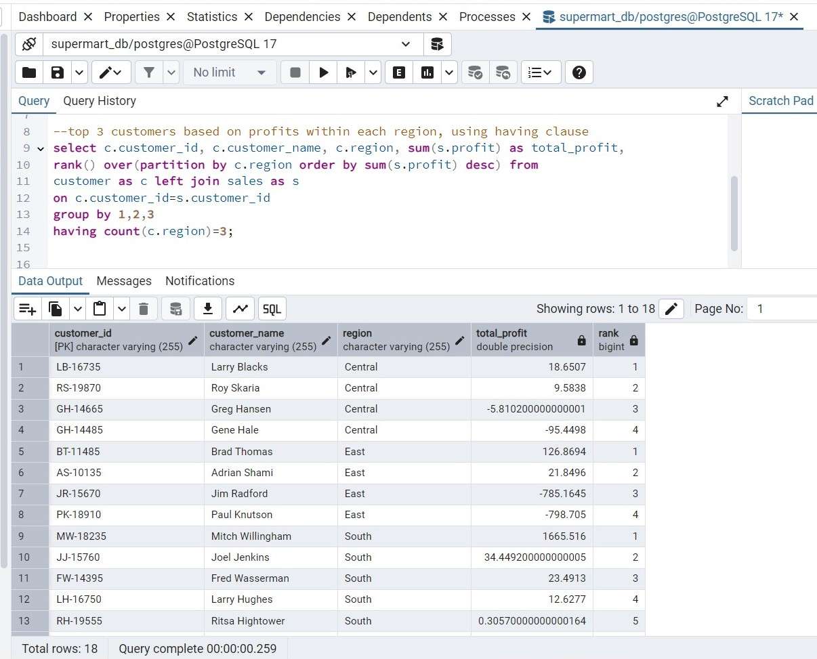

Using CTE

(correct)

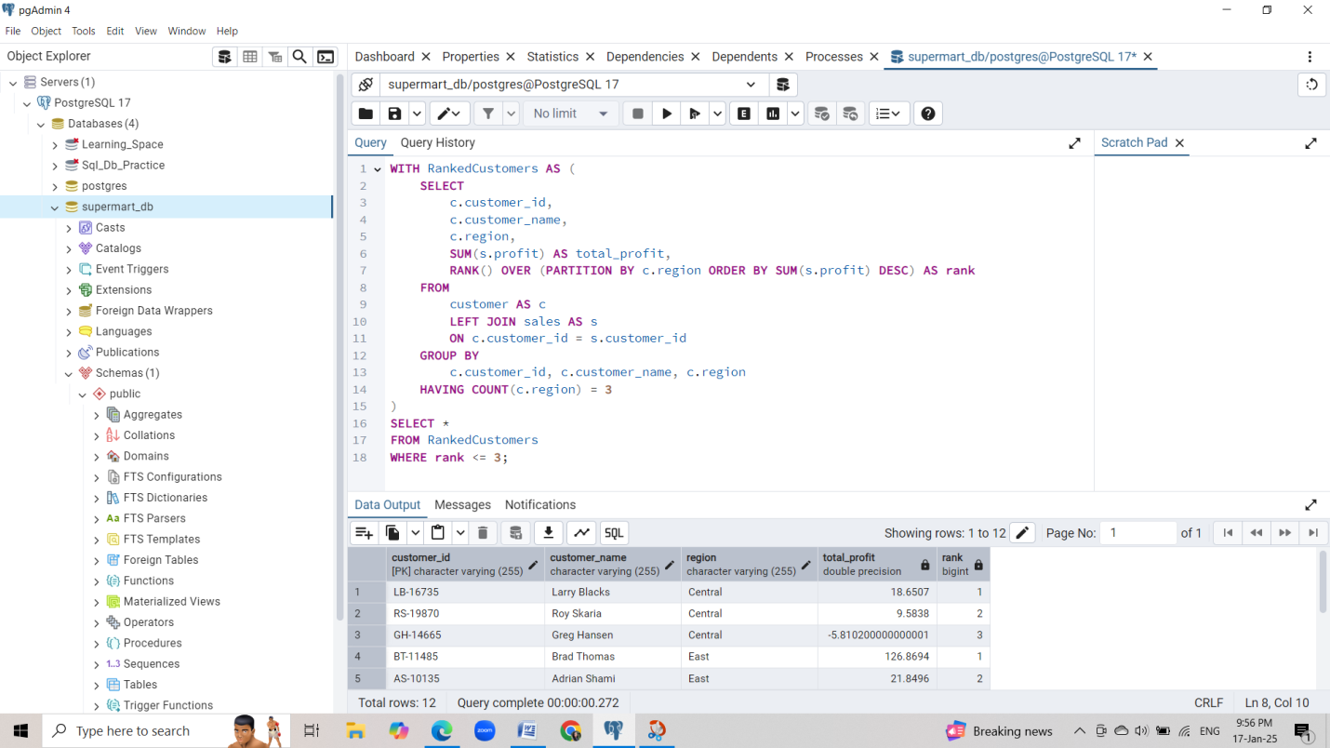

14. Average Sales by Segment with Row Number

● Question: How can we find the average sales for each segment and assign a row number to each customer based on their sales?

OUTPUT: (try--wrong)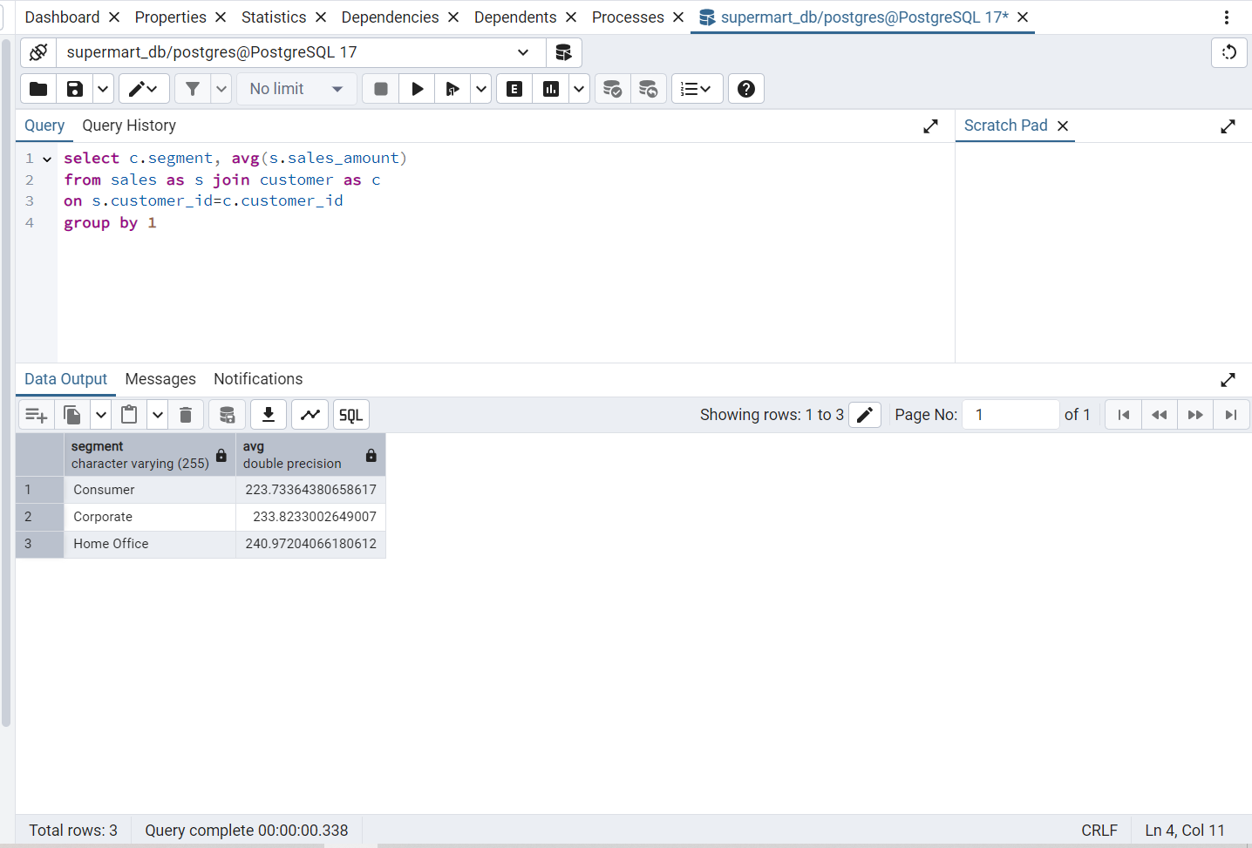

(using CTE – correct (chatgpt))

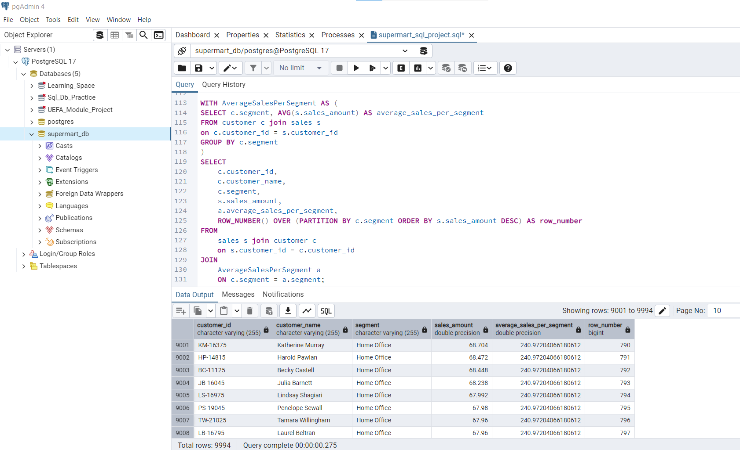

15. Difference in Sales Between Consecutive Days

● Question: How can we calculate the difference in sales between consecutive days for each product?

OUTPUT:

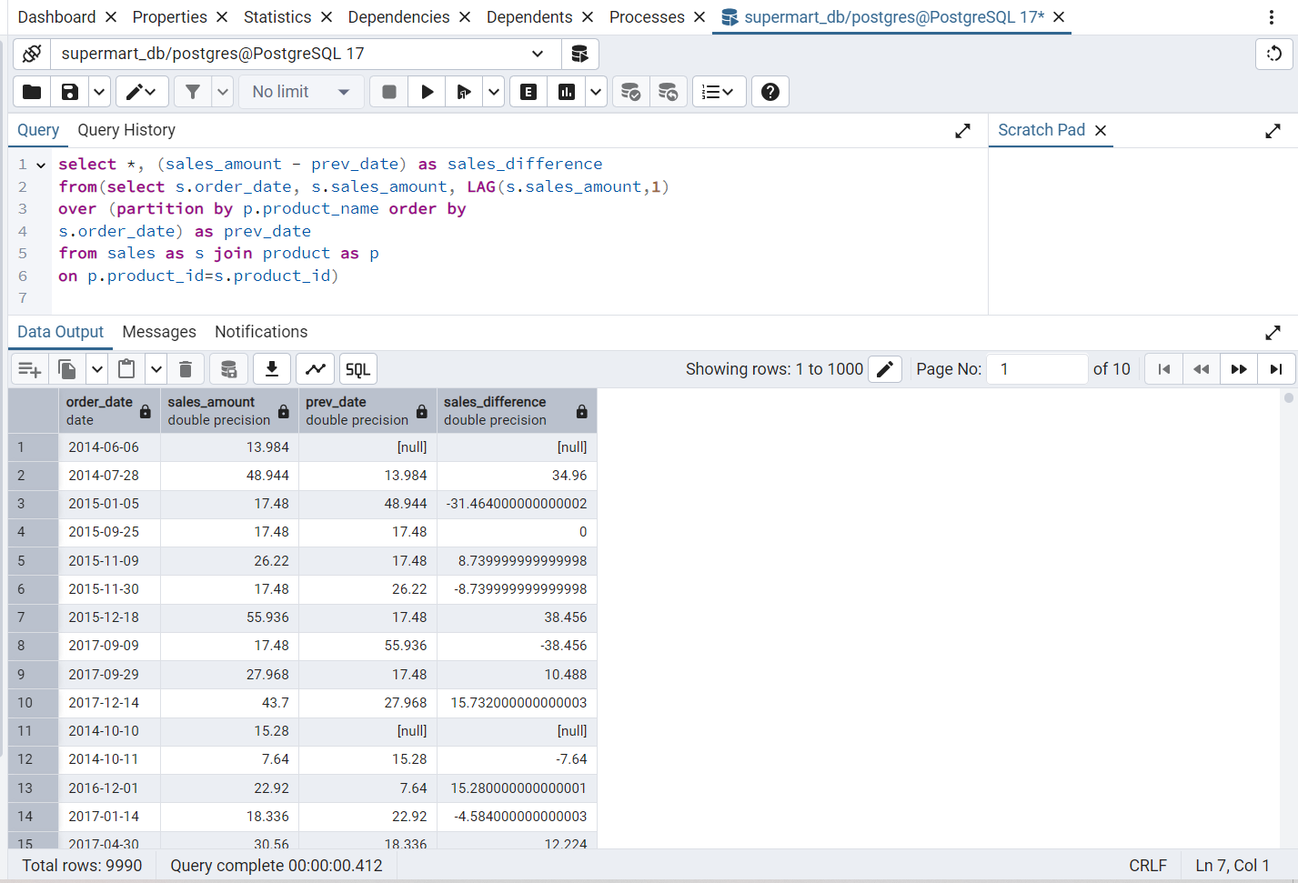

16. Find Percent of Total Sales by Region

● Question: How can we calculate the percentage of total sales contributed by each region?

OUTPUT:

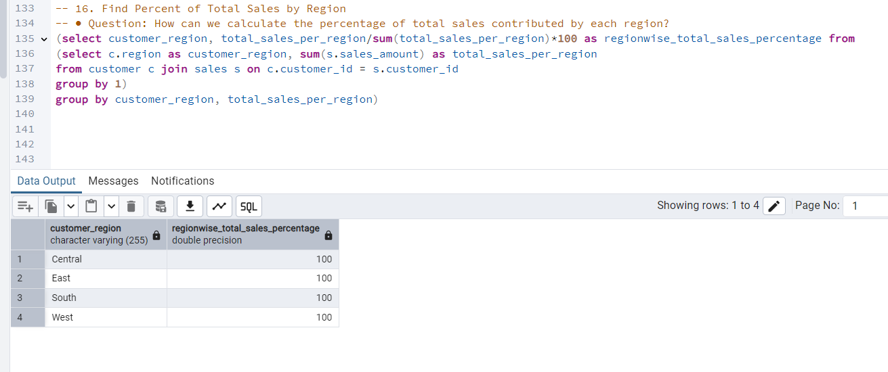

17. Calculate Moving Average of Sales

● Question: How can we calculate the moving average of sales over the last 3 orders for each product?

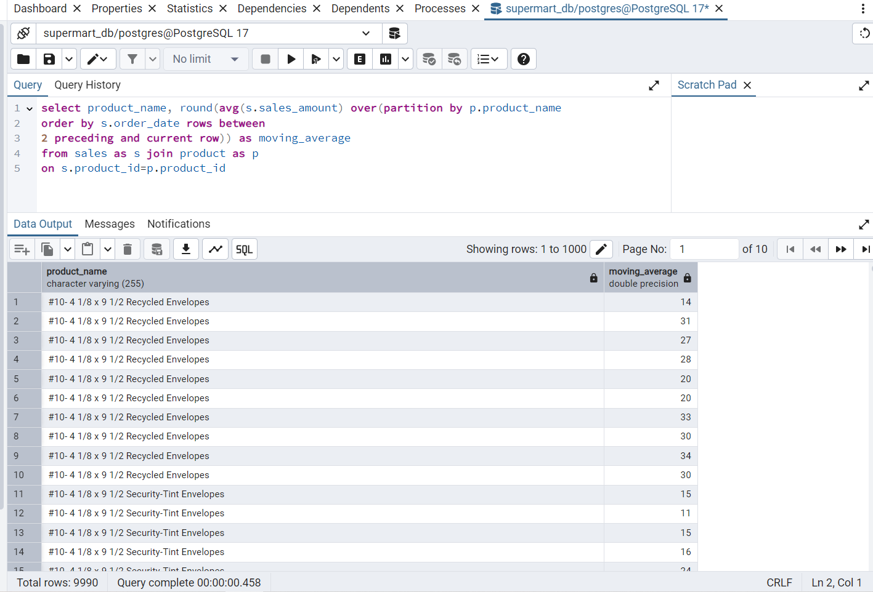

18. Find Largest and Smallest Order by Customer

● Question: How can we find the largest and smallest order (by sales) for each customer?

OUTPUT:

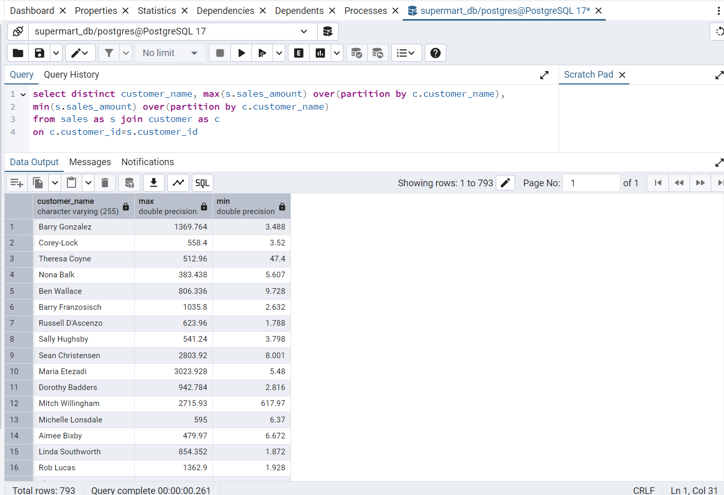

19. Running Total of Profit by Customer

● Question: How can we calculate the running total of profit for each customer?

OUTPUT:

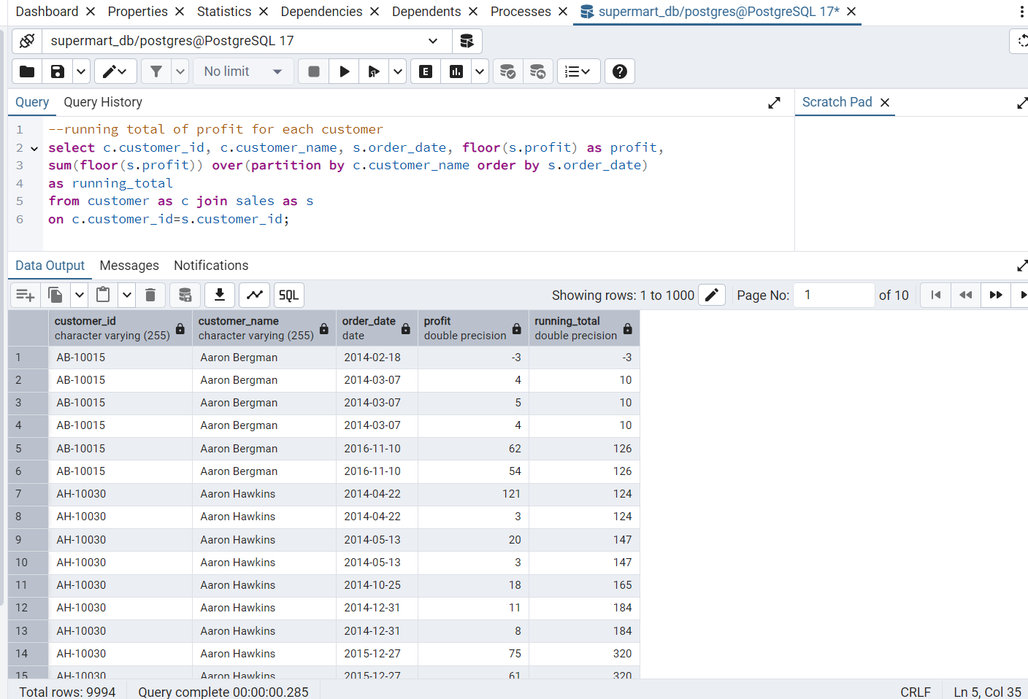

20. Calculate Dense Rank of Sales by Ship Mode

● Question: How can we assign a dense rank to each sale based on total sales, grouped by ship mode?

OUTPUT:

