**Abstract**

Crafting User-Centric Login, Signup, and Verification Experiences.

In the realm of user authentication and engagement, our platform endeavours to deliver an unparalleled experience through thoughtfully designed login, signup, forget password, and OTP verification pages. The login page showcases a dynamic mouseover effect on the login button, employing colour changes to enhance user interaction subtly. Furthermore, an aesthetically pleasing background gradient and a delicate box shadow contribute to an elegant design.

The signup page seamlessly integrates form shake effects and red border indicators, guiding users to complete all required fields effectively. Password matching checks and a confirmation alert post-signup ensure a smooth and positive interaction. A strategically placed login link facilitates effortless navigation between functionalities.

In the forget password page, a shaking effect and red border elegantly handle empty email fields, while a logical transition to the OTP entry page ensures a user-friendly password recovery process. The OTP verification page, designed with efficient navigation, numeric input restrictions, and intelligent button activation, aims for a secure and seamless verification process.

To complement these features, the overall design prioritizes aesthetics, leveraging attractive gradients to enhance visual appeal. Responsiveness is paramount, ensuring an optimal user experience across diverse devices and screen sizes. CSS is maximized for decorative elements, experimenting with styles, fonts, and spacing to create visually engaging interfaces.

Form validation on the signup page adds another layer of user-friendly functionality, providing clear error messages for invalid inputs. This holistic approach to design and functionality aims to create an immersive, error-resistant, and visually captivating experience for users accessing the platform.

**Login Page**

**Features**

**1. Mouseover Effect on Login Button**

The login button on the page exhibits a dynamic visual response when the mouse is hovered over it. This feature is designed to enhance user experience by providing a visual cue, indicating that the button is interactive. The colour change on mouseover serves as a subtle yet effective way to engage users.

**2. Form Shake Effect on Empty Fields**

**a. Empty Email and Password Fields**

When attempting to submit the login form with empty email and password fields, a shaking effect is implemented on the entire form. This visual feedback draws the user's attention to the specific areas that require input. It serves as a reminder to fill in the necessary information before proceeding with the login attempt.

**b. Empty Password Field**

If the password field is left empty while attempting to log in, a shaking effect is specifically applied to the password input field. This targeted animation ensures that the user is alerted to the missing password input and encourages them to provide the required information.

**3. Successful Login Alert**

Upon successful authentication, an alert message is displayed, notifying the user that the login process was successful. This pop-up message serves as a confirmation and reassures the user that their credentials are correct. It enhances the overall user experience by providing immediate feedback on the login status.

**4. Background Body Colour Gradient and Box Shadow**

The login page features a visually appealing background gradient applied to the entire body. This gradient not only adds an aesthetic element to the page but also contributes to a cohesive and polished design. Additionally, a subtle box shadow is applied to the login form, creating a sense of depth and separation from the background. This stylistic choice adds a touch of elegance to the overall login page design.

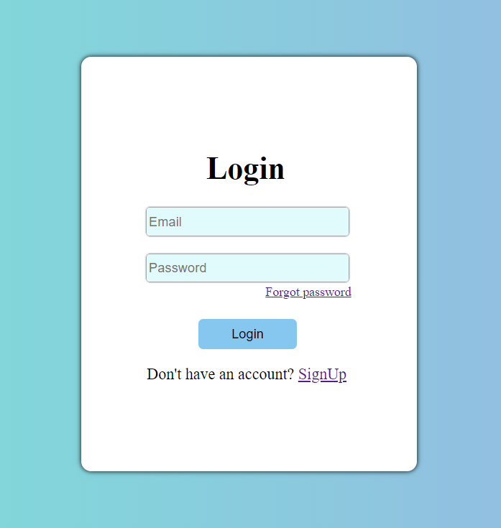

*By incorporating these features, the login page aims to create a user-friendly and visually engaging experience for individuals accessing the platform. These elements collectively contribute to a seamless and aesthetically pleasing login process.*

**Sign-Up Page**

**Features**

**1. Form Shake Effect on Empty Fields and Red Border**

**a. All Fields Empty**

When attempting to submit the sign-up form with all fields (email, password, and confirm password) left empty, a shaking effect is applied to the entire form. Additionally, the border colour of all empty input fields turns red, providing a clear visual indication of the missing information. This serves as a prompt for the user to complete all required fields before proceeding with the sign-up process.

**b. Any One Field Empty**

If any one of the three fields (email, password, or confirm password) is left empty while attempting to sign up, a shaking effect is specifically applied to the empty field, and the border colour of that field turns red. This targeted animation draws attention to the specific field that requires input, guiding the user to provide the necessary information.

**2. Password Matching Check**

When entering information in the password and confirm password fields, the sign-up page includes a check to ensure that the entered password matches the confirmation password. If the passwords do not match, a shaking effect is applied to the confirm password field, and its border colour turns red. This visual feedback notifies the user of the password mismatch and prompts them to verify the entered information.

**3. Successful Sign-Up Alert**

Upon successfully completing the sign-up process with accurate information, an alert message is displayed. This pop-up message serves as a confirmation to the user that their registration was successful. It provides immediate feedback on the sign-up status and encourages a positive interaction with the platform.

**4. Login Link**

The sign-up form includes a link to the login page, allowing users to easily navigate between the login and sign-up functionalities. This link enhances user convenience by providing a direct path to access the login page for those who may already have an account or wish to explore other features.

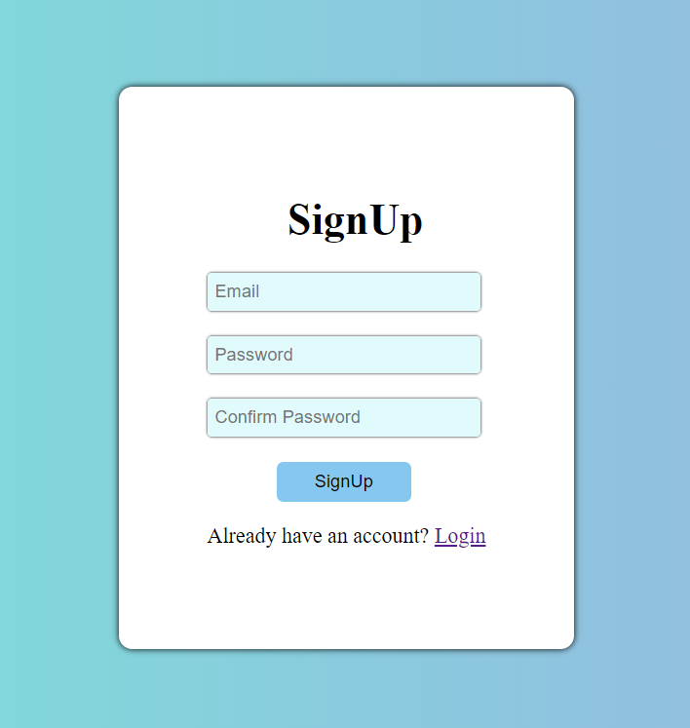

*By incorporating these additional features, the sign-up page aims to deliver a comprehensive and user-friendly experience. The combination of visual cues, error feedback, and navigation links contributes to a seamless and effective sign-up process for users on the platform.*

**Forget Password Page**

**Features**

**1. Empty Email Field Handling**

**a. Email Field Empty**

If the user attempts to initiate the password recovery process by clicking the "Send OTP" button with the email field left empty, a shaking effect is applied to the email field. Additionally, the border colour of the email field changes to red. This visual feedback highlights the missing information and prompts the user to enter a valid email address before proceeding with the password recovery.

**2. Move to OTP Entry Page**

Upon successfully entering a valid email address and clicking the "Send OTP" button, the user is redirected to the next page dedicated to entering the OTP (One-Time Password). This step-by-step approach enhances the user experience by guiding them through a logical sequence of actions, starting with email verification.

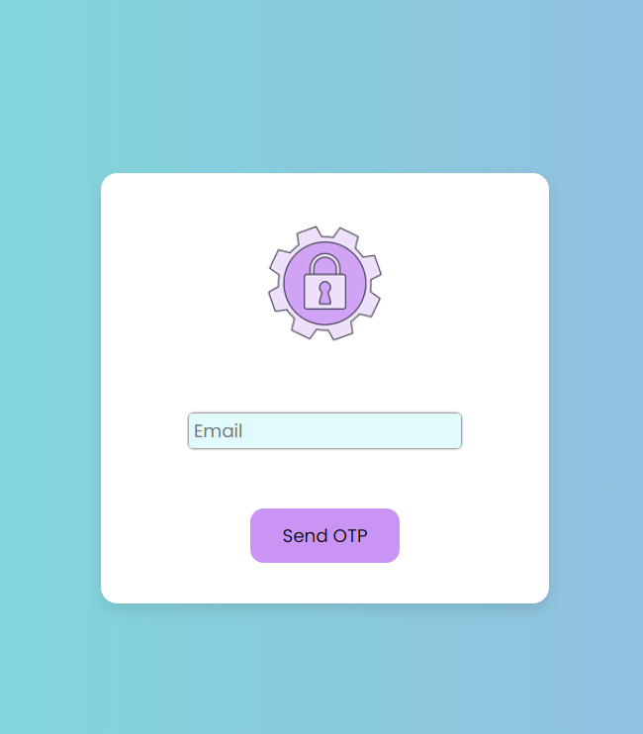

*By incorporating these features, the forget password page provides clear feedback on the status of the email field and ensures a smooth transition to the OTP entry page for users who have entered a valid email address. This user-friendly design aims to simplify the password recovery process and reduce potential errors or confusion.*

**OTP Verification Page**

**Features**

**1. Seamless Navigation Between OTP Input Fields**

The OTP verification page is designed with four input fields, each dedicated to one digit of the OTP. A convenient and user-friendly feature has been implemented, allowing users to seamlessly move between the input fields. When a user enters a digit in a field, the focus automatically shifts to the next input field, facilitating a quick and efficient entry process. Similarly, when a user removes a digit, the focus shifts to the previous input field, ensuring a smooth and intuitive experience.

**2. Numeric Input Restriction**

To enhance data accuracy and ensure that only valid OTPs are entered, the input fields are restricted to accept only numeric values. This restriction prevents users from entering non-numeric characters, reducing the likelihood of errors during the OTP verification process.

**3. Button Activation on Complete OTP Entry**

The verification page includes a button, possibly labelled "Verify" or a similar term, which remains inactive until all four OTP input fields are filled with numeric values. This intelligent design ensures that users can only attempt to verify the OTP once all necessary information has been provided. The button becomes clickable only when the user successfully enters a four-digit OTP, preventing premature or incomplete verification attempts.

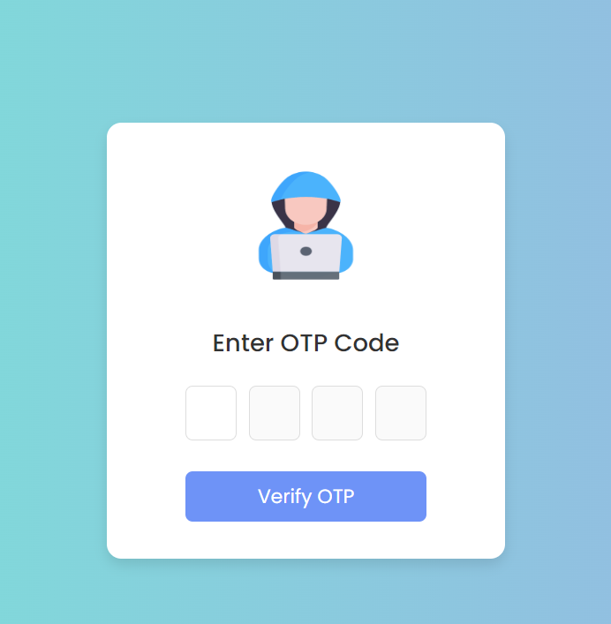

*By incorporating these features, the OTP verification page aims to streamline the user experience, making it efficient and error resistant. The automatic navigation between input fields, numeric input restriction, and button activation upon complete entry collectively contribute to a seamless and secure OTP verification process.*