Lab 2: Docker
Learning objectives
By the end of this lab, students will be able to:
- Understand and explain key Docker concepts: images, containers, and registries.
- Create a Dockerfile to containerize a simple Node.js or Python web app.
- Build and tag Docker images using the CLI.
- Run containers and map ports between host and container.
- Push and pull images to and from Docker Hub.
- Use volumes and bind mounts for persistent storage.
- Define and deploy multi-container applications with Docker Compose.

Part 1: Containerize an application

I successfully built the Docker image and ran the container. The application worked correctly in the browser on my local machine.
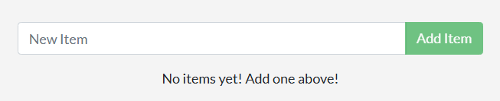
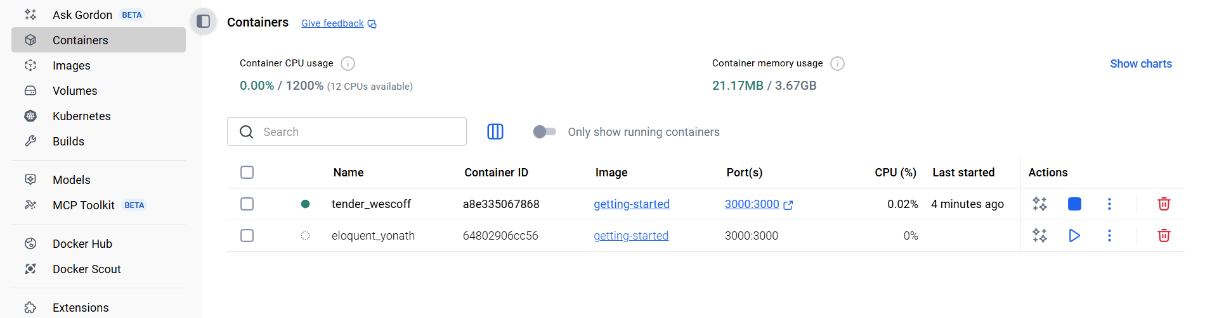

Part2: update application
The previous container with ID a8e335067868 was removed because it caused an error. I followed the instructions by checking the container ID, stopping it, and then removing it.

After updating, I rebuilt and restarted the new container, and the updated application worked properly.
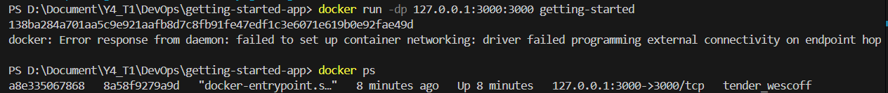
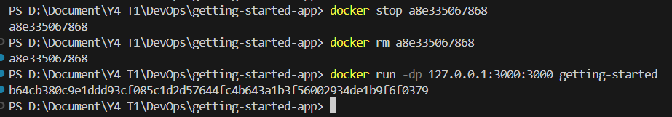

After updating the container
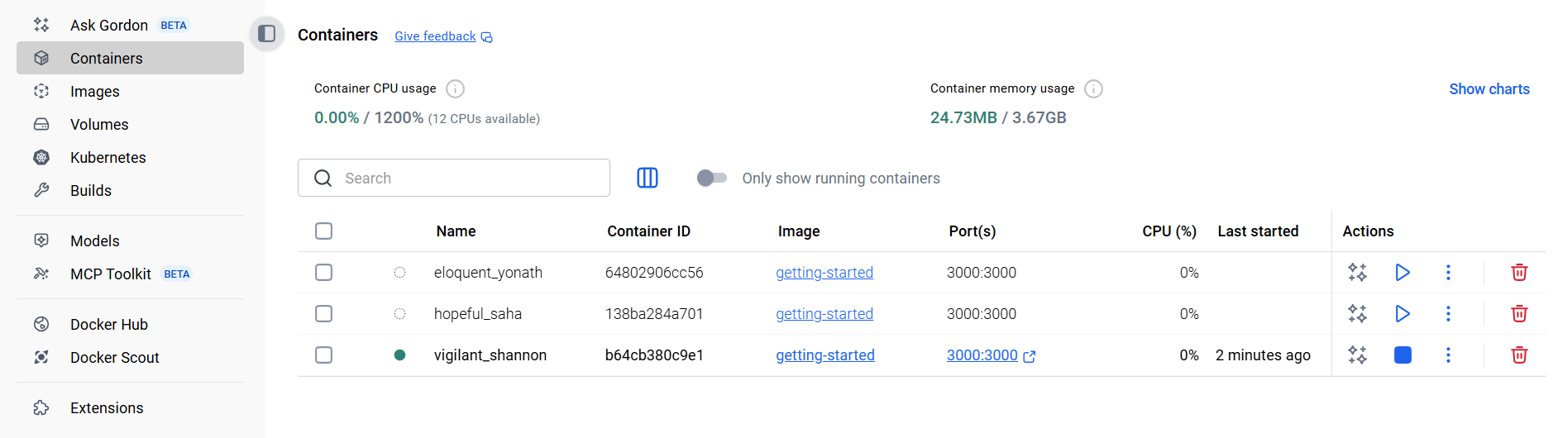

After updating the application, I replaced the old container.
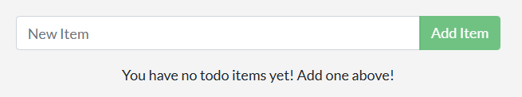

Part3: Share Application
I created a new repository on Docker Hub.
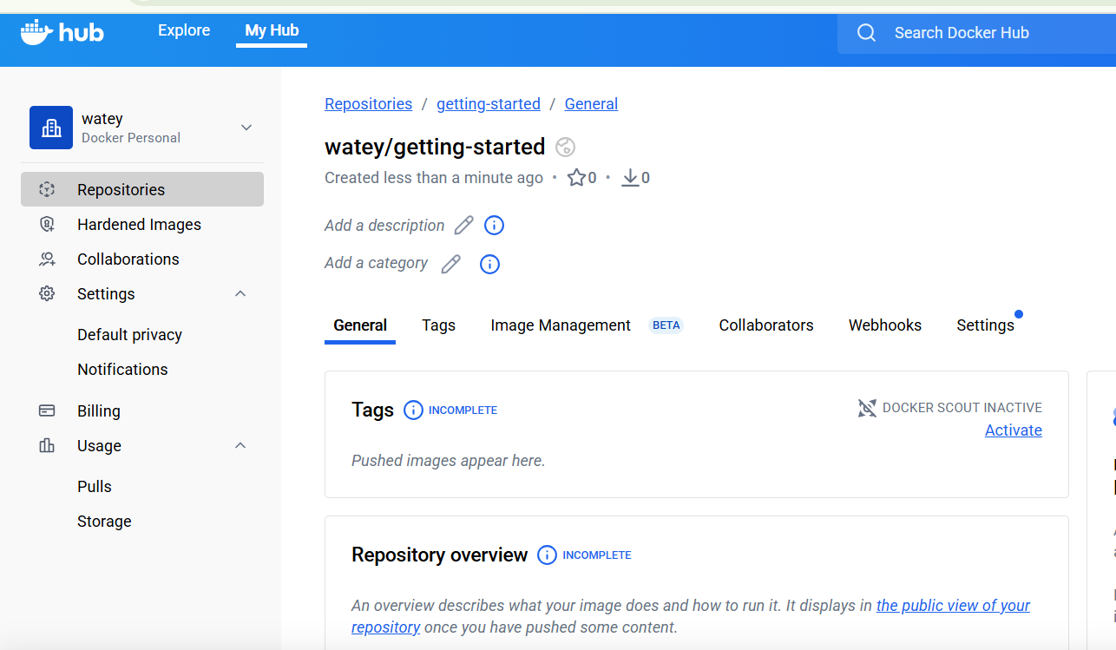

Then I pushed my Docker image to Docker Hub successfully.
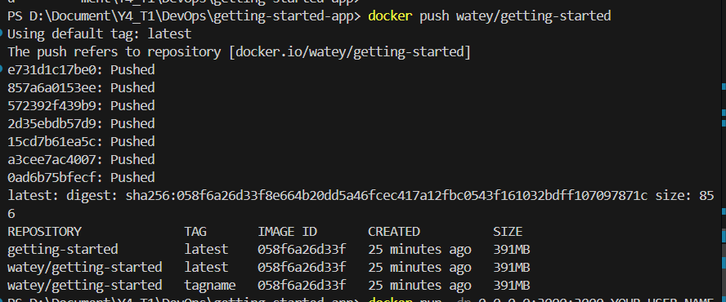

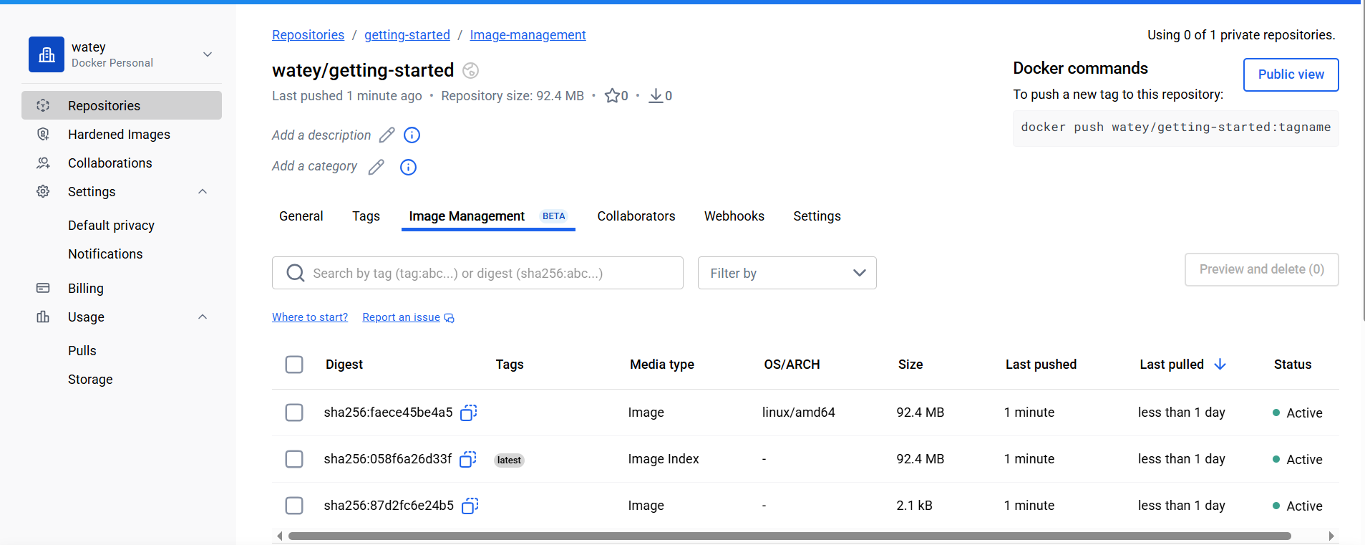

After that, I tested the image using Play With Docker.
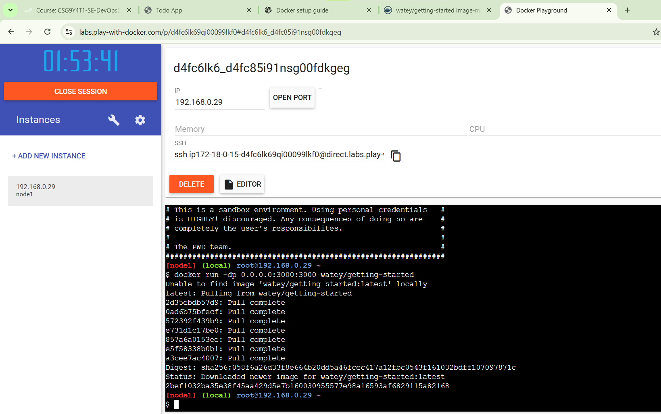

I ran the container and opened port 3000, and the web app worked correctly in the online environment.
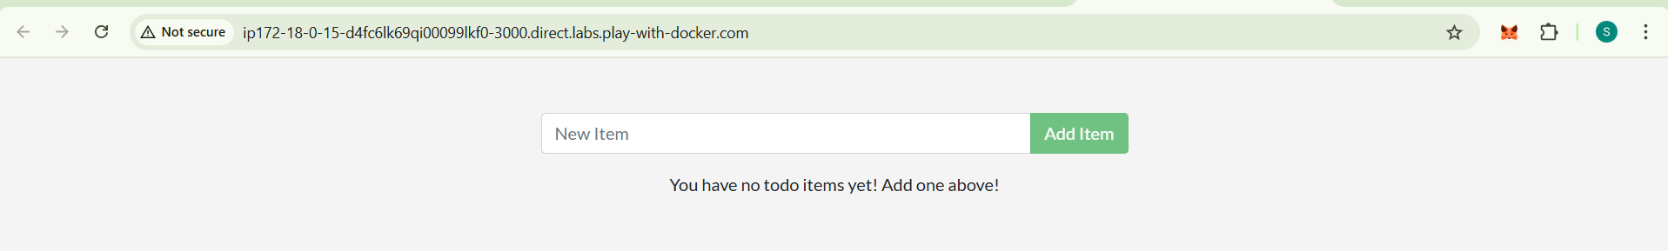

Part 4: Persist the DB
I ran a new container and created items in the list on port 3000.
Then I removed the container and started a new one. The data still existed, meaning the volume worked correctly and the data was persistent.
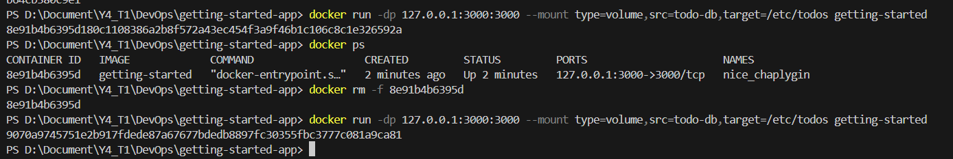
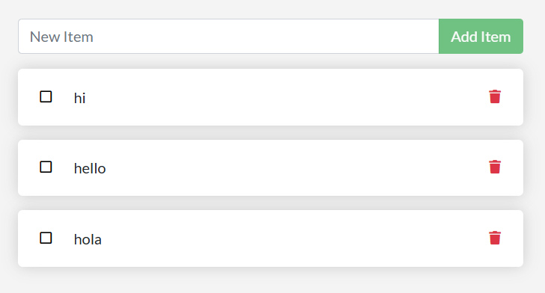

I also checked where Docker stores the data.
The Mountpoint shows the actual location of the stored data on the host machine.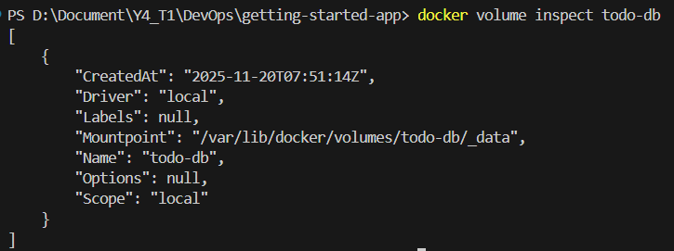
The Mountpoint shows the actual location of the stored data on the host machine.

Part 5: Use bind mounts
I created a myfile.txt file inside the src directory using the container. The file appeared both inside the container and on the host system.
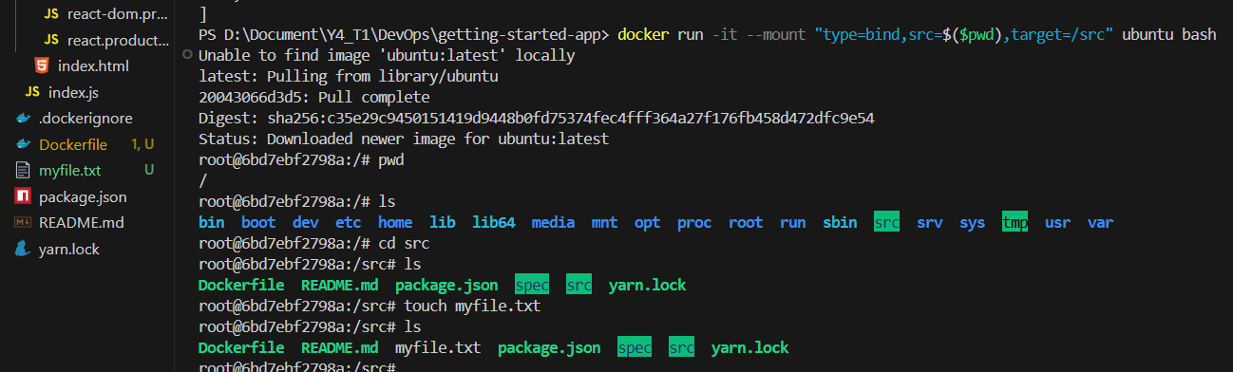

After deleting the file from the host, it was also removed from the container.
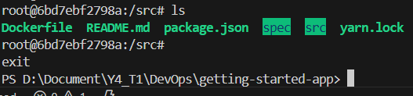

This proved the bind mount synchronization between host and container.
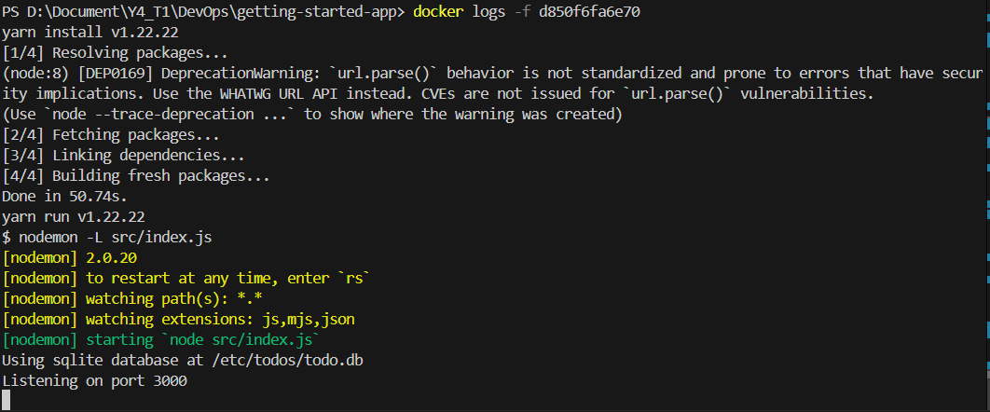

I also updated the UI text from “Add Item” to “Add ”, and the changes were visible immediately.
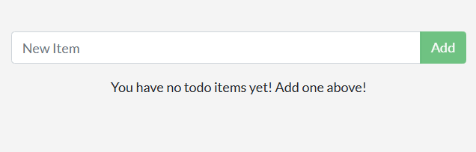

Part6: Multi-container apps
I created a new database named todos.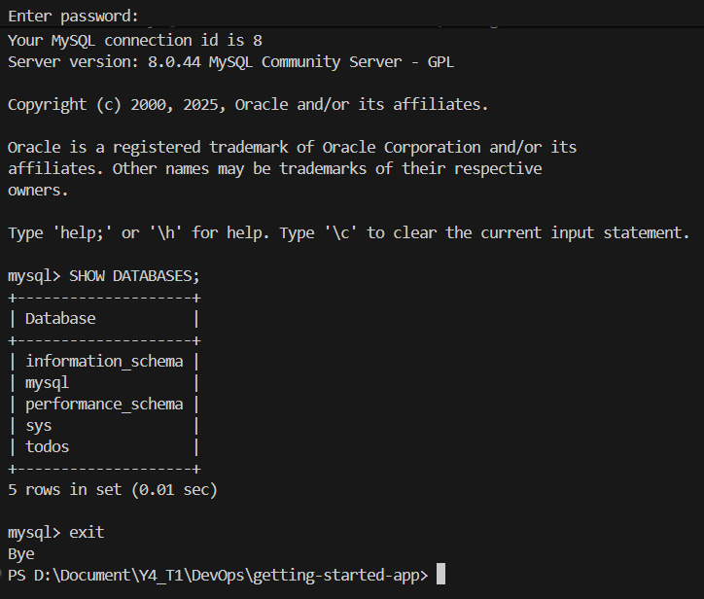
By checking the Docker logs, I confirmed that the app successfully connected to the MySQL database running on the host named mysql.
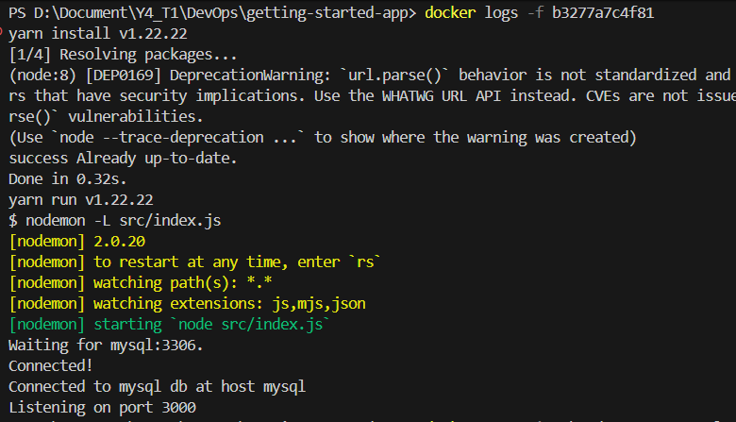

I also checked the MySQL container to verify that the data added through the app was correctly stored in the database.
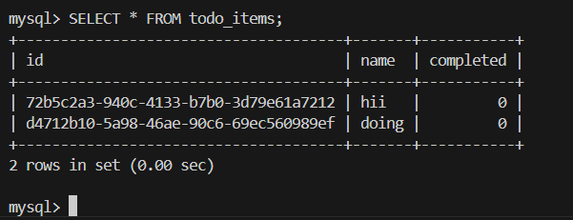

Part 7: Use Docker Compose
With Docker Compose, the application now connects to MySQL automatically.
Running docker compose logs -f allowed me to see the real-time logs for both services.
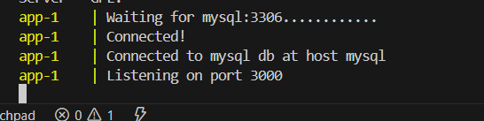

I also checked to verify that the data added through the app was correctly stored in the database.
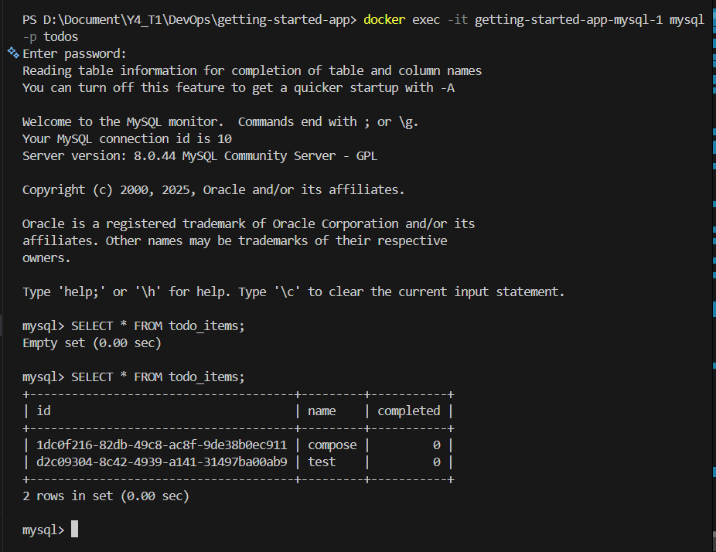

Docker Compose
- Single command to start/stop entire application
- Version controlled configuration
- Automatic network creation
- Easy to share with team members

Part 8: Image-building best practices
After clearing the cache and rebuilding the application, the system ran faster and the updated changes were applied correctly.
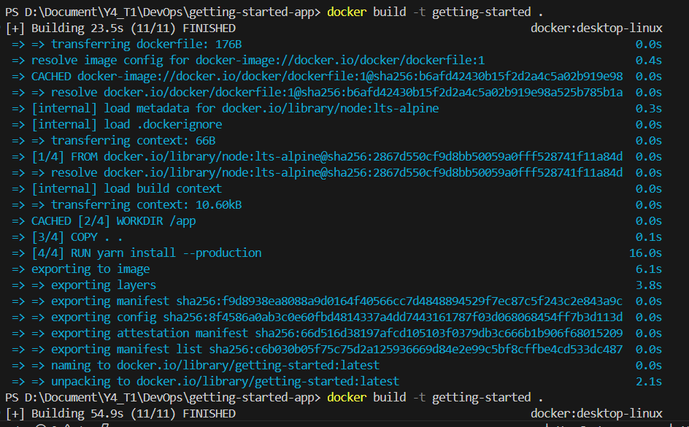
Rebuild and check what change.
