Problem Statement & Solution
A discovery layer for early-stage founders and the investors looking for them

1. The Problem
Finding a company is hard on its own. Right now, especially, in India, it's made harder by a discovery problem: the people who could help each other — cofounders, investors, and the builders themselves — have almost no reliable way to find one another without a network they may not have.
Team gaps and capital-discovery friction are not two separate problems — they're the same problem showing up on both sides of the table. Founders can't find the right people to build with or raise from, and investors can't efficiently find the founders worth their time. Both sides are unraveling this manually today, through personal networks and cold outreach that convert at very low rates.

Who Does This Affect?
Three groups sit on either side of this gap:
- 1. Founders — people trying to build a team, validate an idea, and get in front of capital, especially those without an existing professional network: students, first-generation founders, and people outside major startup hubs. This includes both early-stage founders (technical and non-technical) and refined founders looking to plunge into another opportunity.
- 2. Investors — people with capital to deploy who need a proper, behavior-based matching pipeline instead of relying on referrals and conferences to build deal flow (Angel Investors, VC firms, CVC, Incubators, Family Offices).
- 3. The wider community — people who post problems worth solving and upvote them, creating a public signal for what founders should actually work on — with or without revealing their own identity.

2. Why This Matters

2.1 The Team Formation Bottleneck
- Team-related issues account for a significant, recurring share of startup deaths. CB Insights' postmortem analysis puts “not having the right team” at roughly 23.37% of startup failures, and a deeper read of the same data shows seven of the top 20 failures cause trace back to people issues and company culture.
- In India, this sits on top of a fast-growing base of first-time founders competing for the same limited support: over 55,234 startups received DPIIT recognition in FY26 alone — a 51.62% year-on-year jump — pushing the total past 2.4 lakh recognized startups nationally. More founders are forming companies every year, but the infrastructure to help them find the right people hasn't scaled with that growth.
— CB Insights postmortem analysis; Gregory Shephard

2.2 Finding Investors Without a Network Is Close to a Dead End
- Cold emails to VCs sit around a 95.93% non-reply rate, with unsolicited pitches converting to meetings at roughly 1–5%.
- Warm introductions convert to first meetings at 20–30% — roughly ten to twenty times the cold-email rate.
- The gap compounds over time: deals sourced through cold outreach take about six months to close, versus three months for warm-introduced deals — three extra months of runway burned purely on discovery friction, not on building.
- India shows the same pattern with its own numbers attached: angels report seeing 50+ inbound pitch emails a week, and reply mainly to founders who already lead with hard metrics like MRR or retention — which filters for founders who already know how to package themselves, not necessarily the ones with the strongest ideas. Because Indian angel checks are smaller (typically ₹10 lakh–₹75 lakh), founders also need to win over a larger number of individual relationships to fill a single round, multiplying the discovery problem rather than solving it with one or two connections.
— Malay Gupta; Ashish Kulkarni
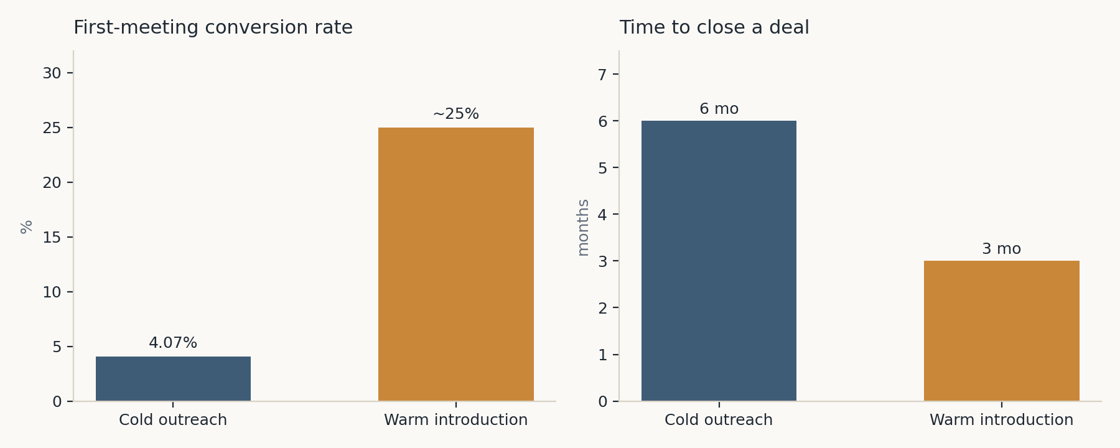
Cold outreach converts far less often, and takes twice as long to close, as a warm introduction.

2.3 Investors Are Hard to Find and Reach — Even Though There Are a Lot of Them
- The capital and infrastructure genuinely exist in India: 164 active angel networks have collectively deployed over $45B across 7,662 rounds, and 700+ incubators and accelerators operate nationwide.
- But access to that capital isn't evenly distributed by merit or effort. Of India's 687,500+ startups, only around 34,400 have ever been funded — roughly 5%.
- The “official” gatekeeper route is similarly narrow: top accelerators, in India as elsewhere, accept only 1–3% of applicants.
- The bottleneck isn't the supply of capital or investors — it's that discovery still runs almost entirely on personal networks and warm intros, which is exactly the kind of access that founders without an existing network don't have.
— Violetta Bonenkamp
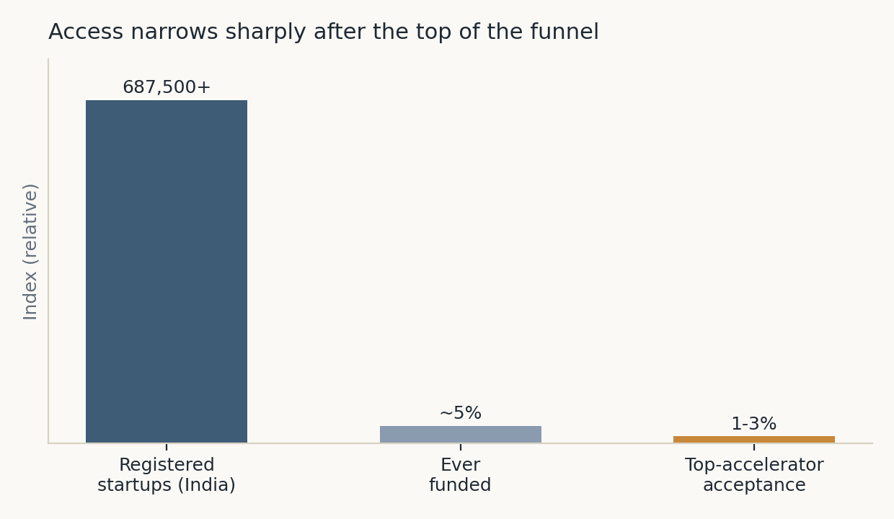
Access narrows sharply at every stage — from all registered startups, to the ~5% ever funded, to the 1–3% top accelerators accept.

2.4 The Problem Runs Both Directions
This isn't just a founder-side problem. Investors have capital to deploy but struggle to build enough quality deal flow to invest well.
- Research on angel returns shows that investors spending fewer than 20 hours per deal on sourcing and diligence average just a 1.1x return, while those spending 40+ hours average 7.9x — meaning the investors who do best are the ones who can spend their time evaluating good matches rather than hunting for them.
- Building a properly diversified portfolio requires sourcing and screening thousands of opportunities, consuming an estimated 1,000–3,000+ hours of front-end work alone.
- Right now, that work is manual and network-dependent on both sides — investors rely on personal referrals and conferences to find startups worth their diligence time, in the same way founders rely on warm intros to find investors. Neither side has an efficient way to surface the other, so good matches are being missed on both sides of the table, not just one.
— Wikipedia, Angel Investor
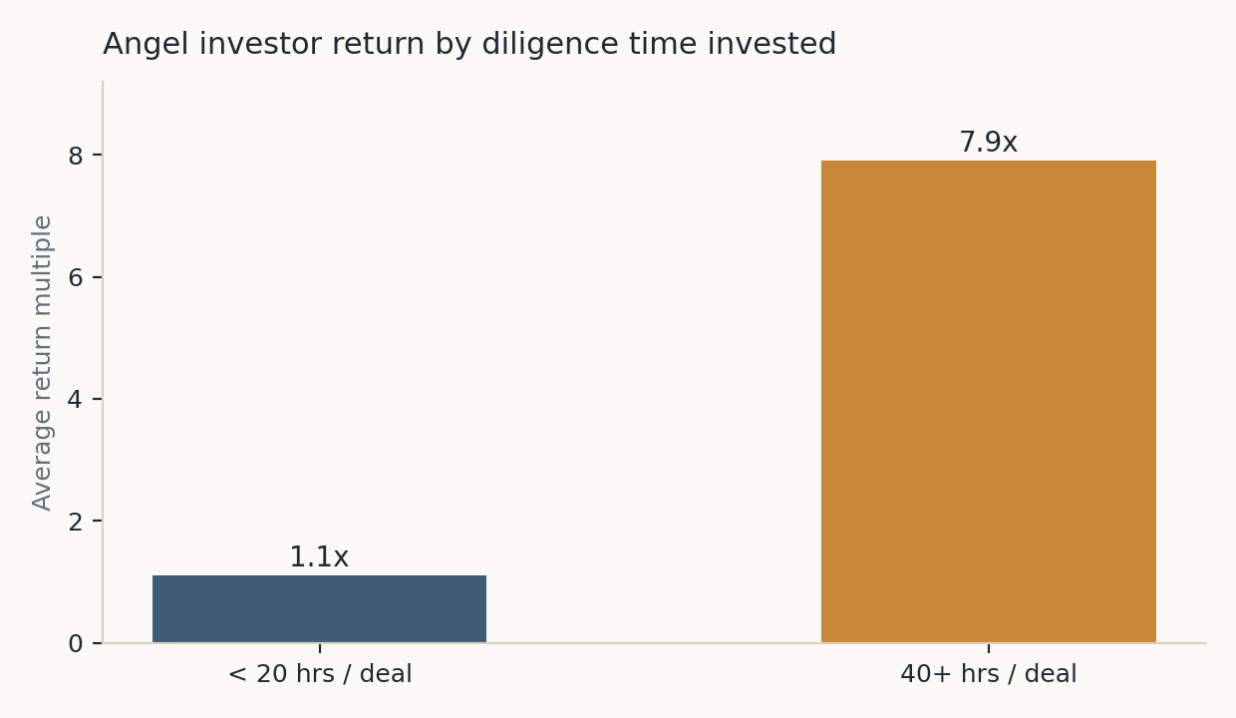
Investors who spend more time on diligence — because they're evaluating good matches instead of hunting for them — see far better returns.

3. Why Current Alternatives Fail

3.1 LinkedIn and Cold Outreach
This is the default tool everyone reaches for, and it fails at exactly the numbers above: cold outreach to investors sits at a ~96% non-reply rate, and even the best-optimized founders following current best practice max out around 12–20% replies. LinkedIn wasn't built for structured discovery — it's a general professional network with no mechanism to filter for “person actively looking to cofound,” “investor actively deploying capital in your sector right now,” or “idea validated against existing patents.” Founders end up manually searching, guessing who's relevant, and sending messages into a format built for job-hunting, not team- or capital-formation.

3.2 Existing Cofounder-Matching Platforms
Platforms like YC Co-Founder Matching and CofoundersLab have the right idea but the wrong depth. Even Y Combinator's own team, responding directly to user complaints on its public forum, has acknowledged this is “a very hard problem” and that the platform still has “a lot of work to do.” The pattern that comes up repeatedly from real users:
- No real search or filtering beyond swiping one profile at a time.
- No quality control — blank profiles, people with zero experience, and outright scam accounts get through unchecked.
- The “idea” section of many profiles sits empty because founders are too worried about idea theft to describe what they're building — which defeats the purpose of the platform before a conversation even starts.
- A mismatch-of-intent problem: the platform fills up with “wantrepreneurs” — people who like the idea of founding something but aren't actually building — alongside people looking for free or cheap labor rather than a real cofounder relationship, with no way to filter for seriousness or commitment level.
This isn't a hypothetical risk. YC's own internal data (via Sam Altman's startup class) found that in one batch, 9 of roughly 75 companies added a new cofounder they didn't already know well between interview and program start — and all 9 of those teams fell apart within a year. The swipe-chat-decide format that most matching platforms use skips exactly the vetting step — extended working trials, hard conversations about equity and expectations — that determines whether a match actually survives contact with reality.

3.3 Accelerators and Incubators
As covered above, this route filters out almost everyone by design: 1–3% acceptance globally, and the same range in India specifically. Even where 700+ incubators exist nationally, they function as a narrow gate rather than a broad on-ramp — most founders who apply are told no, and get nothing in return: no feedback loop, no alternative path, no interim support while they keep building.

3.4 Investor Directories (India-Specific)
Existing India-focused resources — angel investor lists, OpenVC-style databases, government portals like BHASKAR — solve the “does this person exist” problem but not the “will this person actually respond to me” problem. They're static lists a founder still has to manually filter, cross-reference against sector fit, and cold-email one by one — the labor of outreach is untouched, just the labor of finding names is reduced. None of them personalize based on an investor's actual behavior or a founder's actual traction, and none of them do anything to help a founder improve the pitch or idea before it goes out.

3.5 What Investors Rely On Today
Investors aren't better served by the current landscape either. Deal flow largely comes from three sources: personal referrals from other investors or portfolio founders, demo days and conference circuits, and inbound cold pitches that arrive with no consistent structure or verification. All three are time-expensive, biased toward whoever is already in the room, and give an investor no reliable way to compare opportunities against their own actual track record. The tools built for founders (directories, LinkedIn) don't solve this from the investor's side — there's no equivalent “reverse directory” that surfaces founders matched to what a specific investor has actually funded before.

4. Our Solution
A discovery layer purpose-built for this exact problem — where every idea is verified before it's visible, and matching runs on actual track record and traction instead of who happens to be in someone's network.

4.1 Two Entry Paths for Founders
- Refine path — the idea goes through two AI reviewers, one arguing for it and one against, plus open community feedback. This is free and nothing is made public.
- Post path — requires proof of work before anything goes live: a prototype, live product, signed pilot customer, patent filing, press coverage, or similar verified evidence the founder is actually building.

4.2 Verification, Not Just Listing
Every submission is checked before it's posted, so nothing on the platform is an unverified pitch. This is the core difference from a directory: presence on the platform is itself a signal of legitimacy.

4.3 Community Funding
Once posted and verified, an idea can raise funding directly from the community — turning early traction into early capital, before a founder needs to win a single warm introduction.

4.4 Matching, Built on Track Record
- Founder matching — the platform recommends other founders with relevant experience or shared interest in the idea.
- Investor-Founder matching — the platform recommends the idea to investors whose track record fits. Founders can reach out directly, or a strong idea can prompt an investor to reach out first.
- Reverse matching for investors — startups are recommended to investors based on their own investment history and idea tags, so they spend time evaluating strong fits instead of sifting through everything.
- Spam and Ham filters — A curated pipeline with word flags and emotions detector to analyze suspicious behavior in order to make sure the website remains nurturing and growth culture friendly.

4.5 From First Message to Working Relationship
- Built-in chat — founders connect through an inbuilt chat for that first conversation, then move to their own tools once ready to work together.

4.6 Reputation System
As ideas hit real milestones, raise funding, and gain traction, both founders and investors earn compounding credibility and visibility — replacing “who you already know” with a track record anyone on the platform can see. These points can also be earned via community upvotes/downvotes, essentially gamifying the concept of achieving.

How It Fits Together
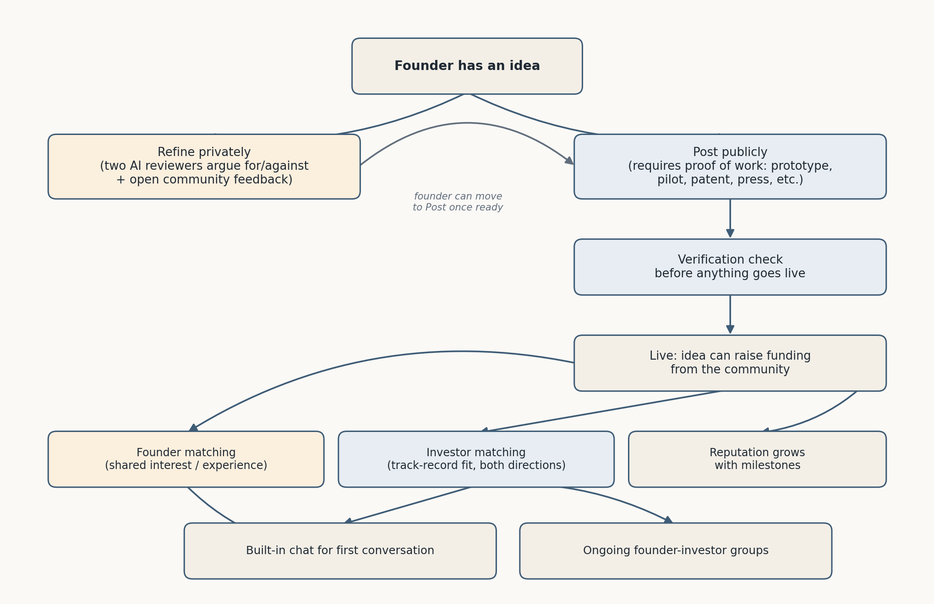
From idea to working relationship: two entry paths converge into a single verified, matched, and reputation-backed ecosystem.

Sources Referenced
CB Insights startup postmortem analysis · Gregory Shephard · Malay Gupta · Ashish Kulkarni · Violetta Bonenkamp · Wikipedia (Angel Investor) · DPIIT startup recognition data (FY26) · Y Combinator Co-Founder Matching community forum · Sam Altman, How to Start a Startup

