SEAMLESS APPOINTMENT BOOKING FOR HEALTH
A Full Stack Web Application Project Report
Submitted By:
Abhishek Rajbanshi – Frontend Developer -- 22MH1A0501
Sombabu Patel – Database Engineer -- 22MH1A0569
Donga Bhavya Sri – Backend Developer – 22MH1A0517
Gummandi Bhuvana Chaturya – Database Engineer – 22MH1A0519

Date: 20 February 2026

ABSTRACT
The Seamless Appointment Booking for Health system is a full-stack web application developed using the MERN stack (MongoDB, Express.js, React.js, Node.js). The system enables patients to book doctor appointments online, manage bookings, and maintain digital health records. Doctors can manage schedules and update consultation status, while administrators monitor platform operations. The application enhances healthcare accessibility, reduces manual scheduling conflicts, and provides a centralized secure appointment management system
1. INTRODUCTION
Healthcare institutions traditionally rely on manual appointment booking systems, leading to scheduling conflicts, long waiting times, and inefficient record management. This project introduces a digital appointment management system that enables real-time booking, secure authentication, and structured workflow management.

2. PROBLEM STATEMENT
Manual appointment systems cause delays, double bookings, poor record tracking, and inconvenience for patients. There is a need for a centralized, secure, and scalable online system to streamline doctor appointment booking.

3. OBJECTIVES
• Develop a real-time online appointment booking system.
• Provide role-based access (Patient, Doctor, Admin).
• Ensure secure authentication using JWT.
• Maintain structured database records.
• Reduce manual healthcare scheduling inefficiencies.

4. LITERATURE SURVEY
Existing healthcare management systems focus primarily on hospital-level ERP solutions. However, many small clinics lack affordable and scalable online booking platforms. Modern web technologies such as the MERN stack enable efficient development of scalable healthcare applications with real-time data handling.

5. SYSTEM ARCHITECTURE
Frontend: React.js (UI & State Management)
Backend: Node.js with Express.js (REST APIs)
Database: MongoDB (NoSQL Database)
Authentication: JWT-based Authentication
Security: Password hashing using bcrypt

6. MODULE DESCRIPTION

6.1 Patient Module
• Register/Login
• Search Doctors
• Book/Cancel/Reschedule Appointments
• View Appointment History

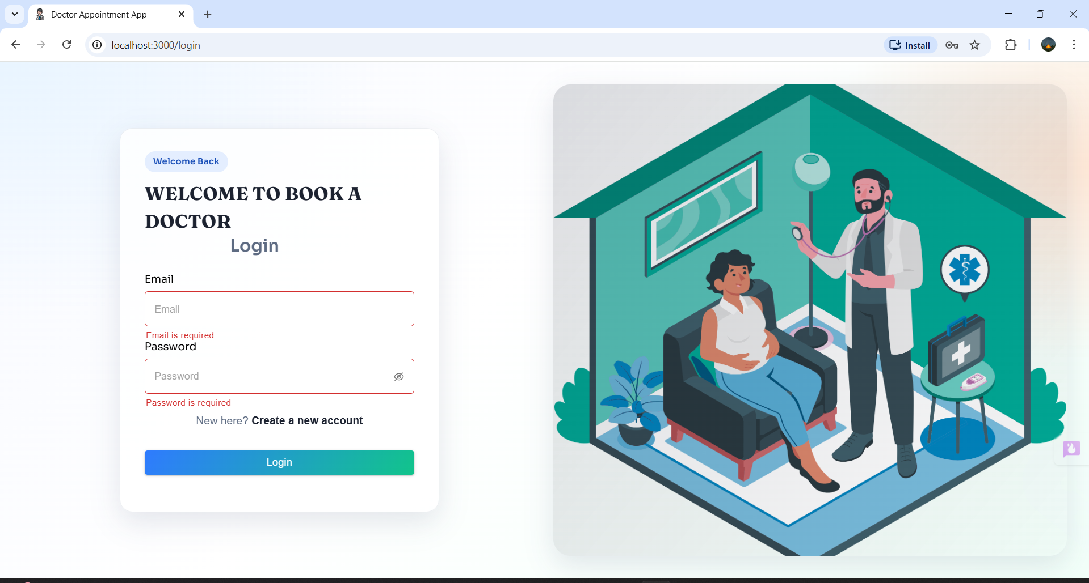

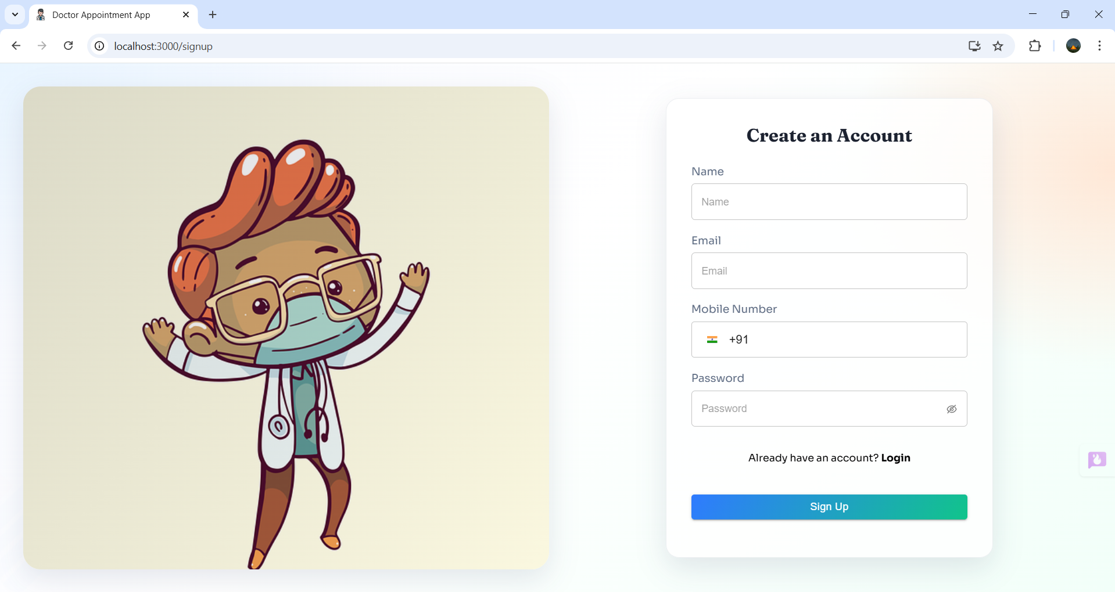

6.2 Doctor Module
• Manage Availability
• Confirm/Reject Appointments
• Update Consultation Status

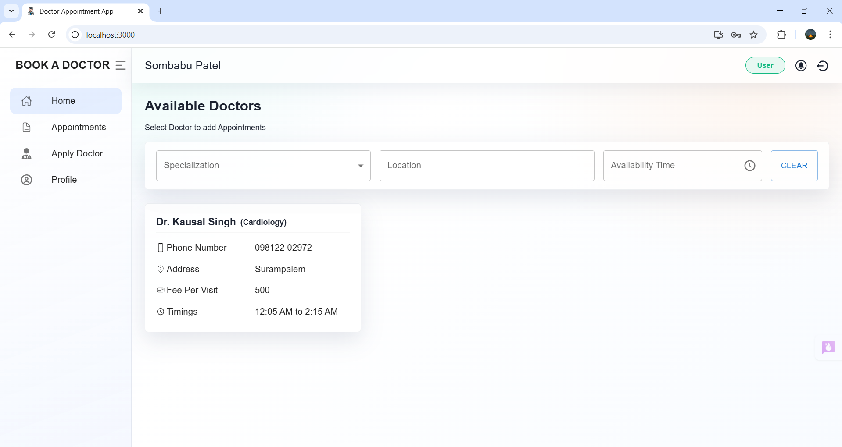

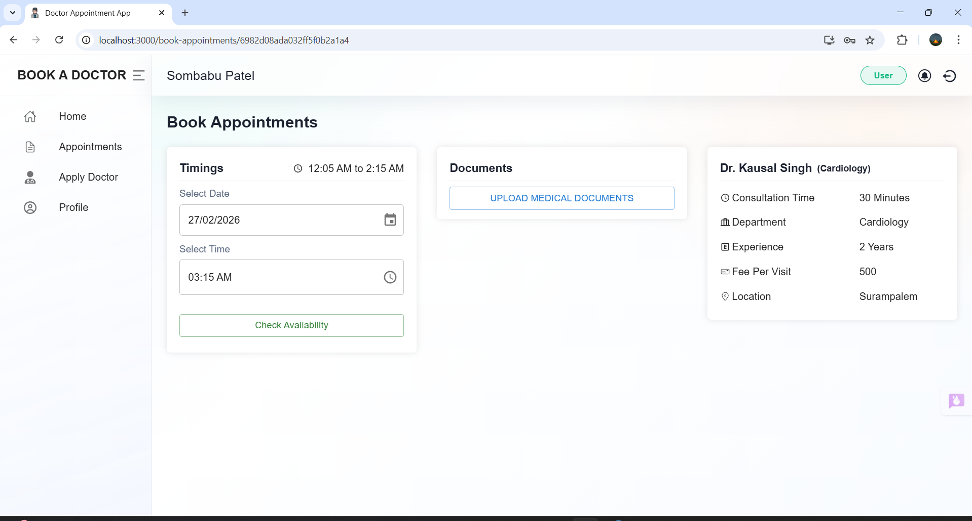

6.3 Admin Module
• Approve Doctor Registrations
• Manage Users
• Monitor Platform Operations

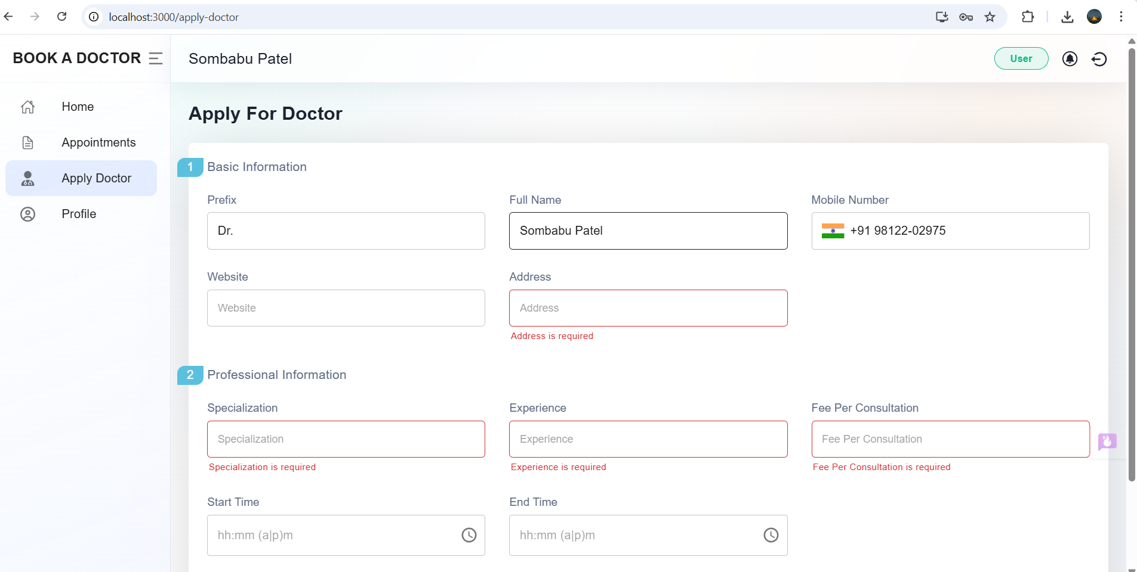

7. DATABASE DESIGN
Users Collection: name, email, password, role, specialization
Appointments Collection: patientId, doctorId, date, time, status
Doctors Collection: name, specialization, availability

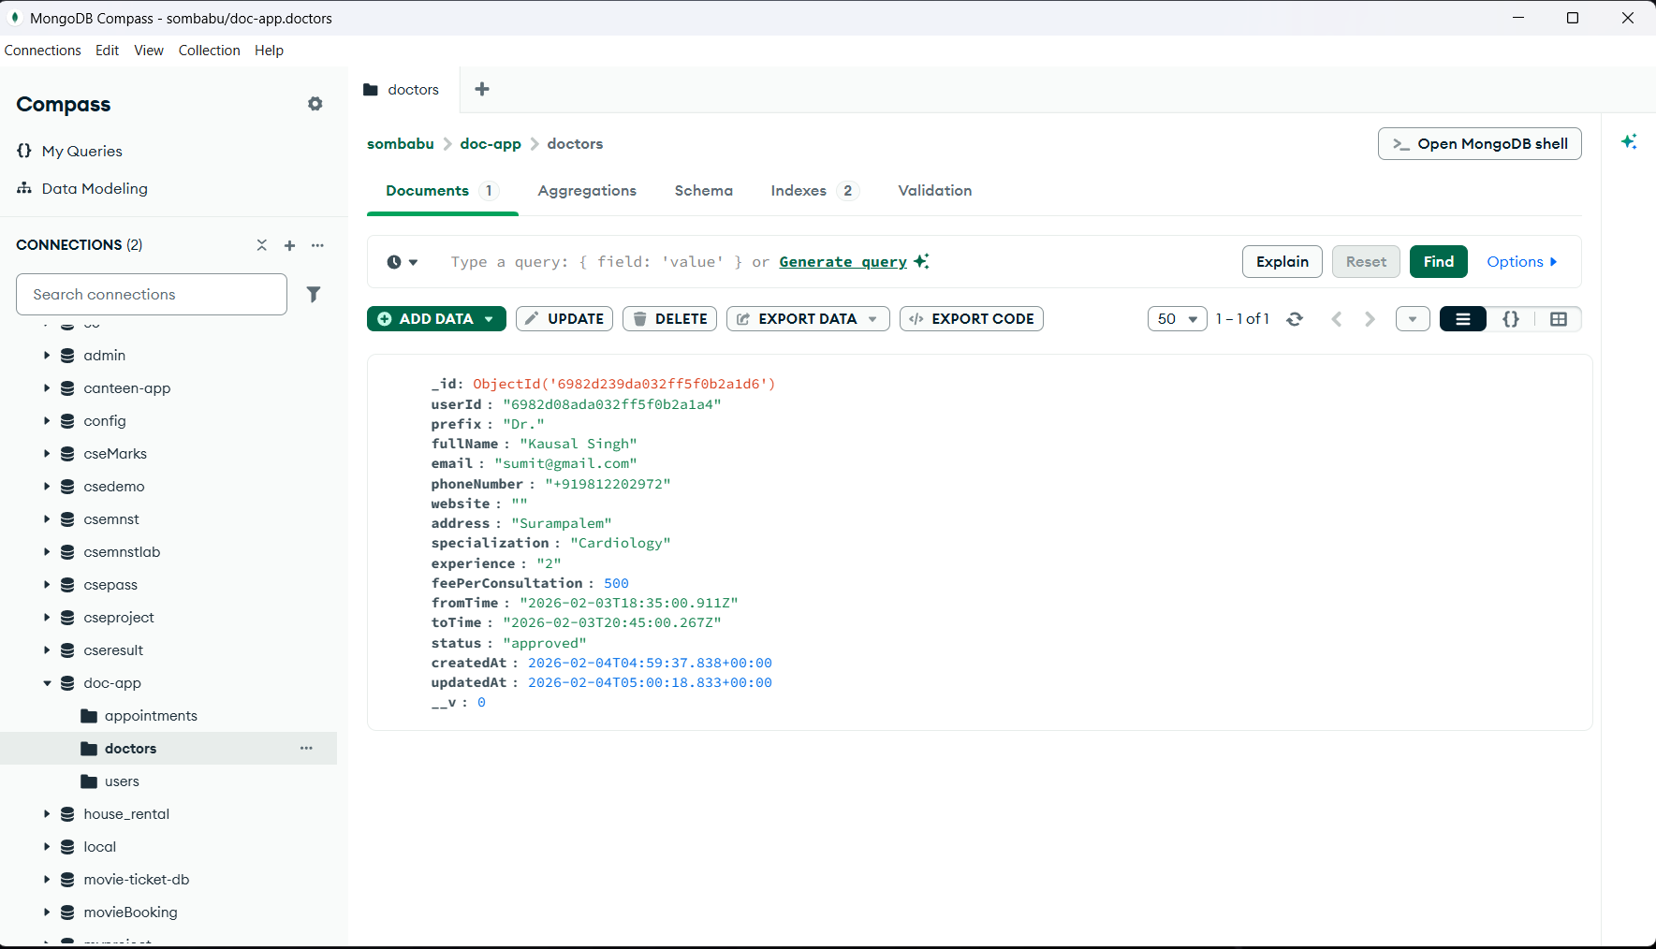

8. API DESIGN
POST /api/auth/register – Register new user
POST /api/auth/login – User login
GET /api/doctors – Fetch doctors
POST /api/appointments – Book appointment

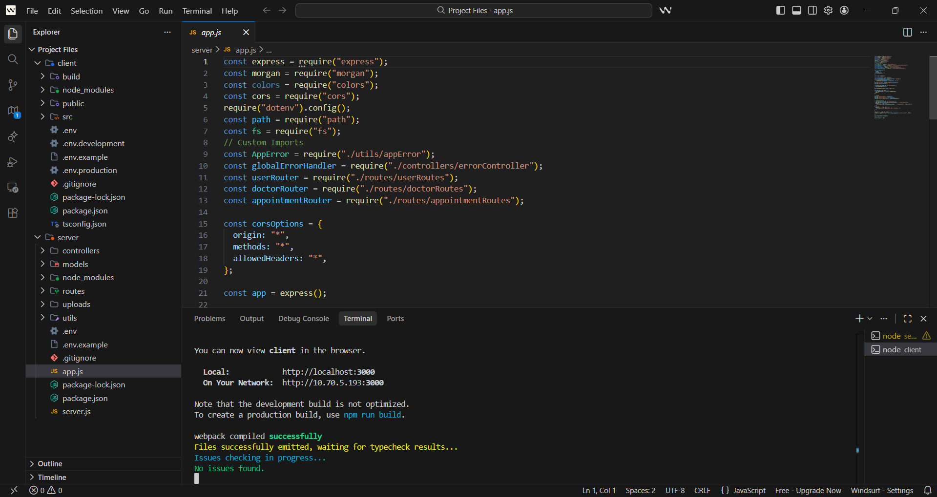

9. SECURITY IMPLEMENTATION
• Password hashing using bcrypt
• JWT token-based authentication
• Role-based access control
• Secure environment variable storage

10. TESTING
• API testing using Postman
• Manual UI testing
• Authentication validation testing

11. ADVANTAGES
• Reduces appointment conflicts
• Improves patient convenience
• Digital centralized records
• Scalable architecture

12. FUTURE ENHANCEMENTS
• Online payment integration
• Video consultation support
• SMS/Email notifications
• Mobile application development

13. CONCLUSION
The Seamless Appointment Booking for Health system successfully demonstrates the implementation of a scalable and secure healthcare appointment management platform. By integrating modern web technologies and structured database design, the project provides a practical solution for digital healthcare scheduling.

Link: https://github.com/Sombabu25/Seamless-Appointment-Booking-for-Health

