# Computer Science Applications

**Activity 3.6.3 Enhance Loops for Arrays**

Copy and paste screenshots and/or answer questions from the activity.

#6-8 Screenshot of code and output for steps 6-8

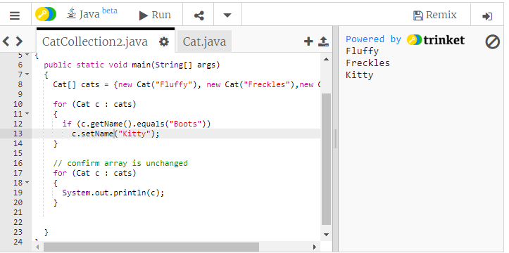

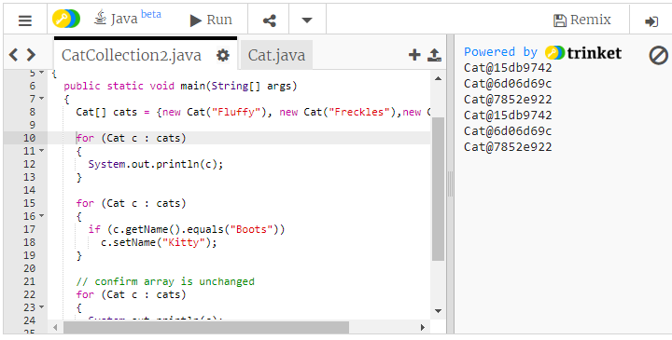

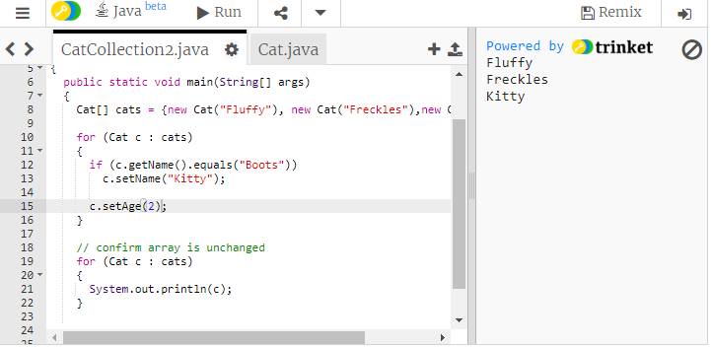

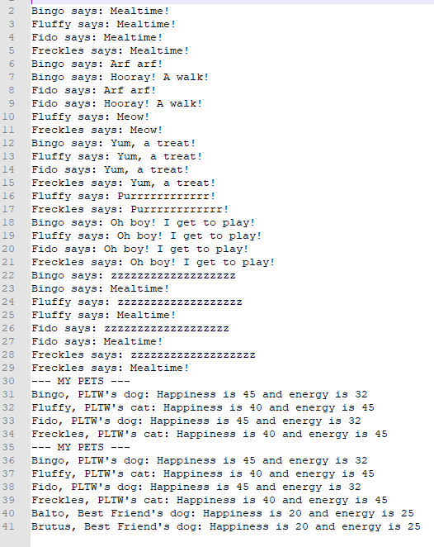

EXAMPLE OUTPUT

#12 It’s Your Turn: Screenshot of Code and Final Output

