# Computer Science Applications

# **Activity 3.6.4 Developing Algorithms Using Arrays**

Copy and paste screenshots and/or answer questions from the activity.

#2 Screenshot of code and output for #2—Computing the sum and average

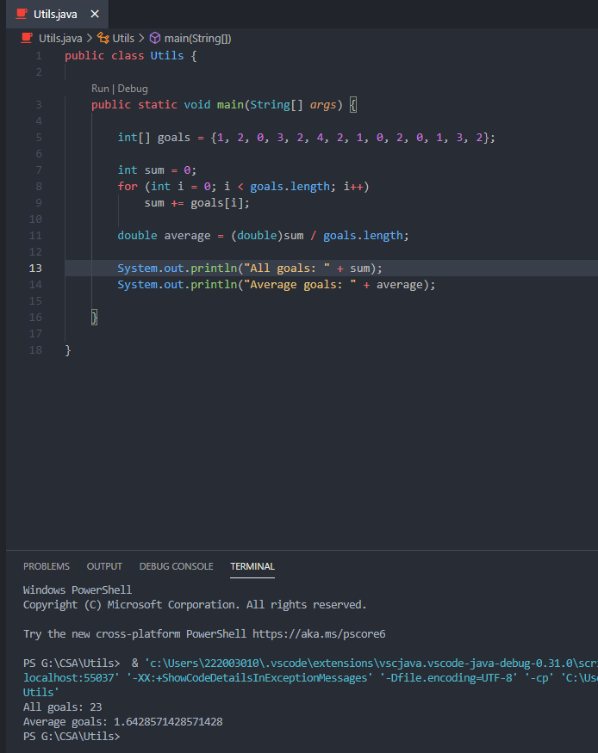

#5 Screenshot of code and output #5—Min and Max

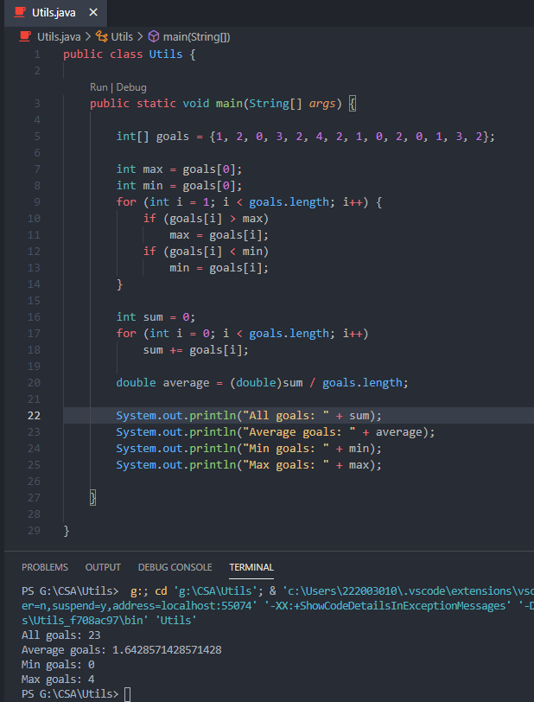

#11 Screenshot of code and output steps 6 through 11—Compute the Mode

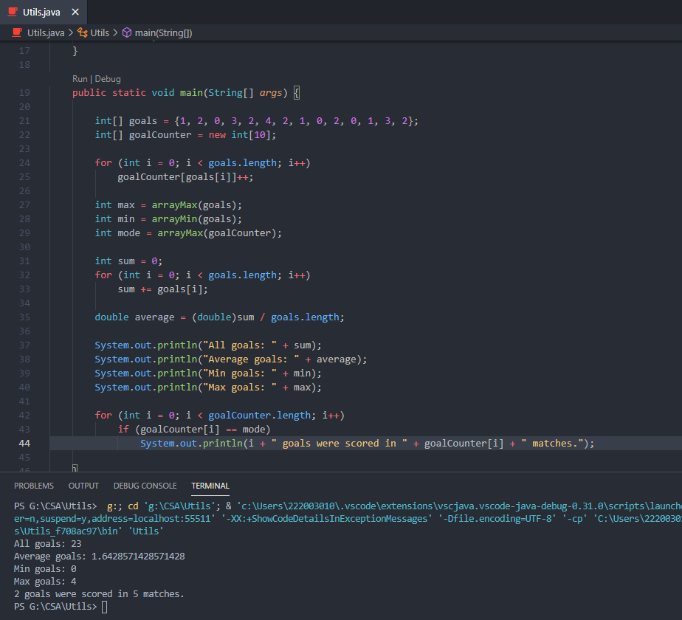

#17 Screenshot of code and output steps 12 through 17—Determine if any player is 18 years or older

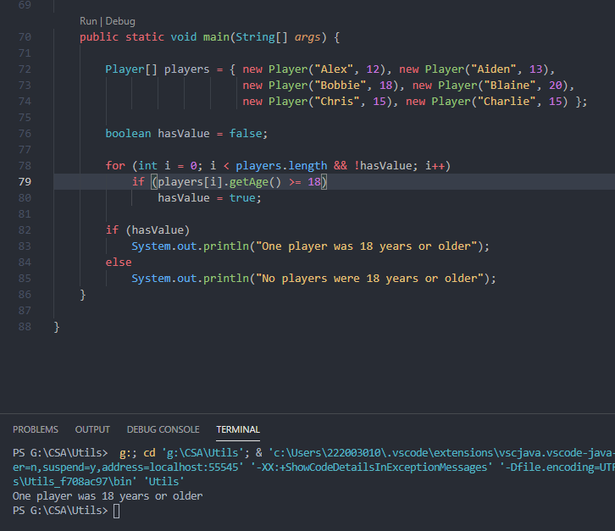

#20 Screenshot of code and output steps 18 through 20—Determine if all the players are under 21

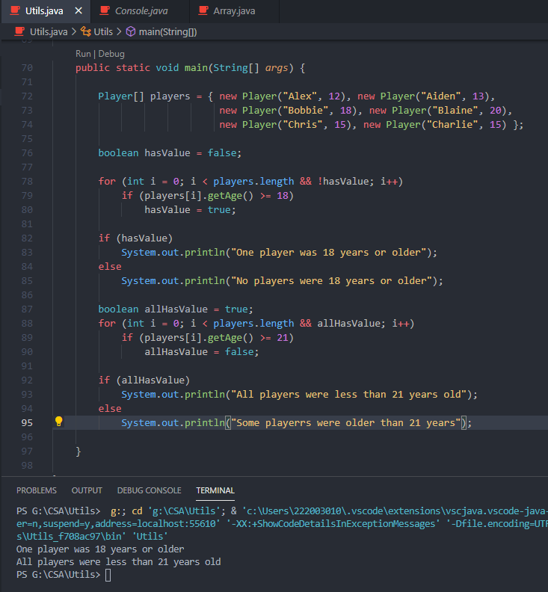

#23 Screenshot of code and output steps 21 through 23—Count the number of players that are 15 years old

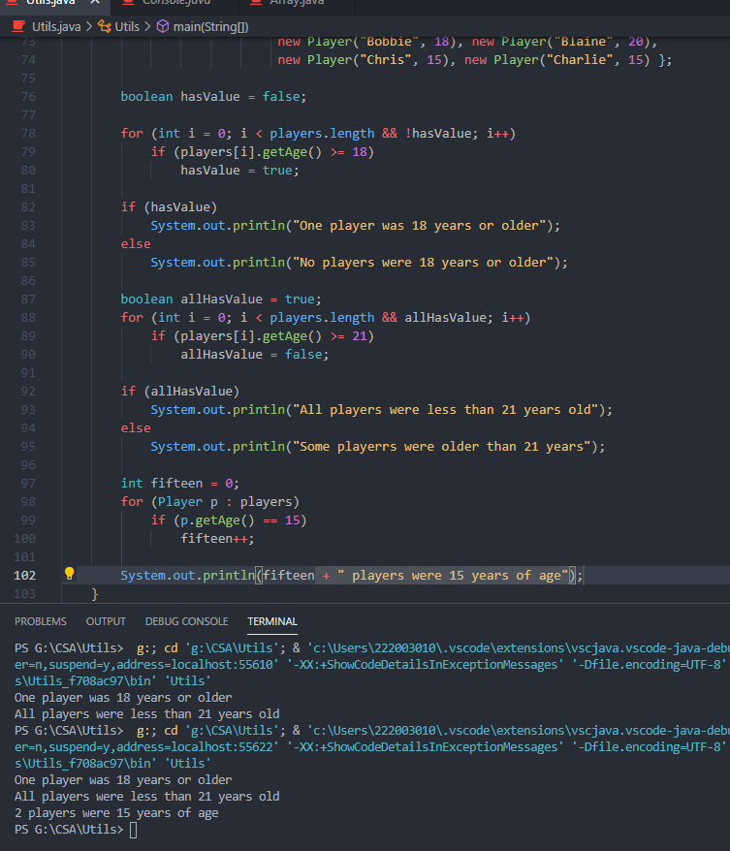

#24 Screenshot of code and output steps 24—Consecutive pairs of players are shown

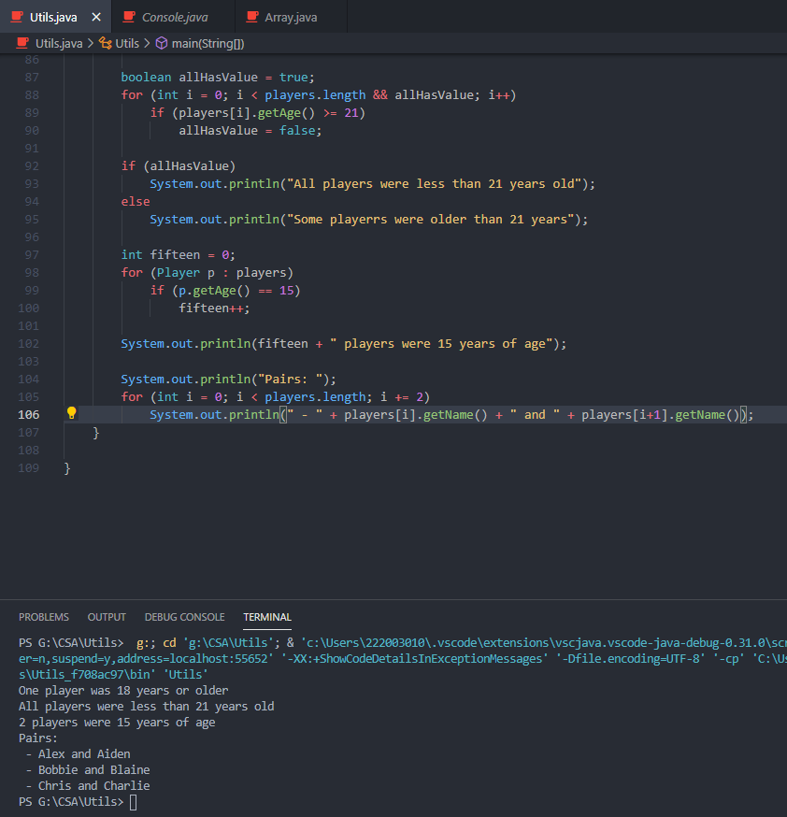

#25 Hand trace Array Traversal 1 to learn what it does and summarize its purpose.

* Each element is shifted to the right with F going to the beginning followed by A and so on.

#26 Hand trace Array Traversal 2 to learn what it does and summarize its purpose.

* Flips the array / turns it backwards.

#29-33 Screenshot of code and results for the “It’s Your Turn” section

