# Computer Science Applications

**Activity 3.7.1 and 3.7.2 Intro to ArrayLists and ArrayList Methods**

Copy and paste screenshots and/or answer questions from the activity.

**3.7.1**

#2 What do you think will happen if you add the following code right before the //display elements comment?

It will work because ArrayList uses the Object class if no generic class is provided

#4 Add the <E> to your ArrayList declaration/initialization, specifying the data type Integer. Refer to the annotated syntax or the ArrayListInit program above if necessary. Comment out the line that adds a String to the list using newList.add("name"). What do you think will happen?

Everything will work as ArrayList is store elements of type Integer and the primitive int’s being added will suffice

#5 Now uncomment the ("name") line. What do you think will happen?

The program will crash as type String is not assignable to type Integer

#9 Screenshot of code and output

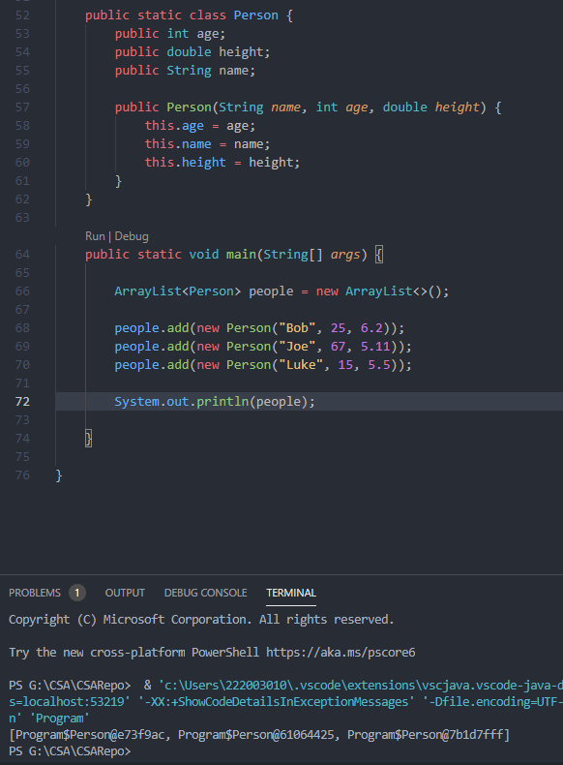

**3.7.2**

#9 Screenshot of code and output

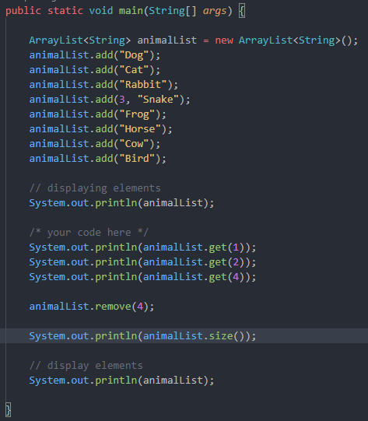

#11 Screenshot of code and output

