# Computer Science Applications

**Activity 3.7.3 Traversing ArrayLists**

Copy and paste screenshots and/or answer questions from the activity.

#3-15 Screenshot of code and output

3-4:

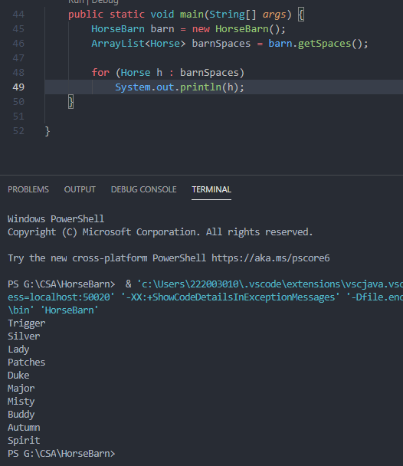

5-8:

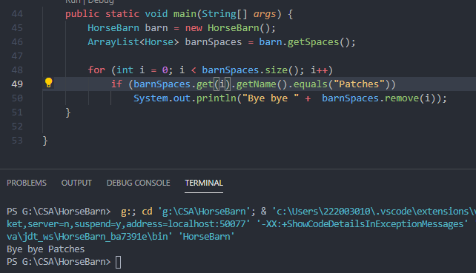

8-15:

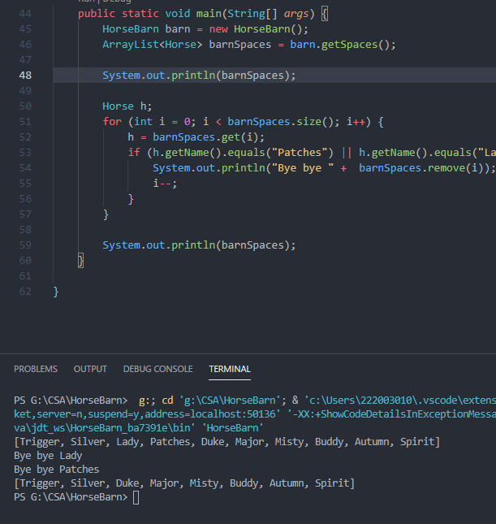

A Horsey FRQ—complete step 3…your solution should be hand-written, do not use Android Studio or another compiler. The goal of this FRQ is to practice for the AP Exam. At-home students should submit a picture of their hand-written solution.

