# Computer Science Applications

**Activity 3.7.6 Sorting**

Copy and paste screenshots and/or answer questions from the activity.

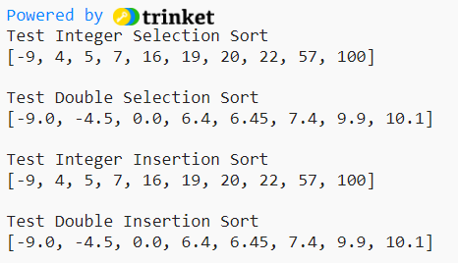#12-15 Screenshot of code and output

