# Computer Science Applications

**Activity 4.9.1 Creating Superclasses and Subclasses**

Copy and paste screenshots and/or answer questions from the activity.

#14 Go to [www.lucidchart.com](http://www.lucidchart.com) and create a UML diagram (copy and paste a screenshot of the finished diagram). Diagram an inheritance relationship beginning with the Pet UML diagram in Figure 2 above. Add relationships for Bird, Rodent, Canary, Parakeet, GuineaPig, and Gerbil. Note that some subclasses may also be superclasses.

* Define a method for the new superclass that has a common behavior for its subclasses.
* Define a method for the subclasses that do not belong in the superclasses. (Did you know that parakeets can learn to talk, gerbils can purr, and guinea pigs whistle?)

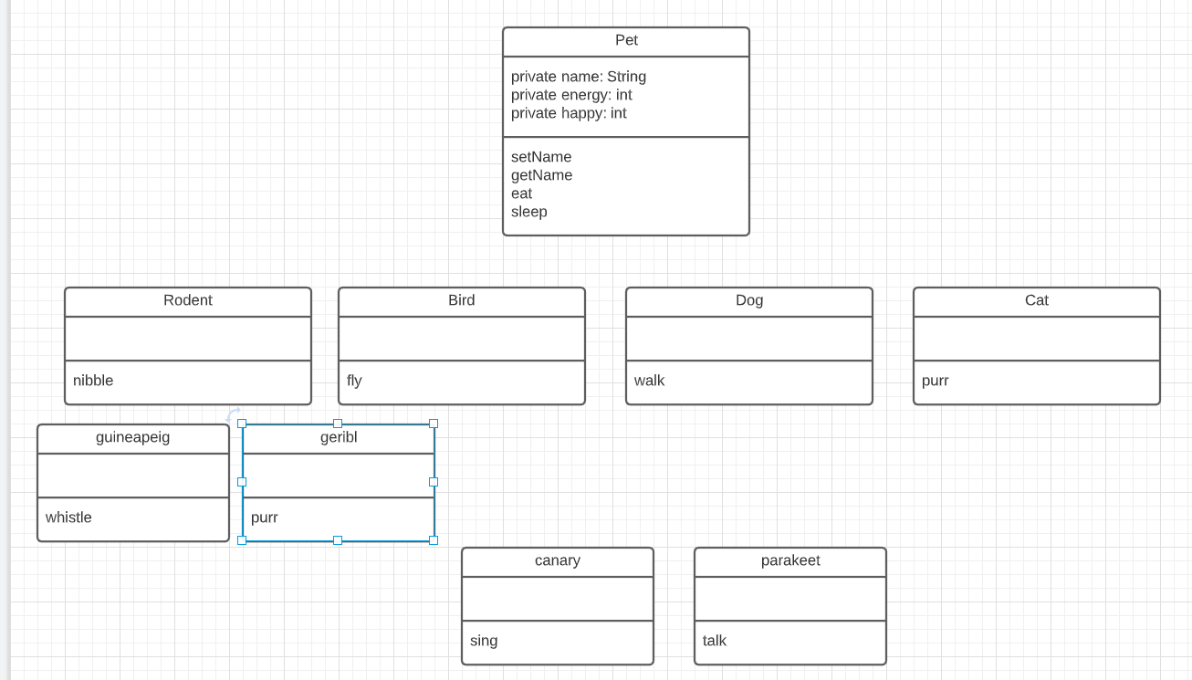

#16 Complete the program (downloaded from #5) to produce the following output. Screenshot your code and output.

