# Computer Science Applications

**Activity 4.9.2 Writing Constructors for Subclasses**

Copy and paste screenshots and/or answer questions from the activity.

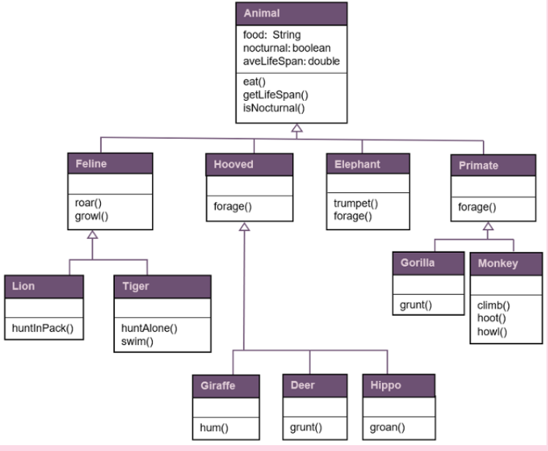

Using the UML diagram and the directions in Activity 4.9.2, complete steps 5-30 and screenshot the output of your program. Your output should be similar to the following example…

