# Computer Science Applications

## Activity 1.1.1: Primitive Types

Copy and paste screenshots and/or answer questions from the activity.

#15 Screenshot

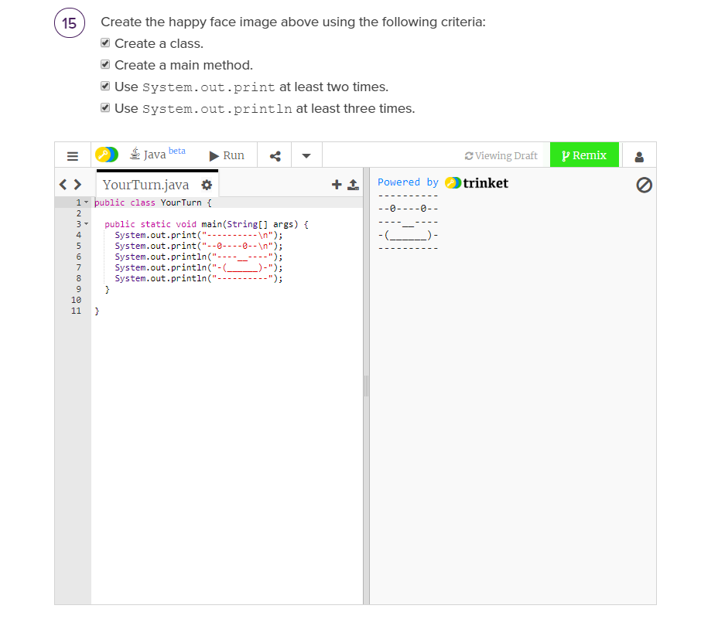

Conclusion:

1. What are some reasons you would want to use System.out.print instead of System.out.println?

You may use System.out.print if you simply want to print one thing and nothing else. Using System.out.println allows you to print multiple items without the use of escape characters at the end.

1. Why is Java such a widely used language for development?

Java is widely use for development because its somewhat versatile and can do a far bit of things, but mainly its similar to other language, if you know java it becomes a lot easier to learn other object orient language.