# Computer Science Applications

## Activity 1.1.2: Variables and Data Types

Copy and paste screenshots and/or answer questions from the activity.

#3 Screenshot

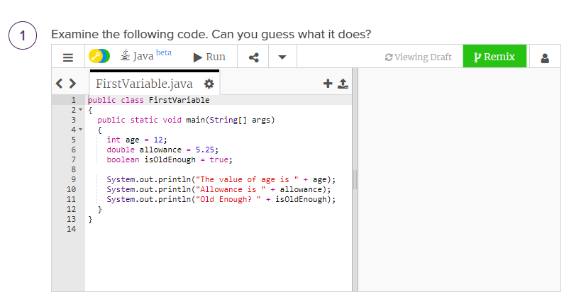

#4 Screenshot

