# Computer Science Applications

## Activity 1.1.3: Expressions and Assignment Statements

Copy and paste screenshots and/or answer questions from the activity.

#3

|  |  |  |  |
| --- | --- | --- | --- |
| **Symbol** | **Name** | **Usage** | **Examples** |
| * | Multiplication | Multiple two values together | x = x * 5  x *= 5 |
| / | Division | Divide two values | x = x /5  x /= 5 |
| % | Modulus | The remainder after dividing two values | x = x % 2  x %= 2 |
| + | Addition | Add two values | x = x + 5  x += 5 |
| - | Subtraction | Subtract two value | x = x - 5  x -= 5 |

#5 Screenshot of code and output that correctly calculates the average of two even integers

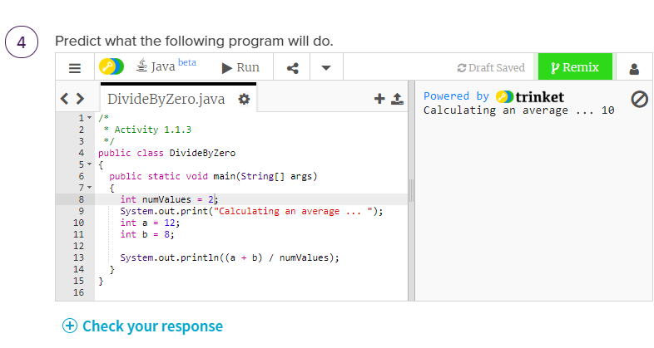

#10 Screenshot of code and output providing information about your weight on 3 different planets

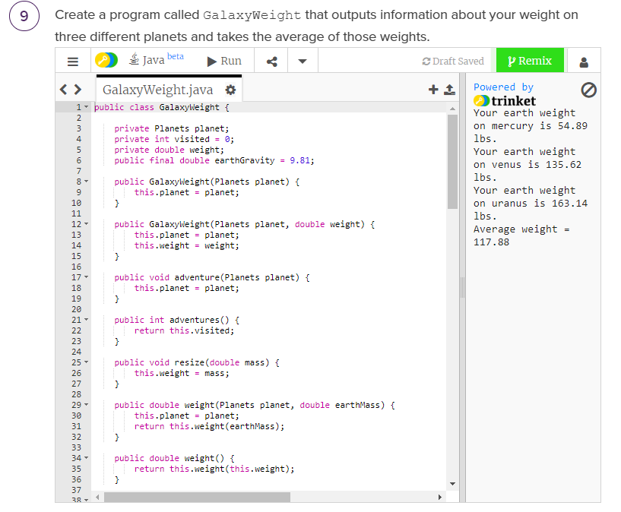

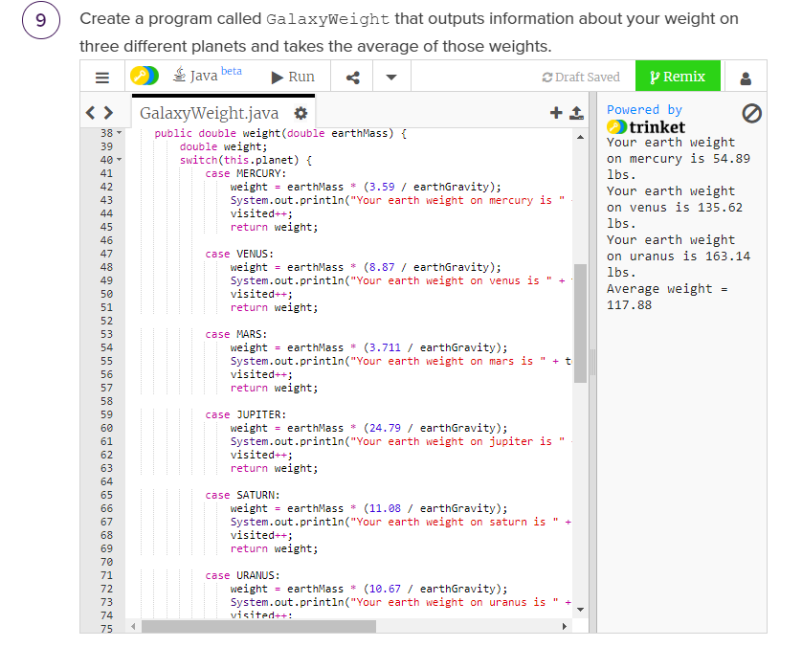

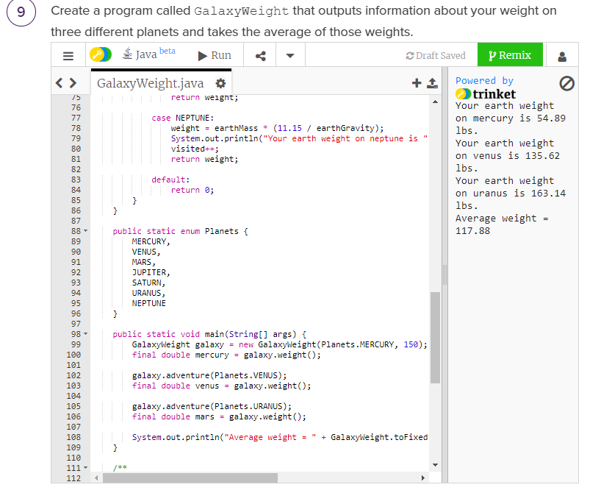

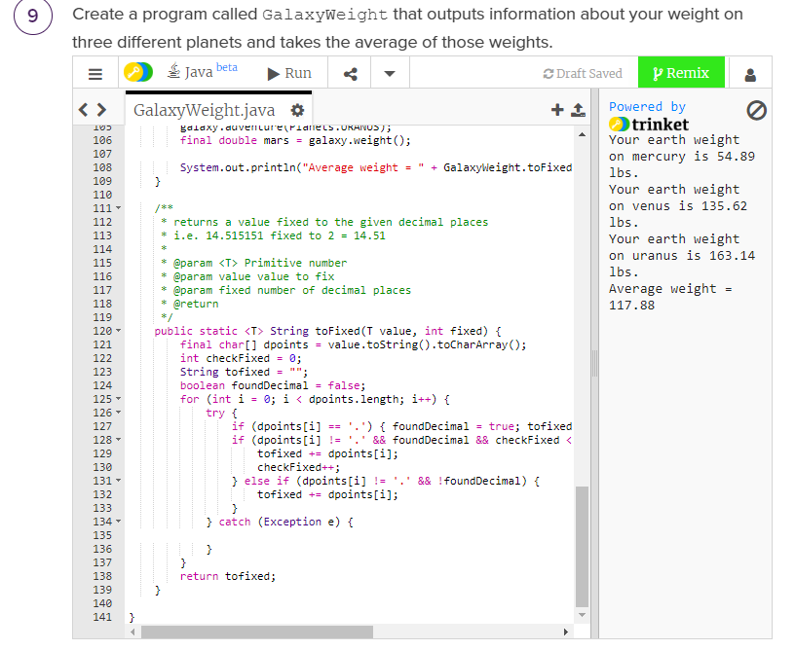

Conclusion:

1. Why is it important to know the type of variable?

It’s important to know the type of variable so you can perform specific operations on that type of variable