# Computer Science Applications

## Activity 1.2.2: Creating and Storing Objects

Copy and paste screenshots and/or answer questions from the activity.

Analyze the following constructor signatures.

|  |  |  |
| --- | --- | --- |
| **Signature** | **Class name** | **Parameter list** |
| Cake ( ) | Cake | None |
| Cookie (int size) | Cookie | Size |
| IceCream (double numScoops) | IceCream | numScoops |
| Pie (int slices, boolean warm) | Pie | Slices, warm |

#12 Screenshot of your overloaded constructors

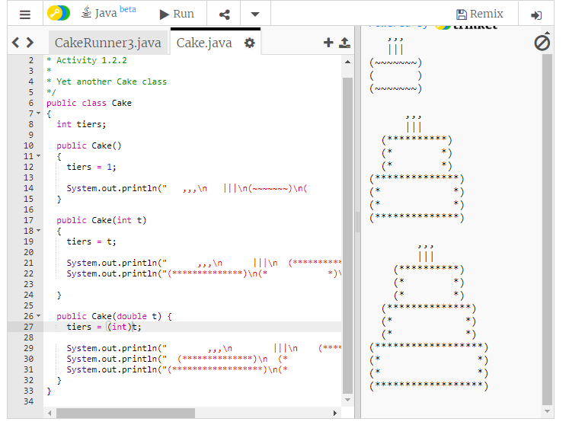

#14 Screenshot of added code and the program output

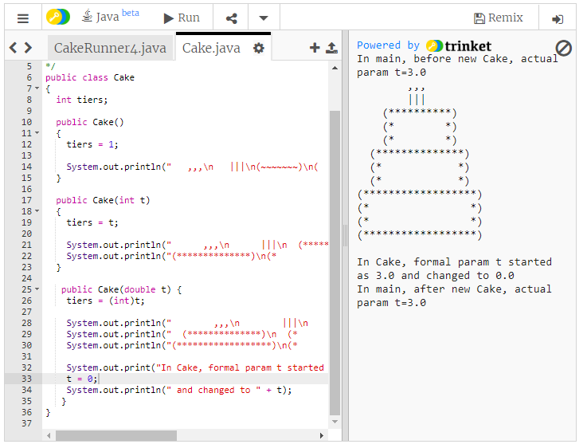

#21 Screenshot of code and program output

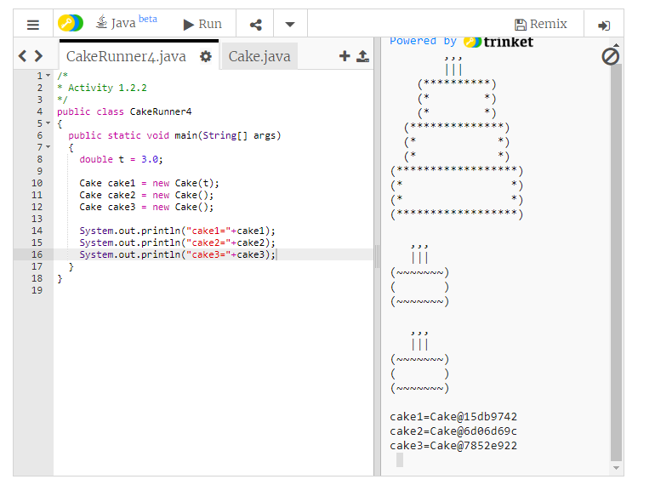

Conclusion ?’s

1. Write the code that would instantiate two objects with object references using the following class.

public static void main(String[] args) {

int pages = 100;

Book book1 = new Book();

Book book2 = new Book(pages);

}

1. Identify all formal and actual parameters.

Formal param p in book class constructor overload.

Actual param pages in main.