# Computer Science Applications

## Activity 1.2.5: Calling a Non-Void Method

Copy and paste screenshots and/or answer questions from the activity.

#2 Screenshot of code and output for part B

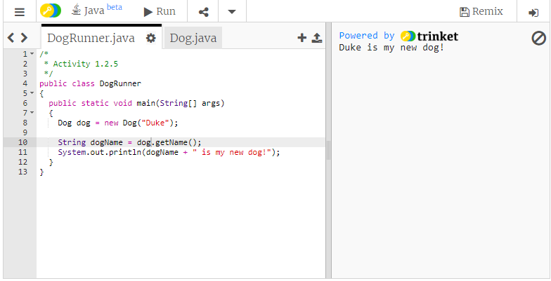

#5 Screenshot of code and output

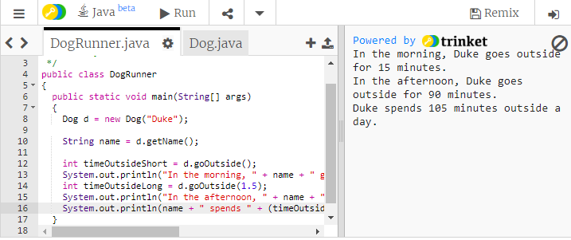

#8 Screenshot of code and output

