# Computer Science Applications

## Activity 1.2.6: String Objects: Concatenation, Literals, and More

Copy and paste screenshots and/or answer questions from the activity.

#12 Screenshot of code and output

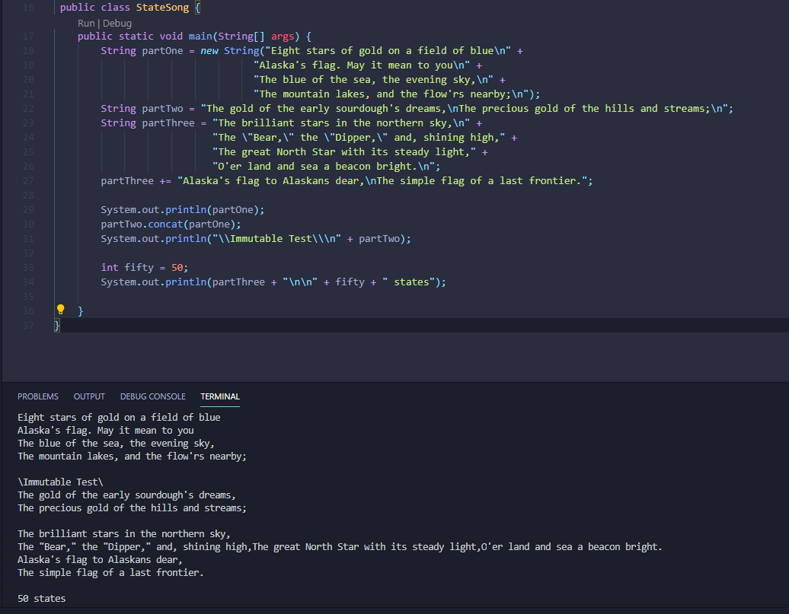

#14 Screenshot of code and output

?