# Computer Science Applications

## Activity 1.2.7: String Methods

Copy and paste screenshots and/or answer questions from the activity.

#10 Screenshot of code and output

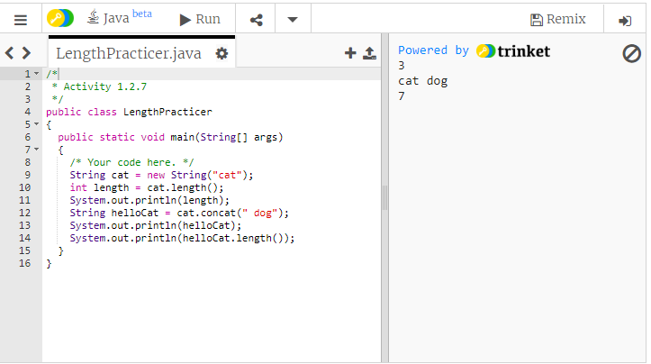

#13 Screenshot of code and output

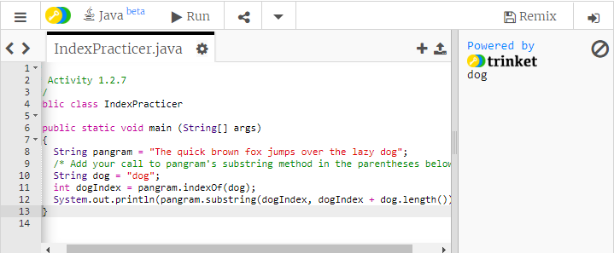

#14 Screenshot of code and output

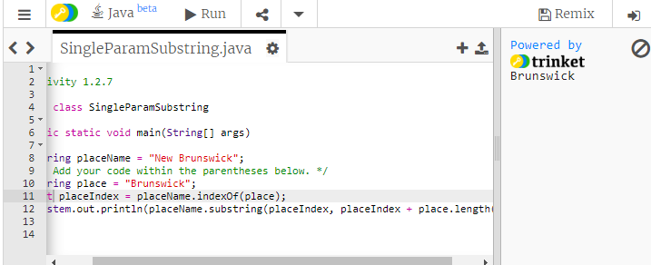

#16 Screenshot of code and output

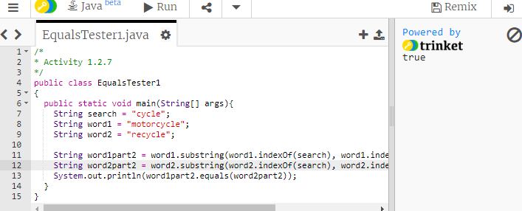

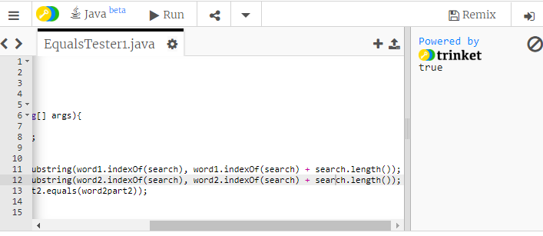

#20 Screenshot of code and output

