# Computer Science Applications

## Activity 1.2.8: Wrapper Classes: Integer and Double

Copy and paste screenshots and/or answer questions from the activity.

#3 Screenshot of code and output

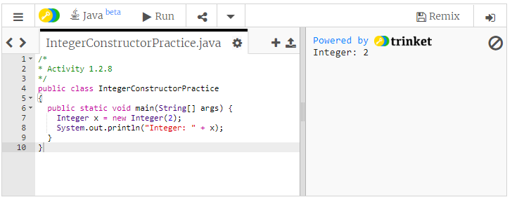

#4 Screenshot of code and output

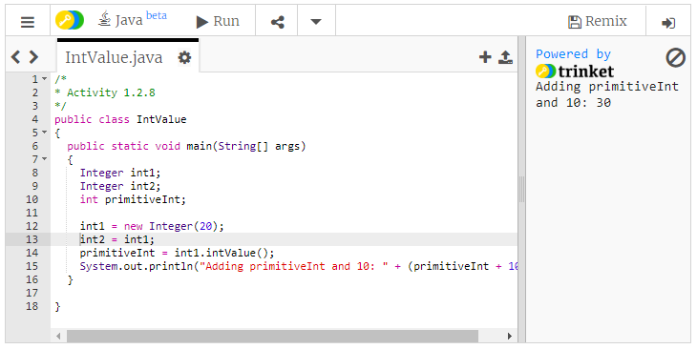

#5 a. Integer.MAX_VALUE

b. Integer.MIN_VALUE

#7 Screenshot of code and output

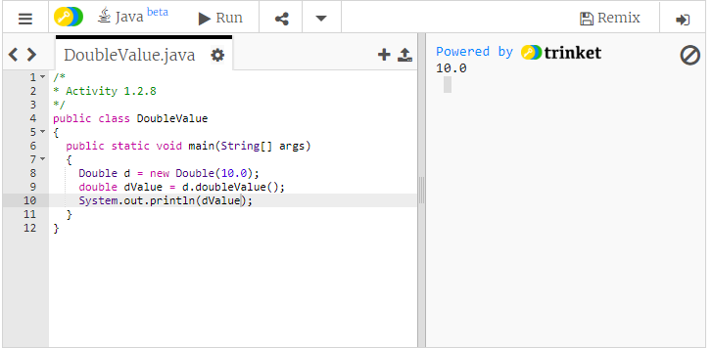

#14 Screenshot of code and output