# Computer Science Applications

## Activity 1.3.1: Boolean Expressions and Activity 1.3.2 If Statements and Control Flow

Copy and paste screenshots and/or answer questions from the activity.

1.3.1

#1 Use all of the relational operators to show a result of true. One example has been done for you.

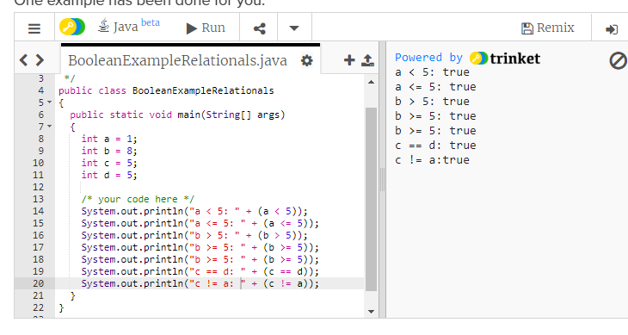

1.3.2

#5 and #6 Screenshot of code and output

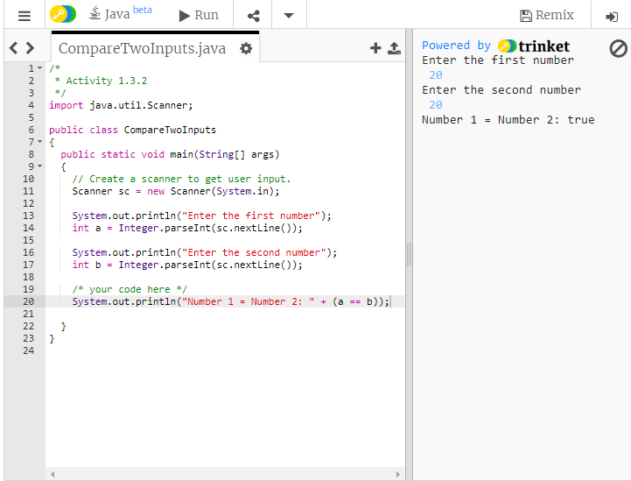

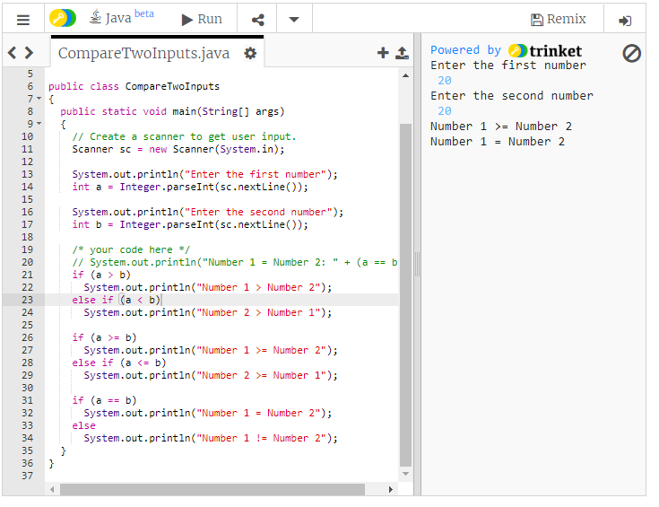

#11 Screenshot of code and output of the completed “It’s Your Turn” section

