# Computer Science Applications

## Activity 1.3.3: If/Else Statements

Copy and paste screenshots and/or answer questions from the activity.

#1 Screenshot of code and output: Take the following code and modify it so that if the numeric input is greater than 90, it prints “[Name] received an A.”

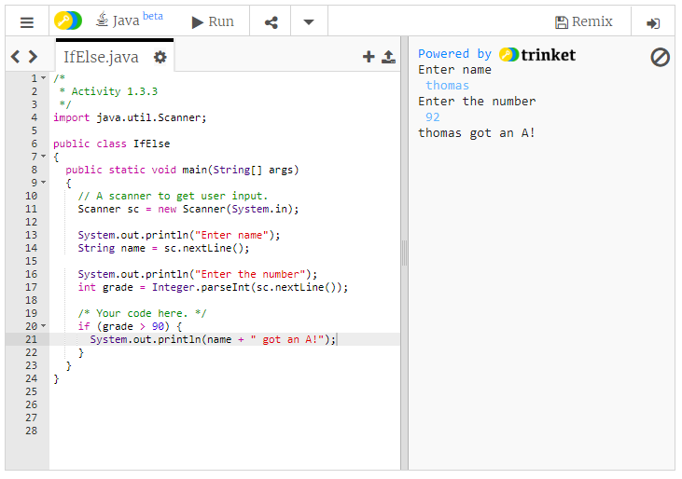

#2 Screenshot of code and output: Modify the IfElseTunnel program as instructed.

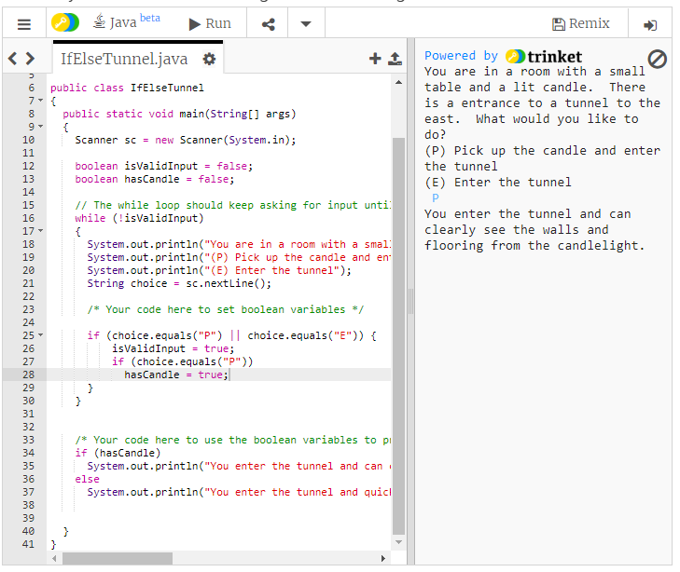

#5 Screenshot of code and output: Modify your program to include “near hits.”

