# Computer Science Applications

## Activity 1.3.5: Compound Boolean Expressions

Copy and paste screenshots and/or answer questions from the activity.

#3 - #7 and #10

|  |  |  |  |  |  |  |
| --- | --- | --- | --- | --- | --- | --- |
| **a > b** | **b > c** | **(a > b)**  **&&**  **(b > c)** | **(a > b)**  **||**  **(b > c)** | **!((a > b)**  **&&**  **(b > c))** |  |  |
| T | T | T | T | F |  |  |
| T | F | F | T | T |  |  |
| F | T | F | T | T |  |  |
| F | F | F | F | T |  |  |

In your own words…Explain the concept of short-circuit evaluation.

If the output of the expression can be determined without having to evaluate the whole thing.

#11 Screenshot of code and output.

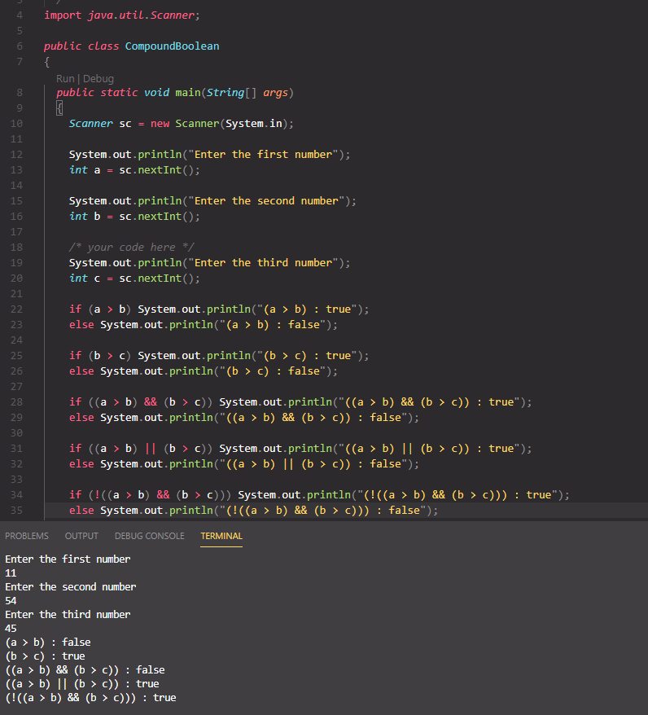

#13 Screenshot your original and your improved code for comparison.

