# Computer Science Applications

## Activity 1.3.6: Equivalent Boolean Expressions

Copy and paste screenshots and/or answer questions from the activity.

#1 and #2

|  |  |  |  |  |  |  |
| --- | --- | --- | --- | --- | --- | --- |
| **a** | **b** | **!a** | **!b** | **a && b** | **!(a && b)** | **!a || !b** |
| T | T | F | F | T | F | F |
| T | F | F | T | F | T | T |
| F | T | T | F | F | T | T |
| F | F | T | T | F | T | T |

|  |  |  |  |  |  |  |
| --- | --- | --- | --- | --- | --- | --- |
| **a** | **b** | **!a** | **!b** | **a || b** | **!(a || b)** | **!a && !b** |
| T | T | F | F | T | F | F |
| T | F | F | T | T | F | F |
| F | T | T | F | T | F | F |
| F | F | T | T | F | T | T |

#3 After completing both the truth tables, what do you notice about the columns whose expressions use De Morgan’s laws?

The columns that use De Morgan’s laws have the same output although the condition looks different.

#5 Screenshot of code and output.

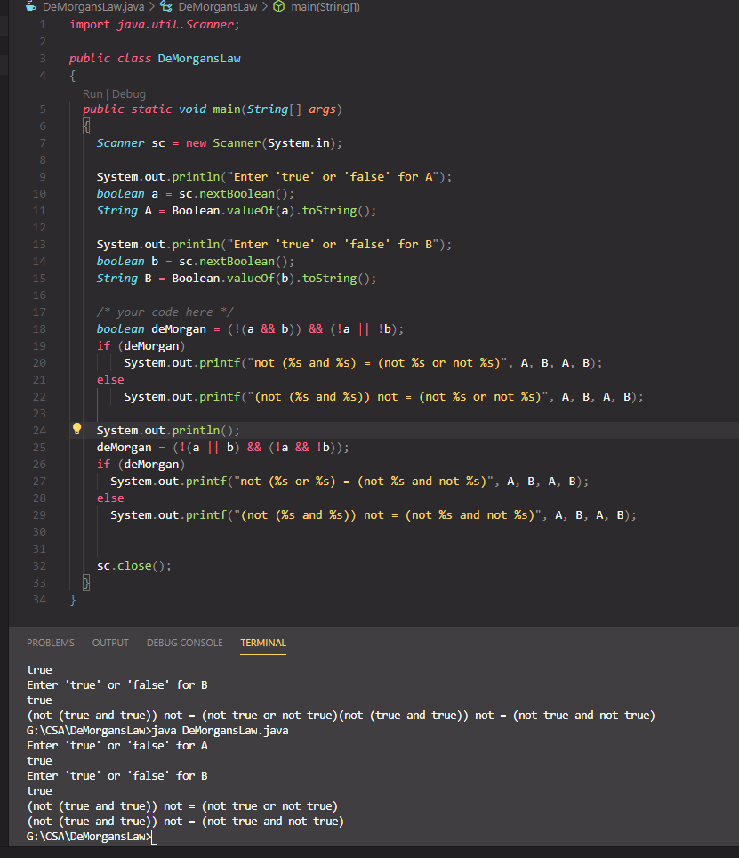

#6 Screenshot of code and output.

See #5