# Computer Science Applications

## Activity 1.3.7: Comparing Objects

Copy and paste screenshots and/or answer questions from the activity.

#13 Screenshot of code and output

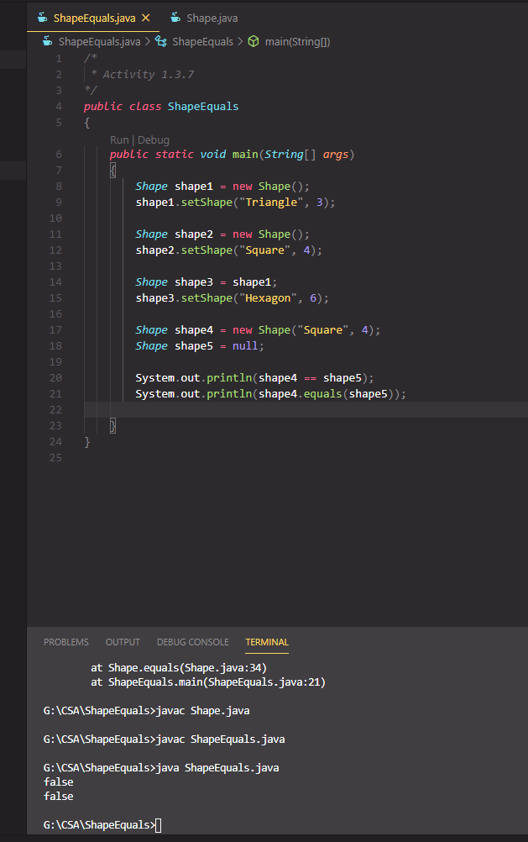

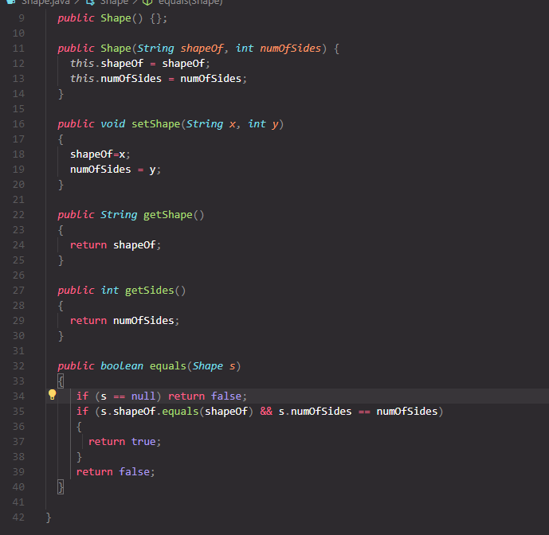

Conclusion

1. Explain the difference between = and == as they relate to objects.

= is used when assigning a value to an object and == is a relational operator to check if two objects are equal.