# Computer Science Applications

## Activity 2.4.1: While Loops

Copy and paste screenshots and/or answer questions from the activity.

#10 Screenshot of code and output

* Print integers starting at 10.
* Increase by one at each iteration.
* Conclude by printing 20.

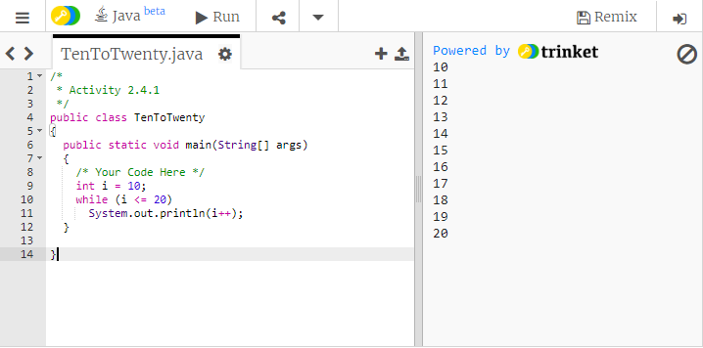

#18 Screenshot of your completed getStudent() method and an output demonstrating a working program

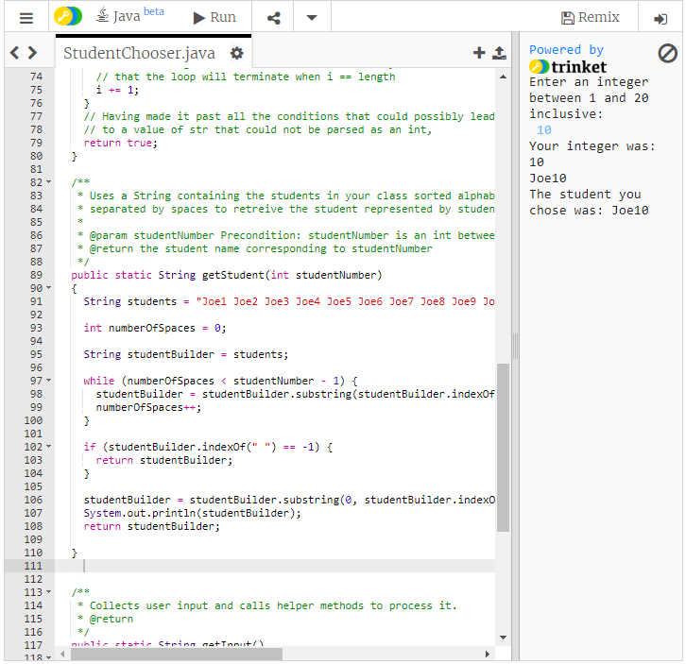

#20 Screenshot of your Divisibility class and an output demonstrating a working program

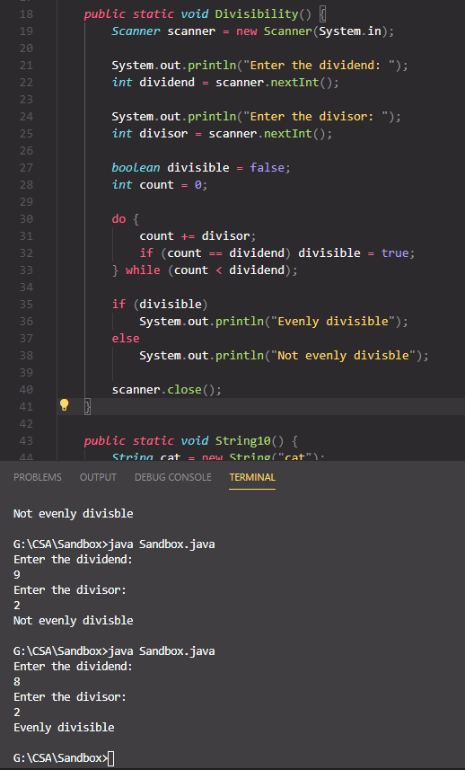

#21 Screenshot of your GetDigits class and an output demonstrating a working program

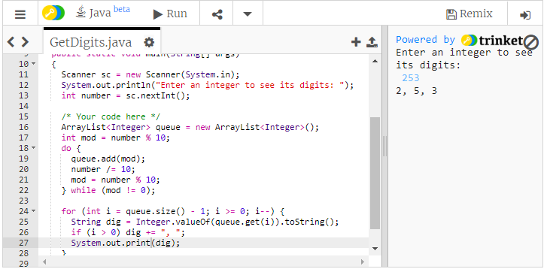

#22 Screenshot of your Pattern class and an output demonstrating a working program

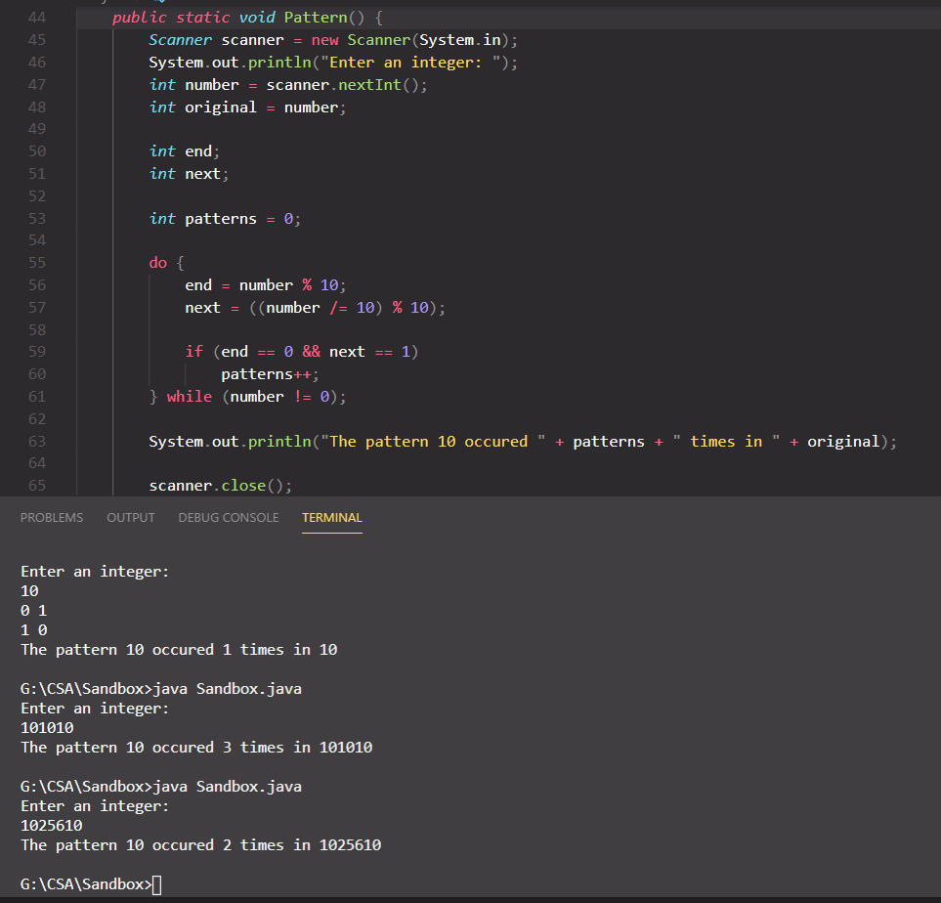

#23 Screenshot of your MinAndMax class and an output demonstrating a working program

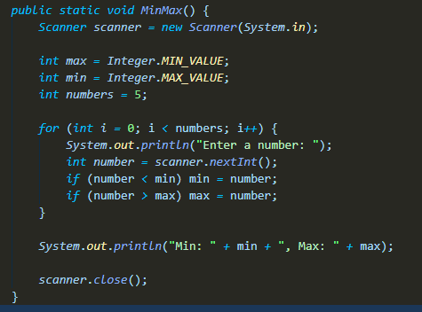

#24 Screenshot of your VS Code and an output demonstrating a working program…example output provided…

