# Computer Science Applications

## Activity 2.4.2: For Loops

Copy and paste screenshots and/or answer questions from the activity.

#3 Copy the body of each program’s main method side by side. Circle, connect with a line, and label each of the following:

1. The initialization of i in the while loop program and the initialization of i in the for loop program
2. The condition in the while loop and the condition in the for loop
3. The increment in the while loop and the increment in the for loop

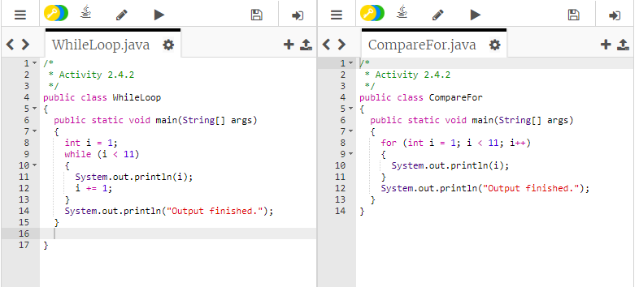

#8 The three parts in a for loop header are the _initialization_, the _boolean expression_, and the _increment or decrement_. The increment statement can also be a decrement statement.

#15 What is the code segment that prevents the off-by-one error in MonthChooser2 and how does it prevent it?

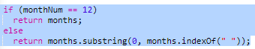

If the month is 12 we know its December and all the other months have been removed from the string so we can just return the months string. Otherwise we just return the month.

#16 Screenshot of the modified while loop and output of the program

