# Computer Science Applications

## Activity 2.4.3: Developing Algorithms Using Strings

Copy and paste screenshots and/or answer questions from the activity.

#7 Create a program in VS Code called RemoveEveryOther.java using the starter code below. Write an algorithm to create a String with every other character from a given String. Provide a screenshot of your code and the output.

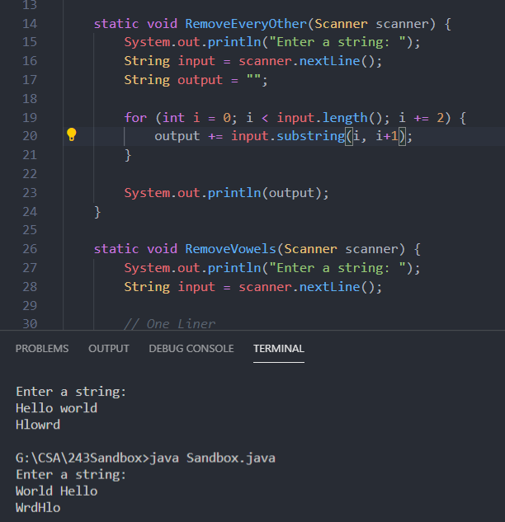

#8 Create a program in VS Code called RemoveVowels.java using the starter code below. Get an input String from the user and create an algorithm that removes all vowels from it. Provide a screenshot of your code and the output.

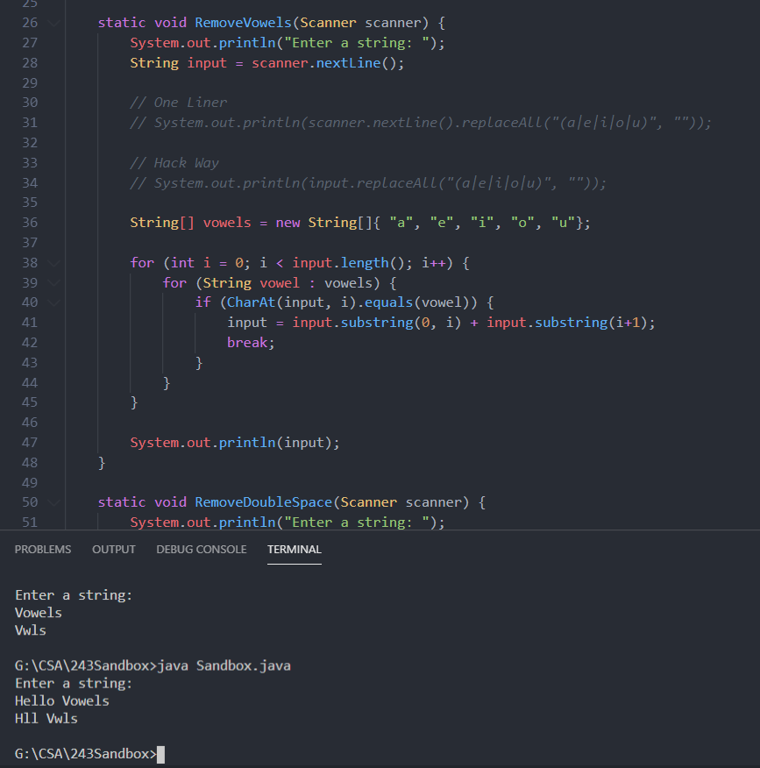

#9 Create a program in VS Code called RemoveDoubleSpace.java using the starter code below. Get an input String from the user and create an algorithm that replaces all instances of two consecutive spaces with a single space. Provide a screenshot of your code and the output.

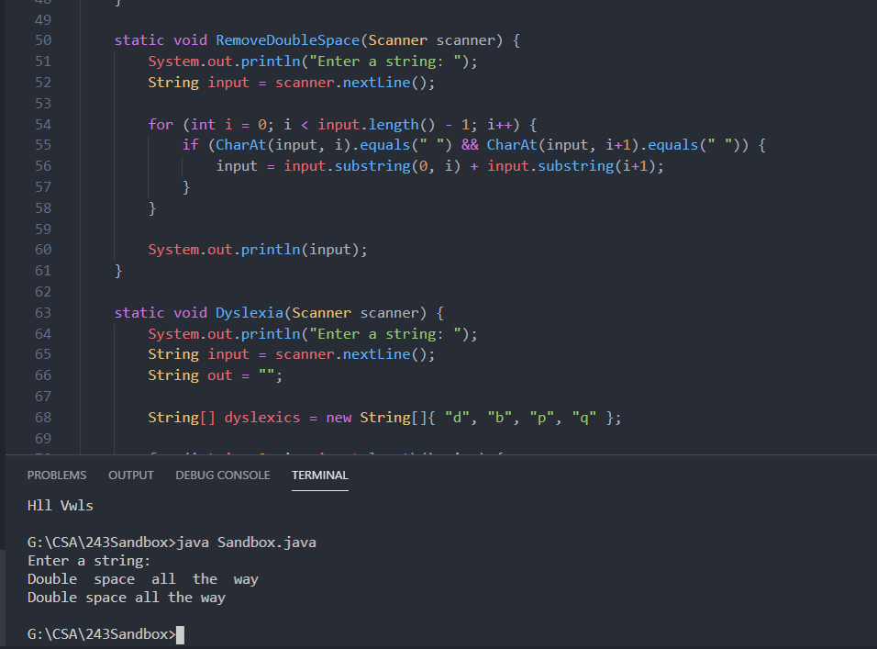

#10 Create a program in VS Code called Dyslexia.java using the starter code below. Get an input String from the user and create an algorithm that replaces each d, b, p, and q with a random d, b, p, or q. Use the Math class to help you achieve randomness. Provide a screenshot of your code and the output.

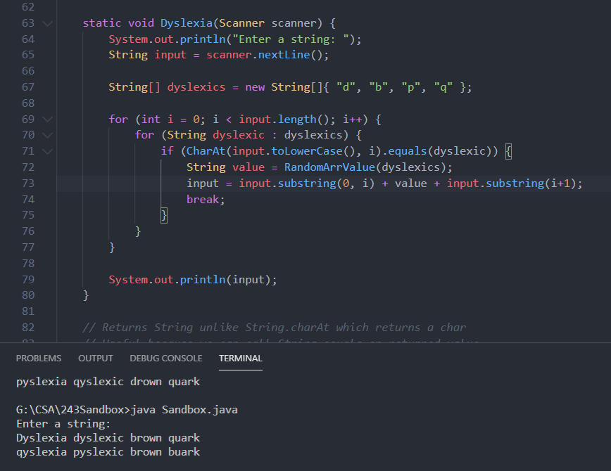

#11 Create a program in VS Code called DuplicateChars.java using the starter code below. Get an input String from the user and create an algorithm that prints all duplicate characters. For example, the String aabbc would produce aabb as output. Provide a screenshot of your code and the output.

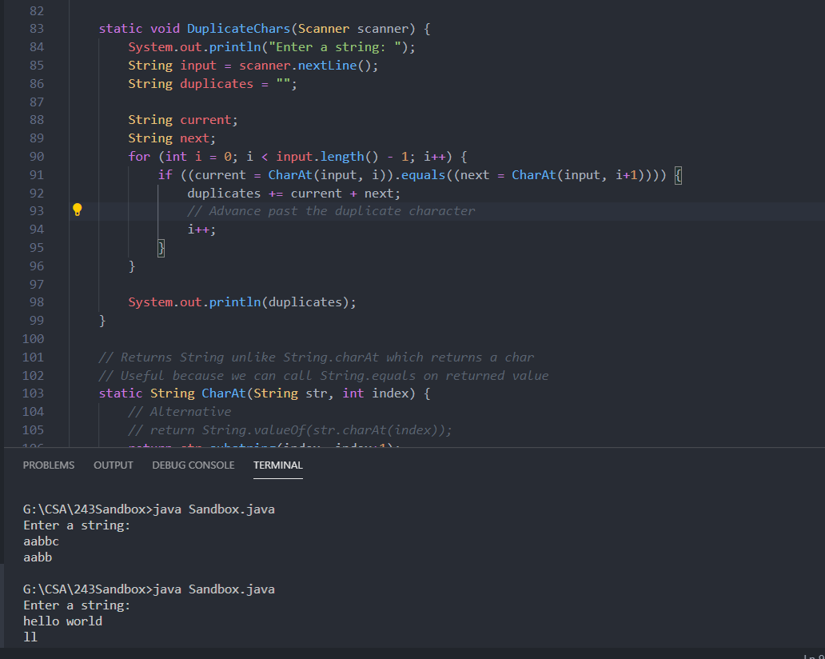

#12 Create a program in VS Code called Anagram.java using the starter code below. Get two input Strings from the user and create an algorithm that determines if they are anagrams. You may assume the user does not use any punctuation or capital letters. You need to account for spaces between words. Provide a screenshot of your code and the output.

