# Computer Science Applications

## Activity 2.4.4: Nested Iteration

Copy and paste screenshots and/or answer questions from the activity.

#4 Use the code space below to modify the program to use a while loop for the outer loop and a for loop for the inner loop.

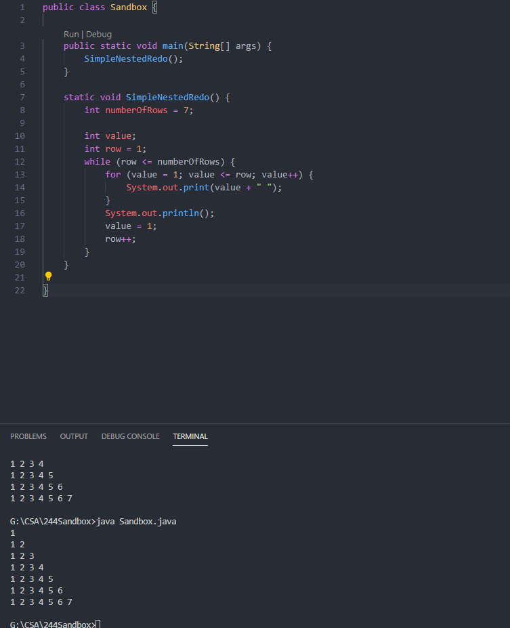

#5 Modify the original program code below so it prints the sequence backwards. For example, all seven columns first, then six, then five, etc. The original code is provided here for your convenience

. 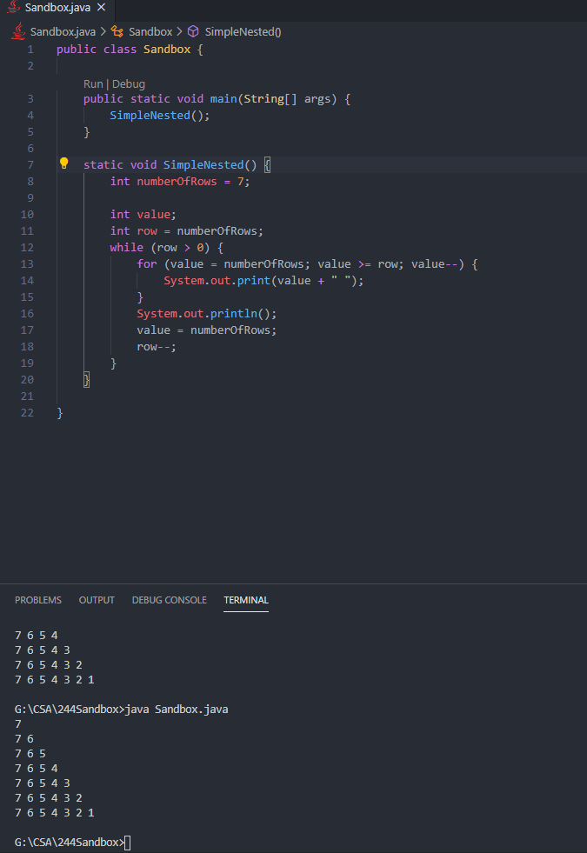

#9 Write a new version of the Palindrome program below to use a while loop for the outer loop and a for loop for the inner loop.

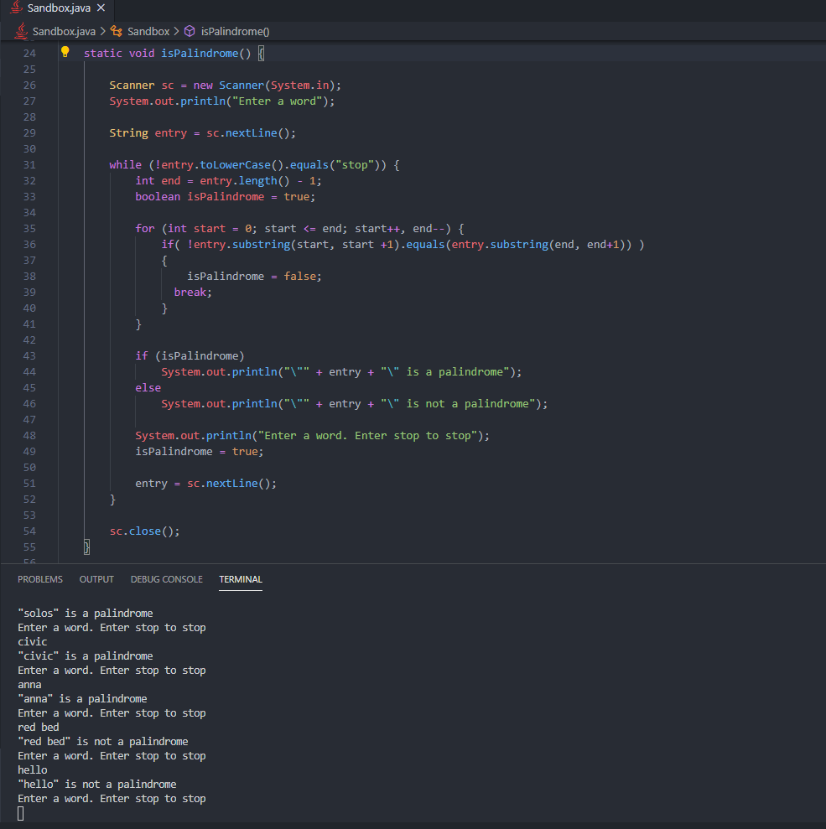

#10 Create LetterFrequencies in VS Code using the provided code below and complete it according to the requirements above.

