# Computer Science Applications

## Activity 2.5.1: Anatomy of a Class

Copy and paste screenshots and/or answer questions from the activity.

Read through all of Activity 2.5.1 before beginning.

The UML diagram for the PhraseSolver class is completed for you…

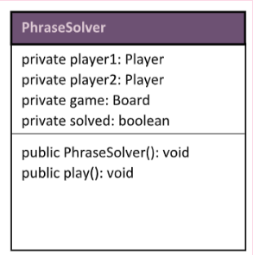

You need to complete the following UML Diagrams…

|  |
| --- |
| **Player** |
| private points: int  private name: string |
| public Player(): void  public givePoints(int amount): void  public getPoints(): int  public getName(): string  public setName(string name): void |

|  |
| --- |
| **Board** |
| private phrase: string  private solved: Boolean  private turn: int  private usedLetters: string |
| public Board(): void |