# Computer Science Applications

## Activity 2.5.2: Constructors

Copy and paste screenshots and/or answer questions from the activity.

#8 Screenshot: Add code in each constructor to set the initial instance state of all variables in each of the three classes.

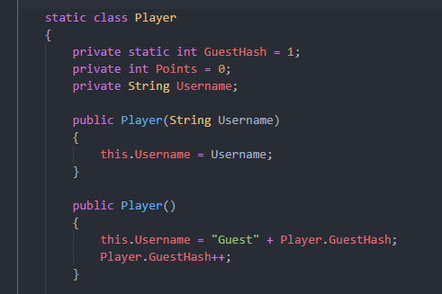

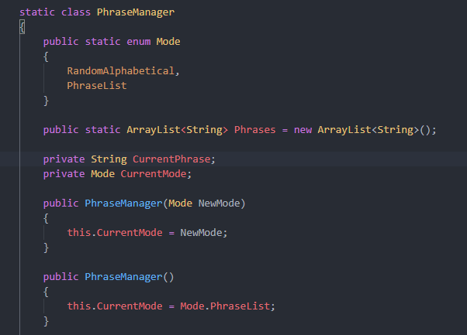

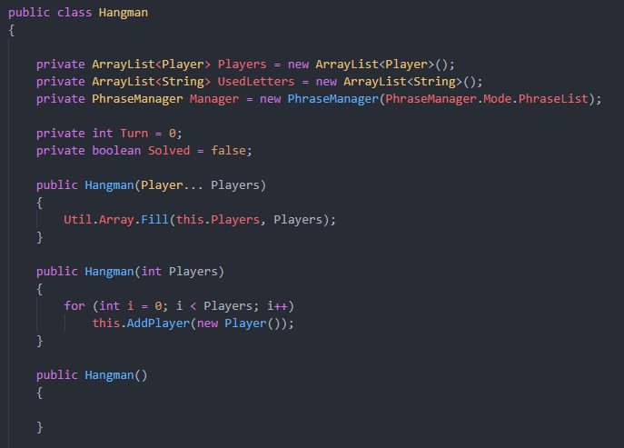

#9 Screenshot: In the Player class, add code to the constructor to prompt the user to input the player’s name and save that to the instance variable. In the constructor, print a message welcoming the player by name to the game.

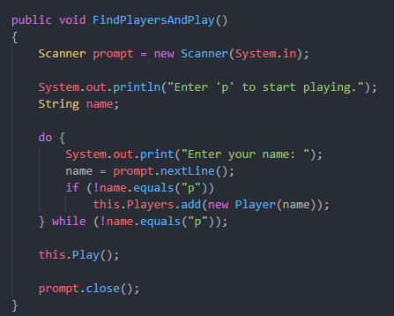

#12 Screenshot of the finished constructor from 10-12



#14 Screenshot of the Board class after 14 is complete

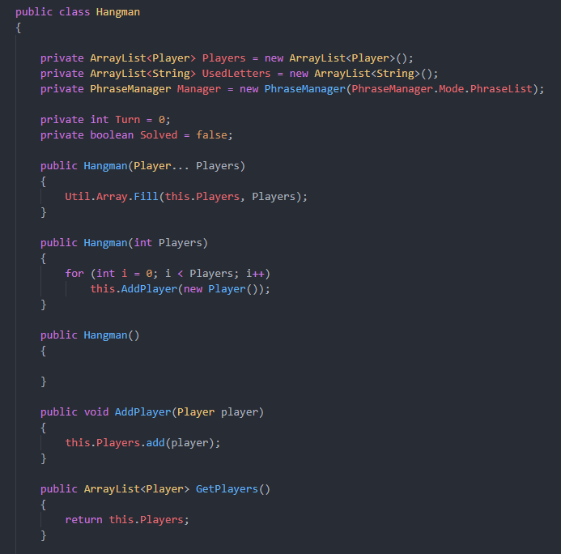

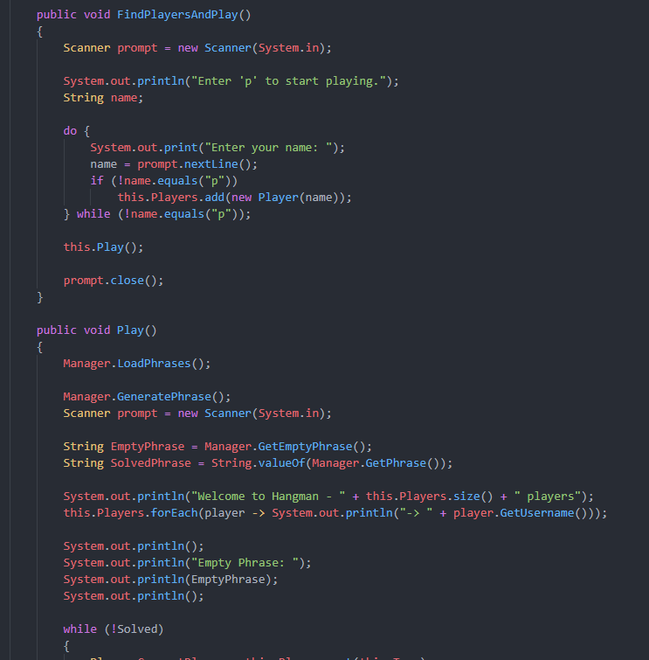

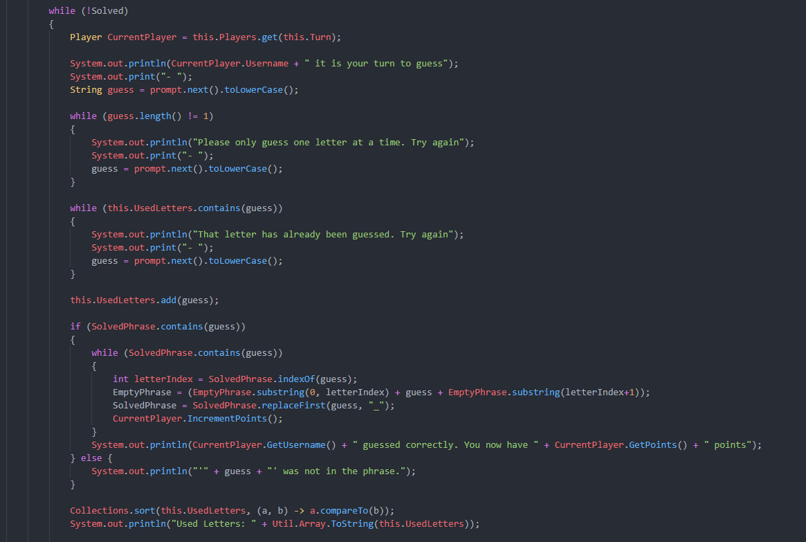

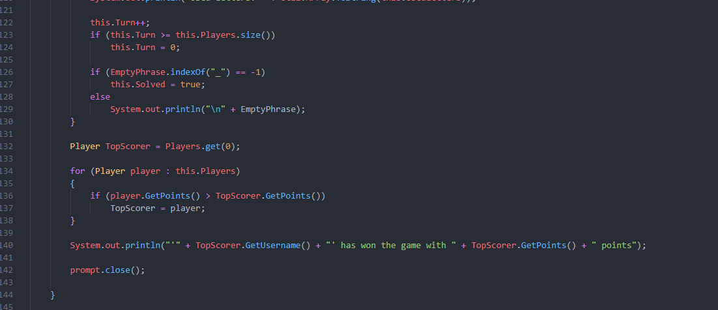

#15 Screenshot: Add code to the PhraseSolver constructor to create two players.

