# Computer Science Applications

## Activity 2.5.4 and 2.5.5: Accessor and Mutator Methods

Copy and paste screenshots and/or answer questions from the activity.

For Activity 2.5.4—Complete the “It’s Your Turn” section and provide screenshots for each of the following…

In the Board class, show the following completed accessor methods- getPhrase(), getSolvedPhrase(), getLetterValue()

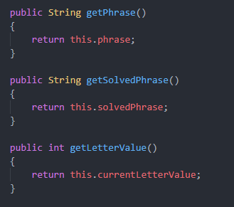

In the Player class, show the following complete accessor methods- getName(), getPoints()

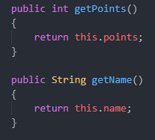

For Activity 2.5.5—Complete the “It’s Your Turn” section and provide screenshots for each of the following…

In the Player class, show the following completed mutator methods- setName()

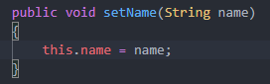

Additionally…in the player class, add the following method

public void addToPoints(int value)

{

points += value;

}

***Complete the play( ) method in the PhraseSolver class. The pseudocode for this method is provided at the end of Activity 2.5.5 in the “Finishing PhraseSolverGame” section.

