# Computer Science Applications

## Activity 2.5.7: Writing Methods

Copy and paste screenshots and/or answer questions from the activity.

#6 Screenshot demonstrating that the book was created properly

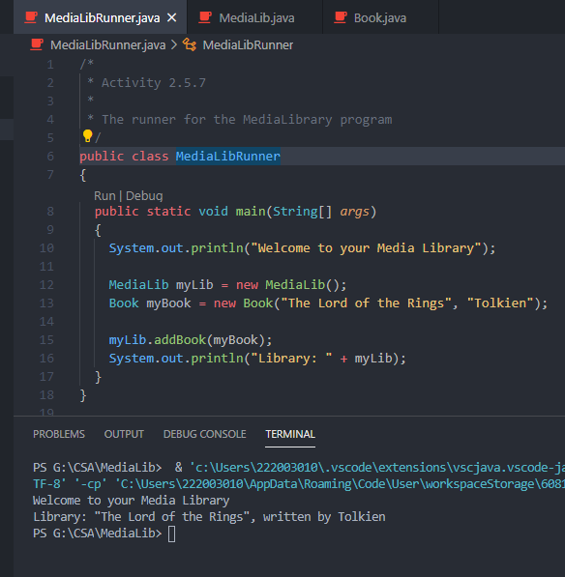

#10 Screenshot demonstrating a working adjustRating method

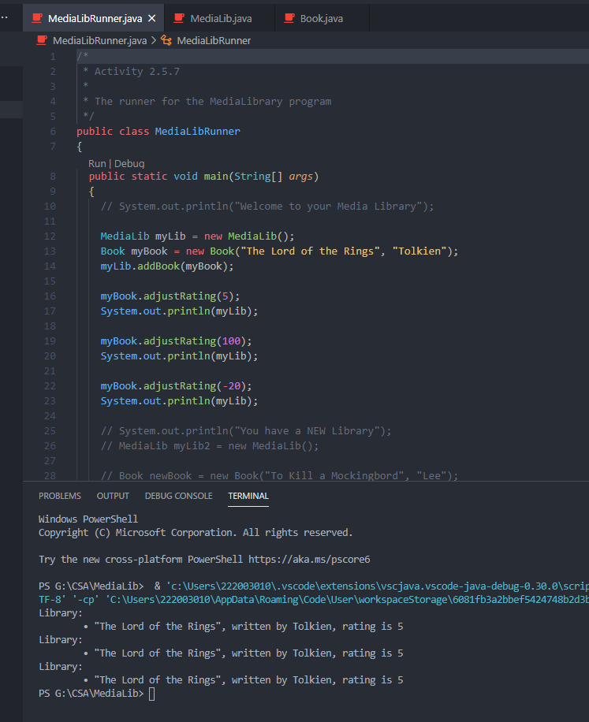

#15 Screenshot demonstrating the creation of a new library and a new book

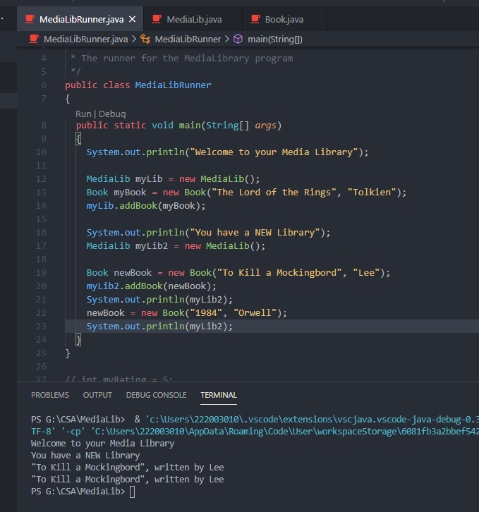

#21 Screenshot demonstrating that the testBook method changed the state of the newBook object and the change was also seen by the caller in MediaLibRunner.

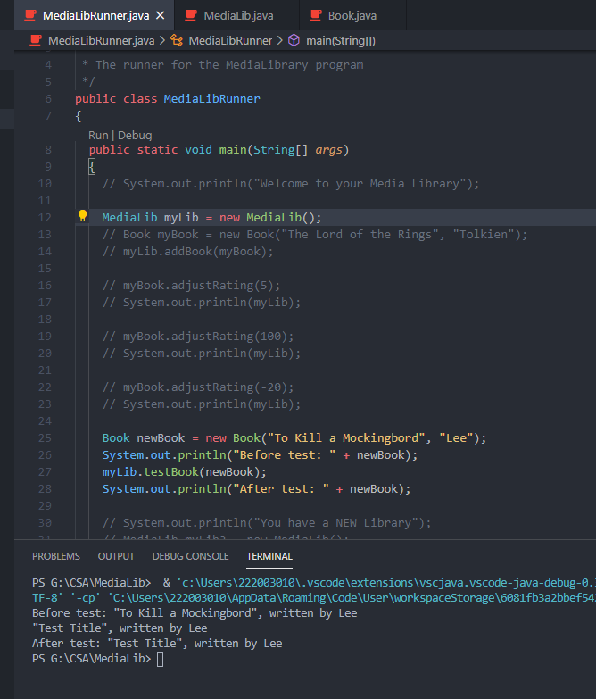

#29 Screenshot of your finished equals method

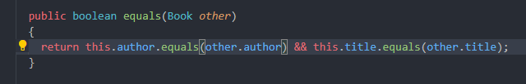

#30 Screenshot your Movie class

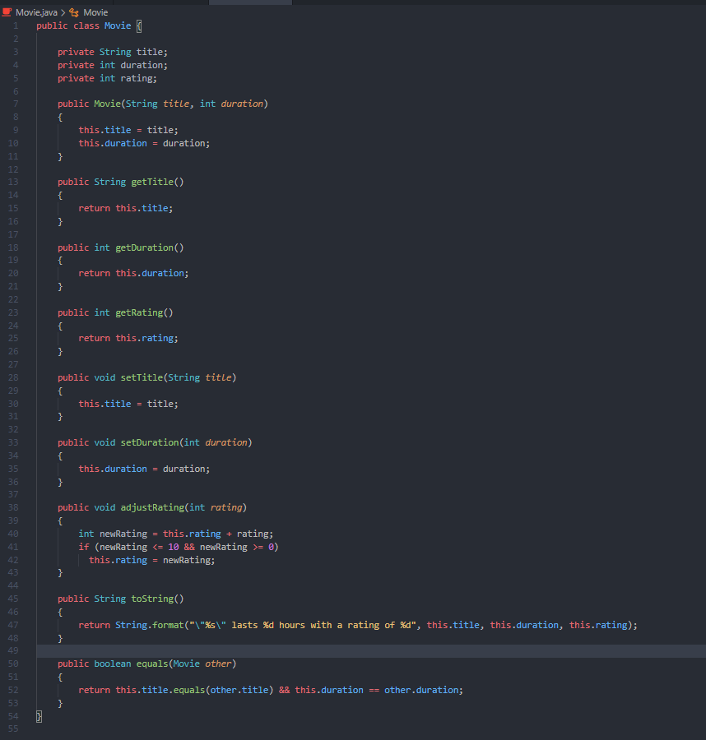

#31 Screenshot of completed parts A, B, and C



#32 Screenshot of your movie, demonstrating that the equals and toString method work

